NSW Education Standards Authority | 
Mathematics K–10 (2022)
curriculum.nsw.edu.au
Generated Sep 2025
Downloaded September 2025
© 2025 NSW Education Standards Authority
NESA acknowledges Traditional Owners and Custodians of Country throughout NSW, and pays respect to Elders past and present. NESA recognises Aboriginal Peoples’ continuing Cultures and Connections to lands, waters, skies and Community.
The documents on the NSW Education Standards Authority (NESA) website and the NSW Curriculum website contain material prepared by NESA for and on behalf of the Crown in right of the State of New South Wales. The material is protected by Crown copyright.
These websites hold the only official and up-to-date versions of the documents available on the internet. Any other copies of these documents, or parts of these documents, that may be found elsewhere on the internet might not be current and are not authorised. You cannot rely on copies from any other source.
All rights are reserved. No part of the material may be:
- reproduced in Australia or in any other country by any process, electronic or otherwise, in any material form
- transmitted to any other person or stored electronically in any form without the written permission of NESA except as permitted by the Copyright Act 1968 (Cth).
When you access the material, you agree:
- to use the material for research or study, criticism or review, reporting news and parody or satire
- to use the material for information purposes only
- not to modify the material or any part of the material without the written permission of NESA
- to reproduce a single copy for personal bona fide study use only and not to reproduce any major extract or the entire material without the permission of NESA
- to include this copyright notice in any copy made
- to acknowledge that NESA is the source of the material.
The documents may include third-party copyright material such as photos, diagrams, quotations, cartoons and artworks. This material is protected by Australian and international copyright laws and may not be reproduced or transmitted in any format without the copyright owner’s permission. Unauthorised reproduction, transmission or commercial use of such copyright material may result in prosecution.
NESA has made all reasonable attempts to locate the owners of third-party copyright material. NESA invites anyone from whom permission has not been sought to contact the Copyright Officer.
Special arrangements applying to the NSW Curriculum Reform
As part of the NSW Curriculum Reform process, NESA grants a limited non-exclusive licence to:
- teachers employed in NSW government schools and registered non-government schools
- representatives from peak school education bodies, such as the NSW Department of Education, Catholic Schools NSW, the Association of Independent Schools of NSW and TAFE NSW
- parents of children registered for home schooling
to use, modify and adapt the NSW syllabuses for non-commercial educational use only. The adaptation must not have the effect of bringing NESA into disrepute.
Note: The above arrangements do not apply to private/home tutoring companies, professional learning service providers, publishers, and other organisations.
For more information on the above or for commercial use or any other purpose, please contact the Copyright Officer for permission.
Email: copyright@nesa.nsw.edu.au

Table of contents
Table of contents 4
Mathematics K–10 (2022) 6
K–2 Implementation survey 6
Overview 6
Syllabus overview 6
Rationale 13
Aim 14
Table of outcomes 15
Secondary (7–10) 15
Outcomes and content for Stage 5 22
Financial mathematics A 22
Financial mathematics B 24
Algebraic techniques A 25
Indices A 27
Equations A 29
Linear relationships A 30
Linear relationships B 34
Non-linear relationships A 37
Non-linear relationships B 39
Numbers of any magnitude 41
Trigonometry A 43
Trigonometry B 45
Area and surface area A 47
Volume A 51
Properties of geometrical figures A 52
Data analysis A 54
Data analysis B 57
Probability A 59
Variation and rates of change A (Path) 62
Variation and rates of change B (Path) 66
Algebraic techniques B (Path) 68
Algebraic techniques C (Path) 70
Indices B (Path) 72
Indices C (Path) 74
Equations B (Path) 76
Equations C (Path) 77
Linear relationships C (Path) 80
Non-linear relationships C (Path) 84
Polynomials (Path) 88
Logarithms (Path) 91
Functions and other graphs (Path) 93
Trigonometry C (Path) 96
Trigonometry D (Path) 97
Area and surface area B (Path) 100
Volume B (Path) 102
Properties of geometrical figures B (Path) 103
Properties of geometrical figures C (Path) 107
Circle geometry (Path) 109
Introduction to networks (Path) 113
Data analysis C (Path) 118
Probability B (Path) 119
Assessment 124
Common Grade Scale 124
Course performance descriptors 124
Assessment of Life Skills outcomes 125

Mathematics K–10 (2022)

K–2 Implementation survey
Provide feedback on the implementation of the Mathematics syllabus for K–2.
The Mathematics K–10 Syllabus (2022): K–2 Implementation survey will run from 8 September – 19 December 2025.
Implementation from 2024
The new Mathematics K–10 Syllabus (2022) is to be implemented from 2024 and replaces the Mathematics K–10 Syllabus (2012).
School sectors are responsible for implementing syllabuses and are best placed to provide schools with specific guidance and information on implementation given their understanding of their individual contexts.

Overview

Syllabus overview

Organisation of Mathematics K–10
The syllabus structure illustrates the important role Working mathematically plays across all areas of mathematics and reflects the strengthened connections between concepts. Working mathematically has been embedded in the outcomes, content and examples of the syllabus.
Mathematics K–10 outcomes and their related content are organised in:
- Number and algebra
- Measurement and space
- Statistics and probability

Working mathematically
The Working mathematically processes present in the Mathematics K–10 syllabus are:
- communicating
- understanding and fluency
- reasoning
- problem solving.
Students learn to work mathematically by using these processes in an interconnected way. The coordinated development of these processes results in students becoming mathematically proficient.
When students are Working mathematically it is important to help them to reflect on how they have used their thinking to solve problems. This assists students to develop ‘mathematical habits of mind’ (Cuoco et al. 2010).
Students need many experiences that require them to relate their knowledge to the vocabulary and conceptual frameworks of mathematics.

Overarching Working mathematically outcome
To highlight how these processes are interrelated, in Mathematics K–10 there is one overarching Working mathematically outcome.
A student develops understanding and fluency in mathematics through:
- exploring and connecting mathematical concepts
- choosing and applying mathematical techniques to solve problems
- communicating their thinking and reasoning coherently and clearly.
The Working mathematically outcome describes the thinking and doing of mathematics. In doing so, the outcome indicates the breadth of mathematical actions that teachers need to emphasise. The overarching Working mathematically outcome is the same across the K–10 Mathematics syllabus.
The Working mathematically processes should be embedded within the concepts being taught. Embedding Working mathematically ensures students are able to fluently understand concepts and make connections to other focus areas. The mathematics focus area outcomes and content provide the knowledge and skills for students to 'reason about', and contexts for problem solving. The overarching Working mathematically outcome is assessed in conjunction with the mathematics content outcomes. The sophistication of Working mathematically processes develops through each stage of learning and can be observed in relation to the increase in complexity of the mathematics outcomes and content. A student's level of competence in Working mathematically can be monitored over time, for example, within Additive Relations by the choice of strategy appropriate to the task, and the use of efficient strategy for the stage of learning the student is working at.
Further information is available in Elaborating on Working mathematically in K–10 (Word, 5 pages, 914.28 kB).
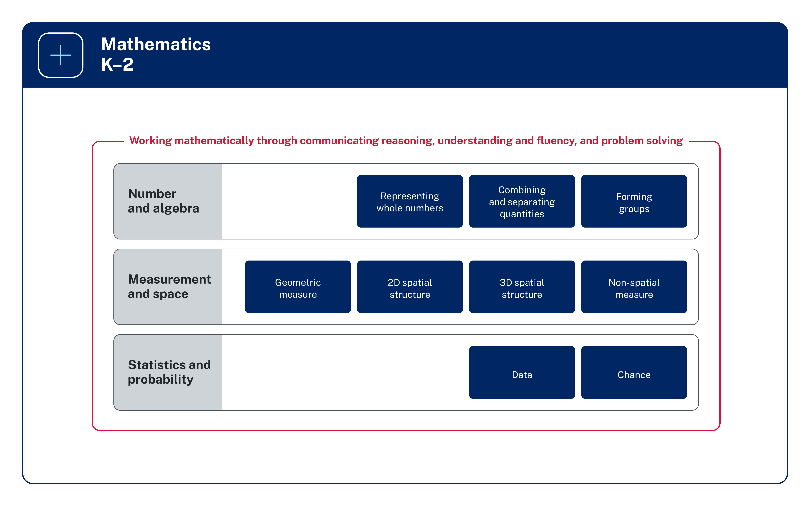
Figure 1: The organisation of Mathematics K–2

Image long description: An overview of the syllabus structure for Early Stage 1 and Stage 1 in Mathematics across the 3 areas of Number and algebra, Measurement and space, and Statistics and probability. Number and algebra reads horizontally across Representing whole numbers, Combining and separating quantities, and Forming groups. Measurement and space reads horizontally across Geometric measure, 2D spatial structure, 3D spatial structure, and Non-spatial measure. Statistics and probability reads horizontally across Data and Chance.
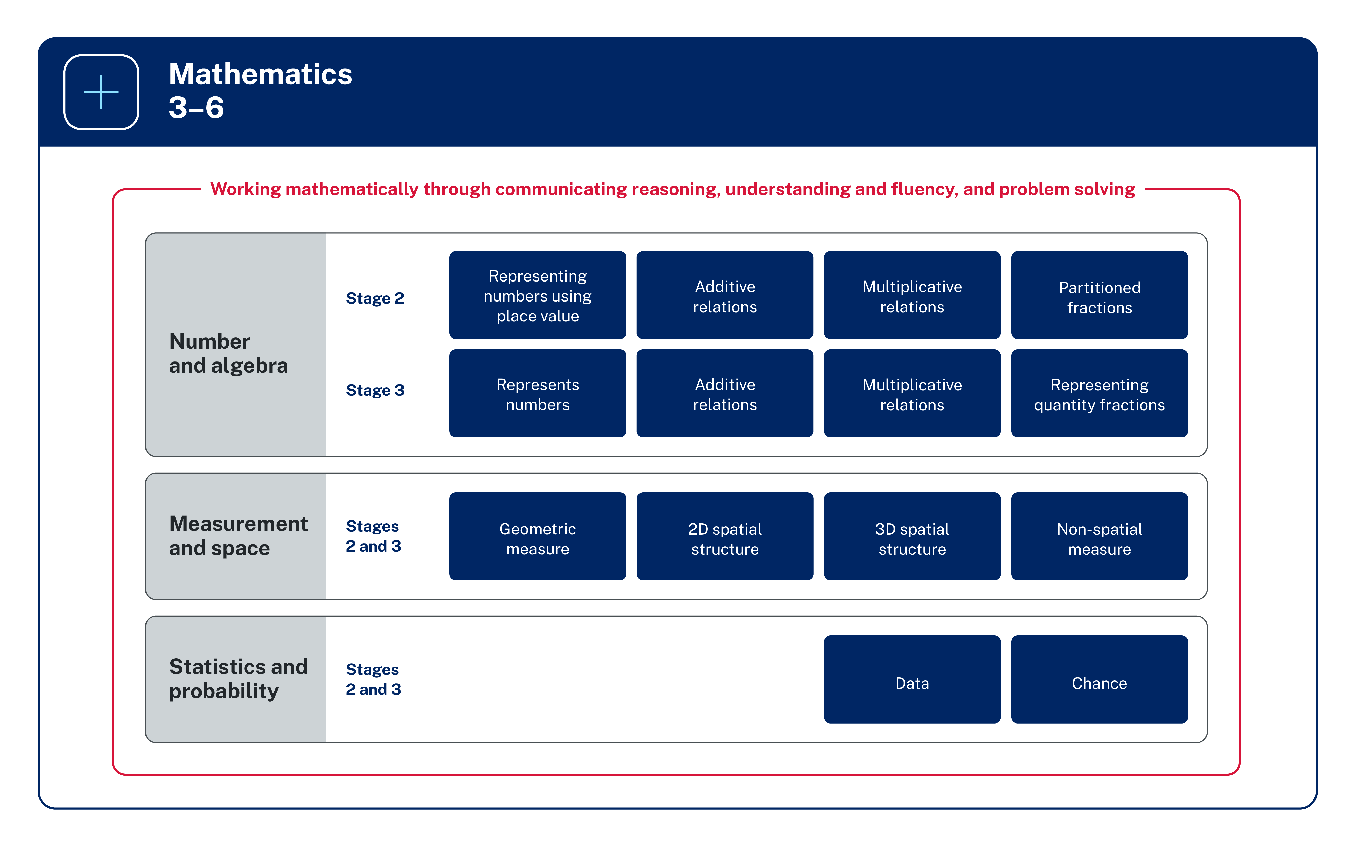
Figure 2: The organisation of Mathematics 3–6

Image long description: An overview of the syllabus structure for Stages 2 and 3 in Mathematics across the 3 areas of Number and algebra, Measurement and space, and Statistics and probability. Number and algebra reads horizontally across 2 stages – Stage 2 and Stage 3. Stage 2 learning areas include Representing numbers using place value, Additive relations, Multiplicative relations and Partitioned fractions. Stage 3 learning areas include Represents numbers, Additive relations, Multiplicative relations, and Representing quality fractions. Measurement and space reads horizontally across 2 stages – Stages 2 and 3. Learning areas include Geometric measure, 2D spatial structure, 3D spatial structure, and Non-spatial measure. Statistics and probability reads horizontally across 2 stages – Stages 2 and 3. Learning areas include Data and Chance.

K–6 Parts A and B
Mathematics focus areas outline the development of several concepts. In Mathematics K–6, where stages span 2 years of learning (for example, Stage 2 includes Year 3 and Year 4), there are concepts that may need to be addressed earlier or later in the stage.
To assist programming, the content in these focus areas has been separated into 2 parts, A and B, such as in Representing Numbers Using Place Value – A and Representing Numbers Using Place Value – B:
- Part A typically focuses on early concept development
- Part B builds on these early concepts.
The content across Parts A and B relates to the same stage-based outcomes. Teachers can choose which content from Part A and/or Part B to address, based on students’ prior learning, needs and abilities.
For example, in Stage 2, Part A does not equate to Year 3 only. When teaching a Year 4 class, the teacher may need to address or consolidate some concepts within Part A prior to addressing concepts in Part B. Similarly, when teaching a Year 3 class, the teacher may decide to address concepts in Part B based on the students’ prior learning, needs and abilities.
The Part A and Part B structure of the content:
- provides flexibility for teachers in planning teaching and learning programs based on the needs and abilities of students
- helps to better visualise the progression and growth of concepts within a stage of learning
- makes clear how content builds to support deep understanding in each focus area.
Considerations for planning teaching and learning programs include:
- when students may have learnt some concepts from Part B content in the first year of a stage, consolidation of these concepts in the second year of a stage may be needed
- revisiting concepts regularly to build deeper understanding of mathematical concepts
- providing extension of certain concepts based on students’ needs and abilities.

Making connections through related content K–6
Many connections exist between the focus areas in mathematics. Skills and knowledge for focus areas often develop in an interrelated manner and can be addressed in parallel.
Within the context of the syllabus, ‘in parallel’ means teaching:
- multiple focus areas at the same time
- parallel content in a sequential manner
- application of knowledge, understanding and skills through interrelated focus areas.
Addressing outcomes in parallel enables teachers to efficiently teach and assess essential concepts within the syllabus content while supporting students to make connections with their learning.
Examples of outcomes and content that could be addressed in parallel are identified for each focus area. These are not an exhaustive list of ways that knowledge, understanding and skills are related or can be taught in parallel.
- Making Connections Early Stage 1
- Making Connections Stage 1
- Making Connections Stage 2
- Making Connections Stage 3
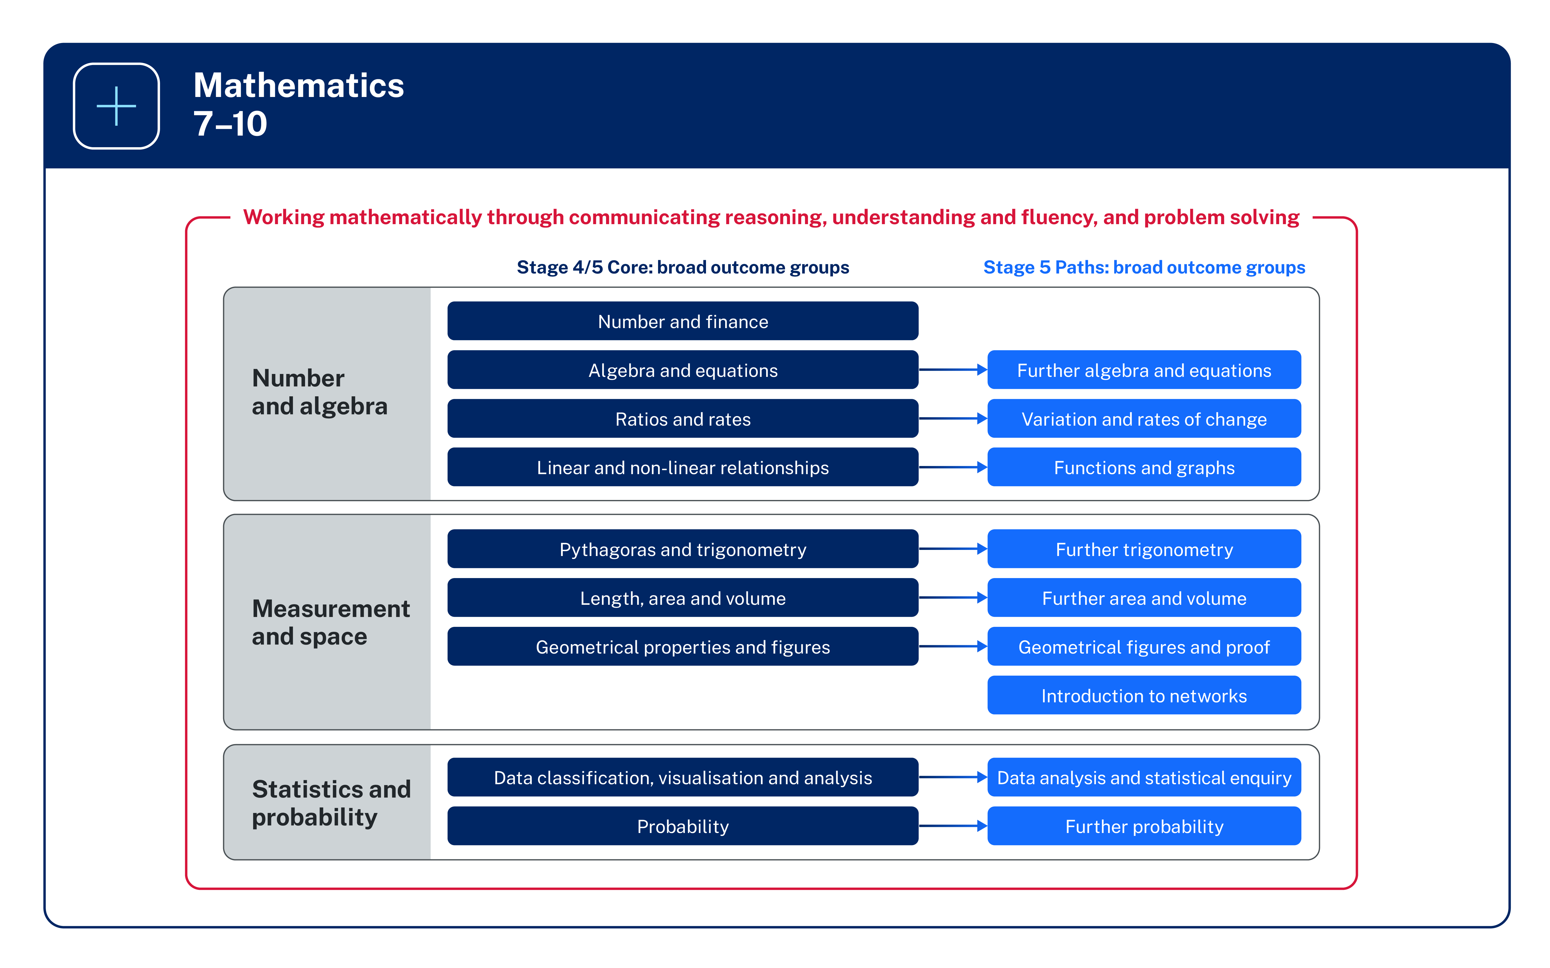
Figure 3: The organisation of Mathematics 7–10

Image long description: Stage 4/5 Core: broad outcome groups are Number and finance, Algebra and equations, Ratios and rates, Linear and non-linear relationships, Pythagoras and trigonometry, Length, area and volume, Geometrical properties and figures, Data classification, visualisation and analysis and Probability. Stage 5 Paths: broad outcome groups are Further algebra and equations, Variation and rates of change, Functions and graphs, Further trigonometry, Further area and volume, Geometrical figures and proof, Introduction to networks, Data analysis and statistical enquiry and Further probability. All content is surrounded by the phrase, Working mathematically through communicating reasoning, understanding and fluency, and problem solving.

7–10 Core–Paths structure
The Core–Paths structure is designed to encourage aspiration in students and provide the flexibility needed to enable teachers to create pathways for students working towards Stage 6. The structure is intended to extend students as far along the continuum of learning as possible and provide solid foundations for the highest levels of student achievement. The structure allows for a diverse range of endpoints up to the end of Stage 5.
The Core outcomes provide students with the foundation for Mathematics Standard 2 in Stage 6. Students who require ongoing support in completing all Stage 5 Core outcomes may consider either Mathematics Standard 1 or the Numeracy CEC course in Stage 6. For these students, teachers are encouraged to continue to extend students towards demonstrating achievement in as many Stage 5 Core outcomes as possible. This is to enable as many students as possible to have the knowledge and skills necessary to engage in the highest level of mathematics possible.
The aim for most students is to demonstrate achievement of the Core and as many Path outcomes as possible by the end of Stage 5 and this should guide teacher planning. Allowing time for students to demonstrate understanding of the Core outcomes must be a key consideration.
Typically, the Core will cover teaching and learning experiences up to the middle of Stage 5. It is not the intention of the Core–Paths structure to lock students into predetermined pathways at the end of Stage 4. Pathways in Stage 5 must be carefully planned to ensure some students have the opportunity to engage with Advanced and Extension courses.
Paths are used to progress students towards Stage 6 courses and may be implemented at any time in Stages 4 and 5 with careful consideration of the continuum of learning. Teachers also have the option of engaging with specific elements of Paths rather than the entire outcome to meet the needs of their students. Teachers should plan to cover as many Paths as practicable.

Course requirements K–10

Mandatory curriculum requirements 7–10
The mandatory curriculum requirements for eligibility for the award of the Record of School Achievement (RoSA) include that students:
- study the Board developed Mathematics syllabus substantially in each of Years 7–10 and
- complete at least 400 hours of Mathematics study by the end of Year 10.
Satisfactory completion of at least 200 hours of study in Mathematics during Stage 5 (Years 9 and 10) will be recorded with a grade. Students undertaking the Mathematics course based on Life Skills outcomes and content are not allocated a grade.
Course numbers:
- Mathematics: 326
- Mathematics Life Skills: 327
Exclusions: Students may not access both the Mathematics Years 7–10 outcomes and content and the Mathematics Life Skills outcomes and content.

Access content points K–6
Access content points have been developed to support students with significant intellectual disability who are working towards Early Stage 1 outcomes. These students may communicate using verbal and/or nonverbal forms.
For each of the Early Stage 1 outcomes, access content points are provided to indicate content that students with significant intellectual disability may access as they work towards the outcomes. Teachers will use the access content points on their own, or in combination with the content for each outcome.
Decisions regarding curriculum options for students with disability should be made in the context of collaborative curriculum planning.

Life Skills outcomes and content 7–10
Students with disability can access the syllabus outcomes and content in a range of ways. Decisions regarding curriculum options should be made in the context of collaborative curriculum planning.
Some students with intellectual disability may find the Years 7–10 Life Skills outcomes and content the most appropriate option to follow in Stage 4 and/or Stage 5. Before determining whether a student is eligible to undertake a course based on Life Skills outcomes and content, consideration should be given to other ways of assisting the student to engage with the Stage 4 and/or Stage 5 outcomes, or prior stage outcomes if appropriate. This assistance may include a range of adjustments to teaching, learning and assessment activities.
Life Skills outcomes cannot be taught in combination with other outcomes from the same subject. Teachers select specific Life Skills outcomes to teach based on the needs, strengths, goals, interests and prior learning of each student. Students are required to demonstrate achievement of one or more Life Skills outcomes.

Balance of content
The amount of content associated with a given outcome is not necessarily indicative of the amount of time spent engaging with the respective outcome. Teachers use formative and summative assessment to determine instructional priorities and the time needed for students to demonstrate expected outcomes.

Working at different stages
The content presented in a stage represents the typical knowledge, understanding and skills that students learn throughout the stage. It is acknowledged that students learn at different rates and in different ways. There may be students who will not demonstrate achievement in relation to one or more of the outcomes for the Stage.
There may be instances where teachers will need to address outcomes across different stages in order to meet the learning needs of students. Teachers are best placed to make decisions about when students need to work at, above or below stage level in relation to one or more of the outcomes. This recognises that outcomes may be achieved by students at different times across stages. Only students who are accelerated in a course may access Stage 6 outcomes.
For example:
- Students in Early Stage 1 could be working on Stage 1 content in the Number and Algebra strand, while working on Early Stage 1 content in the Measurement and Geometry strand.
- In Stage 2 or Stage 3, some students may not have developed a complete understanding of place value and the role of zero to read, write and order two-digit and three-digit numbers. These students will need to access content from Early Stage 1 or Stage 1 before engaging with Stage 2 content in applying place value to larger numbers and decimals.
- In Stage 4 some students may not have developed a complete understanding of fractions, decimals and percentages and will need to access related outcomes from Stage 3.

Rationale
Mathematical ideas have evolved and continue to develop across cultures and have been practised in Australia by Aboriginal and Torres Strait Islander Peoples for thousands of years. Through the study of mathematics, students apply their knowledge and skills to deepen their understanding of the world.
Mathematics is a reasoning and creative activity, integral to scientific and technological advances across many fields of endeavour. The symbolic nature of mathematics provides a powerful and precise means of communication.
Making connections across mathematical concepts and other subject areas enhances students’ ability to understand the purpose of learning mathematics and to develop a deeper conceptual understanding. This helps students to recognise the role of mathematics in solving problems in the world around them, applying their understanding to familiar and unfamiliar situations.
By studying mathematics, students develop essential numeracy skills and fluency, while nurturing the ability to think logically, critically and creatively. They learn about patterns and reason about relationships, creating opportunities to generalise their solutions and to solve non-routine problems.
When students enjoy learning mathematics, they develop a positive self-concept and become self-motivated learners through active participation in appropriately challenging tasks. This can enhance their resilience in solving mathematical problems relevant to further education and their everyday lives.

Aim
The aim of Mathematics K–10 is to enable students to become confident users of mathematics, learning and applying the language of mathematics to communicate efficiently and effectively. They develop an increasingly sophisticated understanding of mathematical concepts and a fluency with mathematical processes that helps them to interpret and solve problems. Students make connections within mathematics and connect mathematical concepts with the world around them. They learn to understand and appreciate how mathematics is a relevant part of their lives.

Table of outcomes

Secondary (7–10)
MAO-WM-01 Working mathematically
develops understanding and fluency in mathematics through exploring and connecting mathematical concepts, choosing and applying mathematical techniques to solve problems, and communicating their thinking and reasoning coherently and clearly
This outcome is aligned to all content in each Stage.
Focus area | Stage 4 | Stage 5
Computation with integers | MA4-INT-C-01  compares, orders and calculates with integers to solve problems | No Stage 5 outcomes
Fractions, decimals and percentages | MA4-FRC-C-01  represents and operates with fractions, decimals and percentages to solve problems | No Stage 5 outcomes
Length | MA4-LEN-C-01  applies knowledge of the perimeter of plane shapes and the circumference of circles to solve problems | No Stage 5 outcomes
Angle relationships | MA4-ANG-C-01  applies angle relationships to solve problems, including those related to transversals on sets of parallel lines | No Stage 5 outcomes
Data classification and visualisation | MA4-DAT-C-01  classifies and displays data using a variety of graphical representations | No Stage 5 outcomes
Financial mathematics  Includes:  Stage 5: Financial mathematics A  Stage 5: Financial mathematics B | No Stage 4 outcomes | MA5-FIN-C-01  solves financial problems involving simple interest, earning money and spending money  MA5-FIN-C-02  solves financial problems involving compound interest and depreciation
Algebraic techniques  Includes:  Stage 5: Algebraic techniques A  Stage 5: Algebraic techniques B (Path)  Stage 5: Algebraic techniques C (Path) | MA4-ALG-C-01  generalises number properties to operate with algebraic expressions including expansion and factorisation | MA5-ALG-C-01  simplifies algebraic fractions with numerical denominators and expands algebraic expressions  MA5-ALG-P-01  simplifies algebraic fractions involving indices, and expands and factorises algebraic expressions (Path: Adv)  MA5-ALG-P-02  selects and applies appropriate algebraic techniques to operate with algebraic fractions, and expands, factorises and simplifies algebraic expressions (Path: Adv)
Indices  Includes:  Stage 5: Indices A  Stage 5: Indices B (Path)  Stage 5: Indices C (Path) | MA4-IND-C-01  operates with primes and roots, positive-integer and zero indices involving numerical bases and establishes the relevant index laws | MA5-IND-C-01  simplifies algebraic expressions involving positive-integer and zero indices, and establishes the meaning of negative indices for numerical bases  MA5-IND-P-01  applies the index laws to operate with algebraic expressions involving negative-integer indices (Path: Adv)  MA5-IND-P-02  describes and performs operations with surds and fractional indices (Path: Adv)
Equations  Includes:  Stage 5: Equations A  Stage 5: Equations B (Path)  Stage 5: Equations C (Path) | MA4-EQU-C-01  solves linear equations of up to 2 steps and quadratic equations of the form $${ax}^{2}=c$$ | MA5-EQU-C-01  solves linear equations of up to 3 steps, limited to one algebraic fraction  MA5-EQU-P-01  solves monic quadratic equations, linear inequalities and cubic equations of the form $${ax}^{3}=k$$ (Path: Adv)  MA5-EQU-P-02  solves linear equations of more than 3 steps, monic and non-monic quadratic equations, and linear simultaneous equations (Path: Adv)
Linear relationships  Includes:  Stage 5: Linear relationships A  Stage 5: Linear relationships B  Stage 5: Linear relationships C (Path) | MA4-LIN-C-01  creates and displays number patterns and finds graphical solutions to problems involving linear relationships | MA5-LIN-C-01  determines the midpoint, gradient and length of an interval, and graphs linear relationships, with and without digital tools  MA5-LIN-C-02  graphs and interprets linear relationships using the gradient/slope-intercept form  MA5-LIN-P-01  describes and applies transformations, the midpoint, gradient/slope and distance formulas, and equations of lines to solve problems (Path: Adv)
Non-linear relationships  Includes:  Stage 5: Non-linear relationships A  Stage 5: Non-linear relationships B  Stage 5: Non-linear relationships C (Path) | No Stage 4 outcomes | MA5-NLI-C-01  identifies connections between algebraic and graphical representations of quadratic and exponential relationships in various contexts  MA5-NLI-C-02  identifies and compares features of parabolas and exponential curves in various contexts  MA5-NLI-P-01  interprets and compares non-linear relationships and their transformations, both algebraically and graphically (Path: Adv)
Numbers of any magnitude | No Stage 4 outcomes | MA5-MAG-C-01  solves measurement problems by using scientific notation to represent numbers and rounding to a given number of significant figures
Pythagoras and trigonometry  Includes:  Stage 5: Trigonometry A  Stage 5: Trigonometry B  Stage 5: Trigonometry C (Path)  Stage 5: Trigonometry D (Path) | MA4-PYT-C-01  applies Pythagoras’ theorem to solve problems in various contexts | MA5-TRG-C-01  applies trigonometric ratios to solve right-angled triangle problems  MA5-TRG-C-02  applies trigonometry to solve problems, including bearings and angles of elevation and depression  MA5-TRG-P-01  applies Pythagoras’ theorem and trigonometry to solve 3-dimensional problems and applies the sine, cosine and area rules to solve 2-dimensional problems, including bearings (Path: Stn, Adv)  MA5-TRG-P-02  establishes and applies the properties of trigonometric functions and finds solutions to trigonometric equations (Path: Adv)
Area and surface area  Includes:  Stage 5: Area and surface area A  Stage 5: Area and surface area B (Path) | MA4-ARE-C-01  applies knowledge of area and composite area involving triangles, quadrilaterals and circles to solve problems | MA5-ARE-C-01  solves problems involving the surface area of right prisms and practical problems involving the area of composite shapes and solids  MA5-ARE-P-01  applies knowledge of the surface area of right pyramids and cones, spheres and composite solids to solve problems (Path: Stn, Adv)
Volume  Includes:  Stage 5: Volume A  Stage 5: Volume B (Path) | MA4-VOL-C-01  applies knowledge of volume and capacity to solve problems involving right prisms and cylinders | MA5-VOL-C-01  solves problems involving the volume of composite solids consisting of right prisms and cylinders  MA5-VOL-P-01  applies knowledge of the volume of right pyramids, cones and spheres to solve problems involving related composite solids (Path: Stn, Adv)
Properties of geometrical figures  Includes:  Stage 5: Properties of geometrical figures A  Stage 5: Properties of geometrical figures B (Path)  Stage 5: Properties of geometrical figures C (Path) | MA4-GEO-C-01  identifies and applies the properties of triangles and quadrilaterals to solve problems | MA5-GEO-C-01  identifies and applies the properties of similar figures and scale drawings to solve problems  MA5-GEO-P-01  establishes conditions for congruent triangles and similar triangles and solves problems relating to properties of similar figures and plane shapes (Path: Ext)  MA5-GEO-P-02  constructs proofs involving congruent triangles and similar triangles and proves properties of plane shapes (Path: Ext)
Data analysis  Includes:  Stage 5: Data analysis A  Stage 5: Data analysis B  Stage 5: Data analysis C (Path) | MA4-DAT-C-02  analyses simple datasets using measures of centre, range and shape of the data | MA5-DAT-C-01  compares and analyses datasets using summary statistics and graphical representations  MA5-DAT-C-02  displays and interprets datasets involving bivariate data  MA5-DAT-P-01  plans, conducts and reviews a statistical inquiry into a question of interest (Path: Stn, Adv)
Probability  Includes:  Stage 5: Probability A  Stage 5: Probability B (Path) | MA4-PRO-C-01  solves problems involving the probabilities of simple chance experiments | MA5-PRO-C-01  solves problems involving probabilities in multistage chance experiments and simulations  MA5-PRO-P-01  solves problems involving Venn diagrams, 2-way tables and conditional probability (Path: Adv)
Ratios and rates  Includes:  Stage 5: Variation and rates of change A (Path)  Stage 5: Variation and rates of change B (Path) | MA4-RAT-C-01  solves problems involving ratios and rates, and analyses distance–time graphs | MA5-RAT-P-01  identifies and solves problems involving direct and inverse variation and their graphical representations (Path: Stn, Adv)  MA5-RAT-P-02  analyses and constructs graphs relating to rates of change (Path: Stn, Adv)
Polynomials (Path) | No Stage 4 outcomes | MA5-POL-P-01  defines, operates with and graphs polynomials and applies the factor and remainder theorems to solve problems (Path: Adv, Ext)
Logarithms (Path) | No Stage 4 outcomes | MA5-LOG-P-01  establishes and applies the laws of logarithms to solve problems (Path: Adv)
Functions and other graphs (Path) | No Stage 4 outcomes | MA5-FNC-P-01  uses function notation to describe and graph functions of one variable and graphs inequalities in one and 2 variables (Path: Adv)
Circle geometry (Path) | No Stage 4 outcomes | MA5-CIR-P-01  applies deductive reasoning to prove circle theorems and solve related problems (Path: Ext)
Introduction to networks (Path) | No Stage 4 outcomes | MA5-NET-P-01  solves problems involving the characteristics of graphs/networks, planar graphs and Eulerian trails and circuits (Path: Stn)
Before deciding that a student should undertake a course based on Life Skills outcomes and content, consideration should be given to other ways of assisting the student to engage with the Stage 4 or Stage 5 outcomes. Further information in relation to planning, implementing and assessing Life Skills outcomes and content can be found on the NESA website.

Outcomes and content for Stage 5

Financial mathematics A

Outcomes
A student:
- develops understanding and fluency in mathematics through exploring and connecting mathematical concepts, choosing and applying mathematical techniques to solve problems, and communicating their thinking and reasoning coherently and clearly MAO-WM-01
- solves financial problems involving simple interest, earning money and spending money MA5-FIN-C-01
Related Life Skills outcomes: MALS-FIN-01, MALS-FIN-02

Content

Solve problems involving earning money
- Solve problems involving wages given an hourly rate of pay including penalty rates for overtime, weekends and public holidays
Example(s):
Calculating the hourly rate of pay if a person worked a 4-hour shift and earned $45 including a $5 tip.
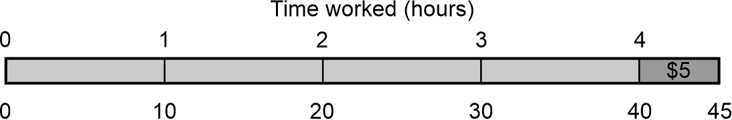
PrT4, PrT5
- Calculate earnings from non-wage sources exploring commission, piece work and royalties
PrT5, PrT6
- Calculate weekly, fortnightly, monthly and yearly earnings assuming 1 year = 52 weeks
MeT4, PrT5
- Calculate leave loading by finding a percentage of eligible normal pay
PrT2
- Investigate sources of published tables or online calculators and use these to calculate the weekly, fortnightly or monthly tax to be deducted from a worker’s pay under the Australian Pay-As-You-Go (PAYG) taxation system
UnM8
- Determine annual taxable income by exploring allowable deductions and current tax rates
UnM8
- Calculate net earnings after deductions and taxation
UnM8

Solve problems involving simple interest
- Establish and use the formula $$I=Prn$$ to find simple interest where $$I=$$simple interest, $$P=$$principal, $$r=$$interest rate per time period and $$n=$$ number of time periods
UnM8, NPA8
- Apply the simple interest formula to solve problems related to investing money at simple interest rates, both algebraically and graphically
PrT6, UnM8, NPA8

Solve problems involving spending money
- Calculate the cost of buying items on terms, by paying an initial deposit and making regular repayments
UnM8
- Examine payment options involving buy now, pay later and investigate the costs associated with these schemes for purchasing goods
Example(s):
Exploring options for a student wanting to buy a laptop valued at $2700. They have the option to buy it using a company that offers a buy now, pay later option. Researching which companies offer this facility, how will the cost of the laptop be split into repayment amounts and what costs or penalties are associated with the purchase if the student cannot make their repayments on time?
PrT6, UnM8
- Examine the principles behind short-term loans involving small dollar amounts and compare borrowing costs associated with using these products
PrT6

Financial mathematics B

Outcomes
A student:
- develops understanding and fluency in mathematics through exploring and connecting mathematical concepts, choosing and applying mathematical techniques to solve problems, and communicating their thinking and reasoning coherently and clearly MAO-WM-01
- solves financial problems involving compound interest and depreciation MA5-FIN-C-02
Related Life Skills outcomes: MALS-FIN-01, MALS-FIN-02

Content

Solve problems involving compound interest and depreciation
- Examine compound interest for up to 3 time periods using repetition of the formula for simple interest
UnM10, NPA8
- Associate the calculation of the total value of a compound interest investment with repeated multiplication, using digital tools
Example(s):
Modelling repeated multiplication with digital tools for a rate of 5% per annum, using 1.05 for each year.

- Establish and use the formula $$FV=PV{\left(1+r\right)}^{n}$$ to find compound interest where $$FV$$ $$=$$ future value of the investment, $$PV=$$ present value of the investment, $$r=$$interest rate per time period and $$n=$$ number of time periods
PrT7, UnM10, NPA8
- Solve problems involving compound interest
Example(s):
Using a guess and refine strategy to determine the number of years required to have $2000 from an investment of $500 if interest is compounded quarterly at 4.8% per annum.
UnM10
- Compare simple interest with compound interest in practical situations
PrT7, UnM10, NPA8
- Use the compound interest formula to establish the depreciation formula $$S=V_{0}{\left(1-r\right)}^{n}$$where $$S=$$ salvage value, $$V_{0}=$$initial value of the asset, $$r=$$ depreciation rate per time period and $$n=$$ number of periods
UnM8, NPA8
- Solve problems involving the depreciation of an asset

Algebraic techniques A

Outcomes
A student:
- develops understanding and fluency in mathematics through exploring and connecting mathematical concepts, choosing and applying mathematical techniques to solve problems, and communicating their thinking and reasoning coherently and clearly MAO-WM-01
- simplifies algebraic fractions with numerical denominators and expands algebraic expressions MA5-ALG-C-01
Related Life Skills outcomes: MALS-PAT-01

Content

Apply the 4 operations to simplify algebraic fractions with numerical denominators
- Simplify expressions that involve algebraic fractions with numerical denominators
Example(s):
Simplifying $$\frac{a}{2}+\frac{a}{3}$$, $$\frac{2x}{5}-\frac{x}{3}$$, $$\frac{3x}{4}×\frac{2x}{9}$$, $$\frac{3x}{4}÷\frac{9x}{2}$$.

Apply the distributive law to the expansion of algebraic expressions, and collect like terms where appropriate
- Expand algebraic expressions, including those with negative coefficients
Example(s):
Expanding $$-3\left(5x^{2}+2y+4\right)$$.

- Expand and simplify algebraic expressions by removing grouping symbols and collecting like terms where appropriate
Example(s):
Expanding and simplifying $$2y\left(y-5\right)+4\left(y-5\right), 4x\left(3x+2y+2\right)-\left(x-1\right), 18-4(x-2)$$.

- Expand binomial products algebraically using the distributive law or consider areas of rectangles as a possible method of expansion
Example(s):
Expanding $$\left(x+3\right)\left(x+8\right)$$ using an area model.
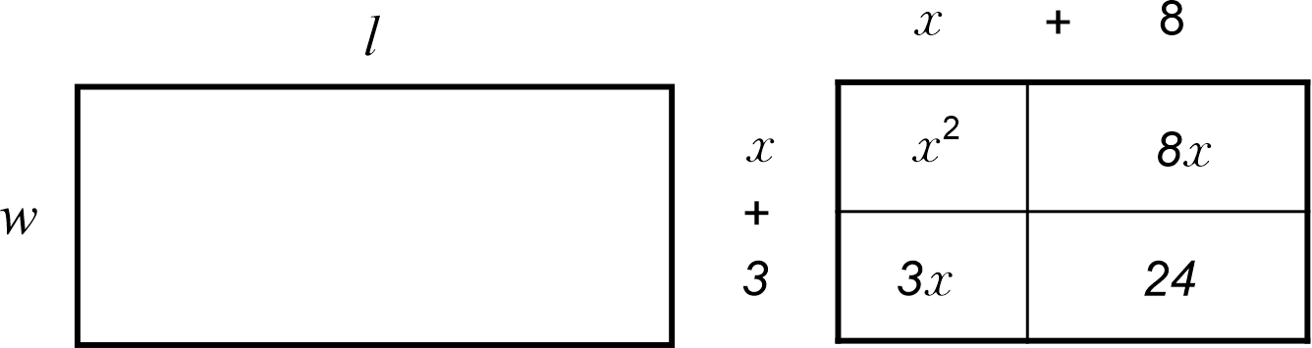
Image long description: A rectangle divided into 4 boxes expanding algebraic terms using the area method. x plus 8 is on the top and x plus 3 is on the left side. x squared, 8x, 3x and 24 are inside the rectangle.
Generalising the commutative property of arithmetic to binomial products, such as $$\left(a+b\right)\left(c+d\right)=\left(c+d\right)\left(a+b\right).$$

Indices A

Outcomes
A student:
- develops understanding and fluency in mathematics through exploring and connecting mathematical concepts, choosing and applying mathematical techniques to solve problems, and communicating their thinking and reasoning coherently and clearly MAO-WM-01
- simplifies algebraic expressions involving positive-integer and zero indices, and establishes the meaning of negative indices for numerical bases MA5-IND-C-01

Content

Extend and apply the index laws to variables, using positive-integer indices and the zero index
- Apply the index laws for numerical bases with positive-integer indices to develop the index laws in algebraic form
Example(s):
Generalising numerical expressions, such as $$2^{2}×2^{3}=2^{2 + 3}=2^{5}$$ to $$a^{m}×a^{n}=a^{m + n}$$.
Generalising numerical expressions, such as $$2^{5}÷2^{3}=2^{5 - 3}=2^{2}$$ to $$a^{m}÷a^{n}=a^{m - n}$$.
Generalising numerical expressions, such as $${\left(2^{2}\right)}^{3}=2^{2 × 3}=2^{6}$$ to $${\left(a^{m}\right)}^{n}=a^{mn}$$.

- Establish that $$x^{0}=1$$ algebraically using index laws
Example(s):
By considering $$\frac{x^{4}}{x^{4}}=x^{4 - 4}=x^{0}$$and $$\frac{x^{4}}{x^{4}}=\frac{x × x × x × x}{x × x × x × x}=1$$, establish that $$x^{0}=1$$.

- Simplify algebraic expressions that involve the zero index
Example(s):
Recognising and explaining that $$7m^{0}=7×1=7$$ and $${\left(3x\right)}^{0}+5=6$$.

Simplify algebraic products and quotients using index laws
- Simplify algebraic expressions that involve powers, products and quotients of simple algebraic terms containing positive-integer indices
Example(s):
Simplifying $${\left({3x}^{2}\right)}^{3}={27x}^{6}$$ and $${15a}^{6}÷{3a}^{2}={5a}^{4}$$.

Apply index laws to numerical expressions with negative-integer indices
- Apply index notation, patterns and index laws to establish the meaning of negative indices for numerical bases
Example(s):
Using numerical patterns:
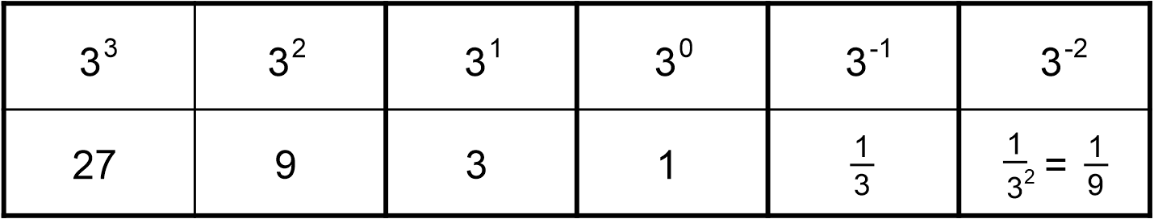
Image long description: 6 columns in a table showing descending powers with a base of 3 on the top row and their calculations on the bottom row. On the top row, 3 cubed, 3 squared, 3 to the power of 1, 3 to the power of 0, 3 to the power of minus 1 and 3 to the power of minus 2. The bottom row is 27, 9, 3, 1, one-third, and 1 over 3 squared equals 1 over 9.
Applying index laws: $$4^{3}÷4^{5}=4^{-2}$$and $$\frac{4^{3}}{4^{5}}=\frac{1}{4^{2}}$$ to establish that $$4^{-2}=\frac{1}{4^{2}}$$.

- Evaluate numerical expressions involving a negative index by first representing them with a positive index
Example(s):
Evaluating $$3^{-4}=\frac{1}{3^{4}}=\frac{1}{81}$$.

- Represent given numbers in index form (integer indices and bases only) and vice versa
Example(s):
Representing $$\frac{1}{125}$$ as $$\frac{1}{5^{3}}$$ and $$5^{-3}$$.

Equations A

Outcomes
A student:
- develops understanding and fluency in mathematics through exploring and connecting mathematical concepts, choosing and applying mathematical techniques to solve problems, and communicating their thinking and reasoning coherently and clearly MAO-WM-01
- solves linear equations of up to 3 steps, limited to one algebraic fraction MA5-EQU-C-01
Related Life Skills outcomes: MALS-ADS-01, MALS-MDI-01

Content

Solve linear equations involving up to 3 steps
- Solve linear equations using algebraic techniques involving up to 3 steps
- Solve linear equations with pronumerals on both sides of the equation
- Solve linear equations involving grouping symbols
- Verify solutions using substitution
NPA6

Solve linear equations involving one algebraic fraction
- Solve linear equations involving one algebraic fraction using up to 3 steps

Solve linear equations arising from word problems and substitution into formulas
- Solve linear equations arising from substitution into formulas
Example(s):
Using the formula to convert temperatures measured in Fahrenheit to Celsius, $$C=\frac{5}{9}\left(F-32\right)$$, find the temperature in Fahrenheit if the temperature in Celsius is $${100}^{°}$$.
NPA6
- Represent word problems as linear equations, solve the equations and interpret the solutions in the context of the problem
NPA7

Linear relationships A

Outcomes
A student:
- develops understanding and fluency in mathematics through exploring and connecting mathematical concepts, choosing and applying mathematical techniques to solve problems, and communicating their thinking and reasoning coherently and clearly MAO-WM-01
- determines the midpoint, gradient and length of an interval, and graphs linear relationships, with and without digital tools MA5-LIN-C-01
Related Life Skills outcomes: MALS-POS-01

Content

Find the midpoint and gradient of a line segment (interval) on the Cartesian plane
- Plot and join 2 points to form an interval on the Cartesian plane and use the interval as the hypotenuse of a right-angled triangle
Example(s):
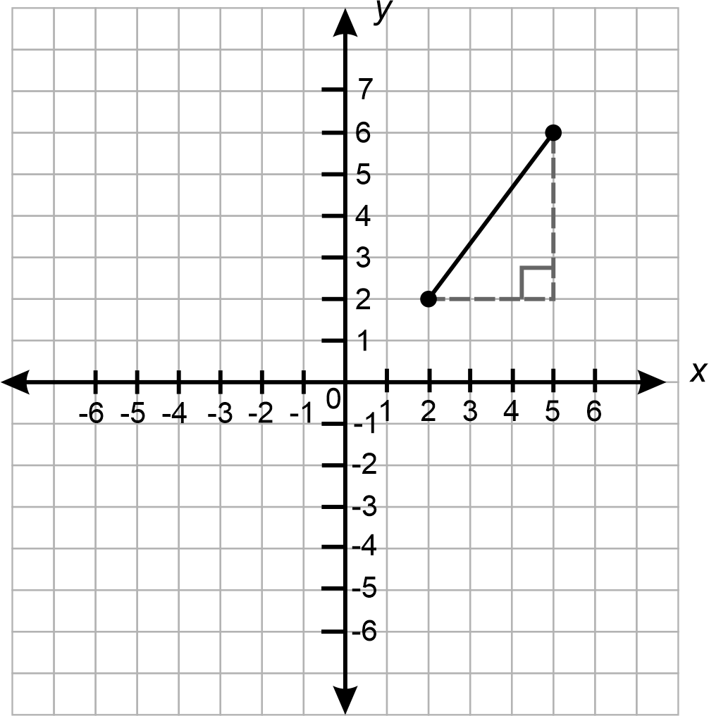
NPA7
- Apply the relationship gradient $$m=\frac{rise}{run}$$ to find the gradient/slope of the interval joining the 2 points
Example(s):
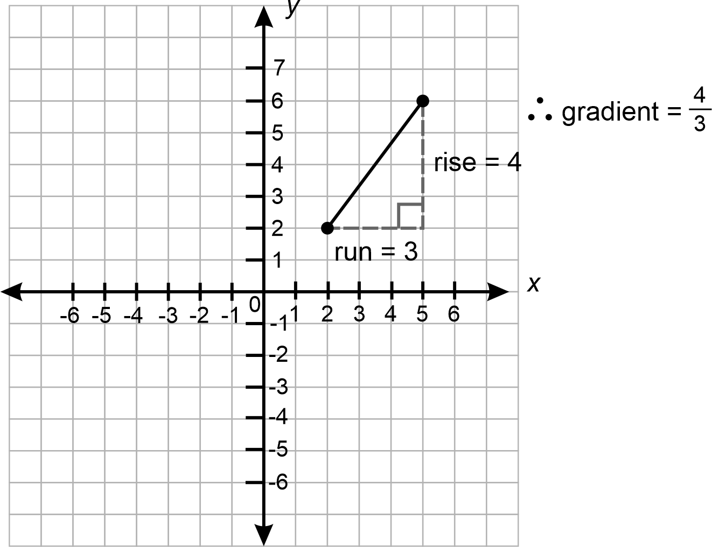
Image long description: A right-angled triangle is formed from the interval on the Cartesian plane with a rise of 4 and a run of 3. Therefore, the gradient is 4 over 3.

- Distinguish between intervals with positive and negative gradients from a diagram
Example(s):
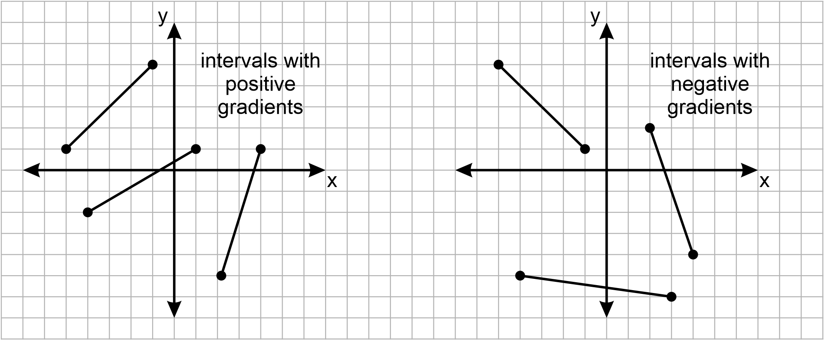
Image long description: On both Cartesian planes, lines sloping upwards are positive gradients and lines sloping downwards are negative gradients.

- Explain why horizontal intervals have a gradient of 0 and vertical intervals have undefined gradients using the gradient relationship
- Determine the midpoint of horizontal and vertical intervals on the Cartesian plane
Example(s):
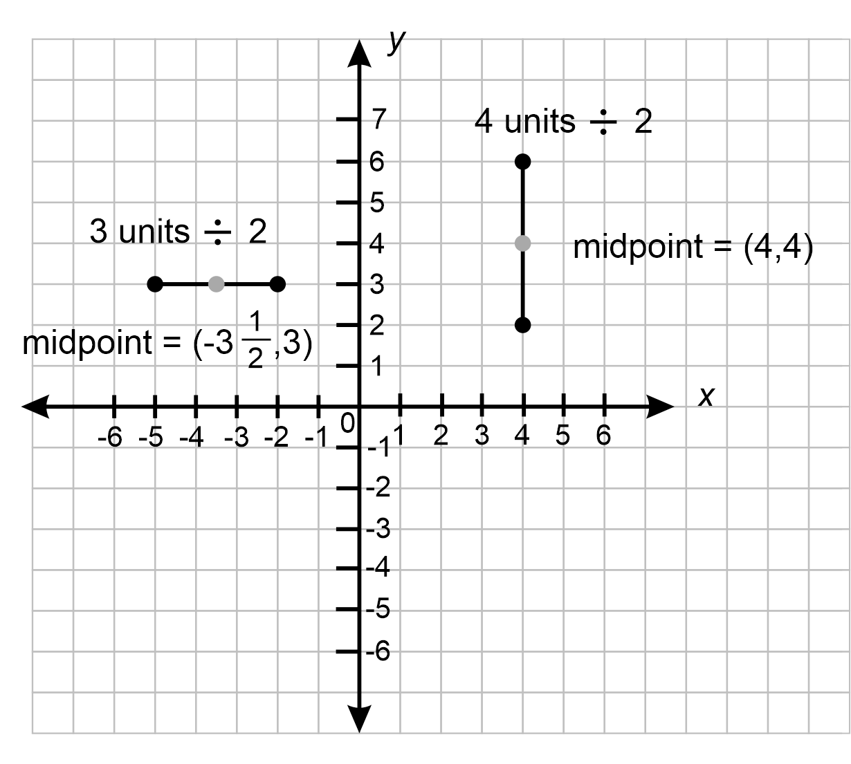
Image long description: Horizontal interval at (minus 2,3) and (minus 5,3) has a midpoint at (minus 3.5,3). Vertical interval from (4,2) to (4,6) has a midpoint of (4,4).

- Apply the process for calculating the mean to find the midpoint, $$M$$ of the interval joining 2 points on the Cartesian plane
Example(s):
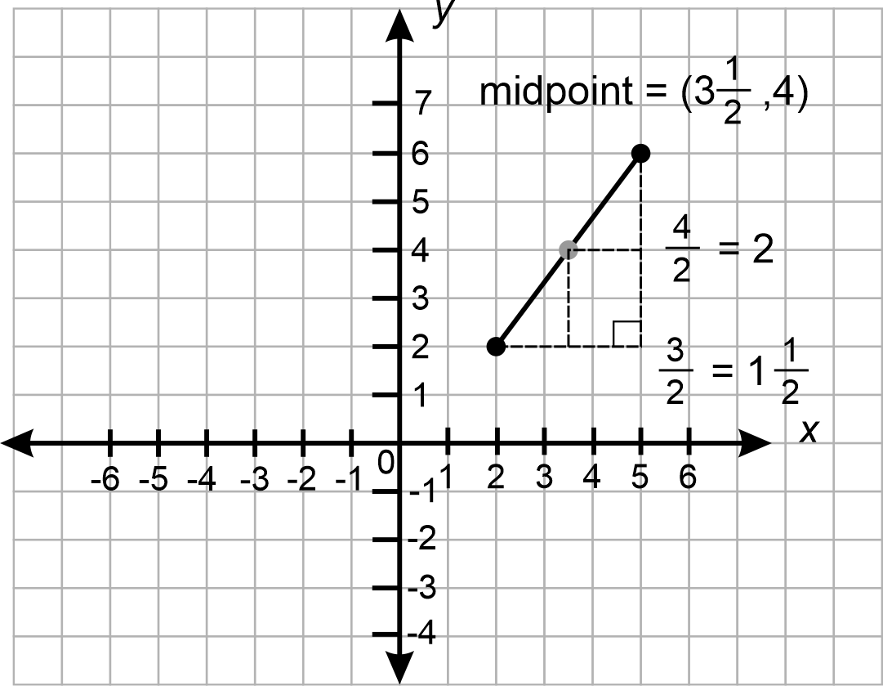
Image long description: Intervals on a Cartesian plane from (2,2) to (5,6) has a midpoint at (3.5,4). The average of the rise is 4 over 2 and the average of the run is 3 over 2.
IRD5
- Use graphing applications to find the midpoint and gradient/slope of an interval

Find the distance between 2 points located on the Cartesian plane
- Use the interval between 2 points as the hypotenuse of a right-angled triangle on the Cartesian plane and apply Pythagoras’ theorem to determine the length of the interval joining the 2 points
Example(s):
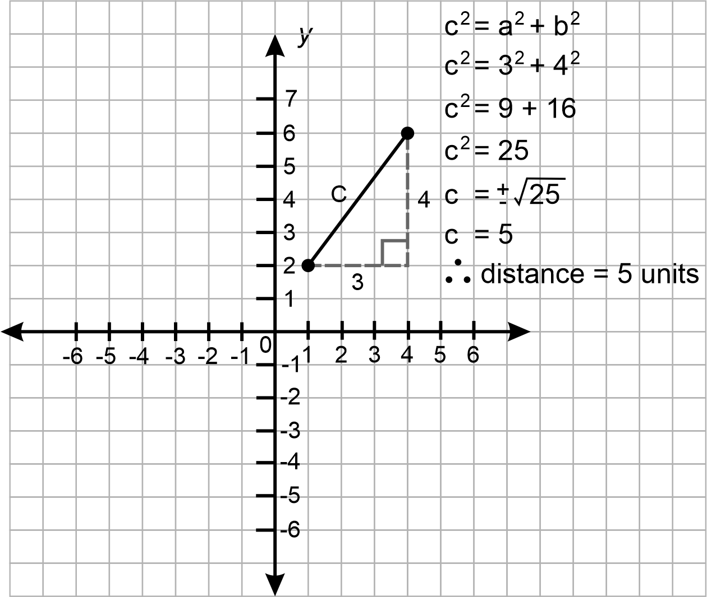
Image long description: Intervals on a Cartesian plane from (1,2) to (4,6). A right-angled triangle is formed with shorter sides 4 and 3. Pythagoras’ theorem is used to calculate the longest side as 5 units in length.
UGP7, UuM10
- Use graphing applications to find the distance between 2 points on the Cartesian plane

Recognise and graph equations
- Recognise that equations of the form $$y=mx+c$$ represent linear relationships or straight lines
NPA8
- Construct tables of values and use coordinates to graph a variety of linear relationships on the Cartesian plane, with and without digital tools
NPA7, NPA8
- Identify the $$x$$- and $$y$$- intercepts of lines
- Determine whether a point lies on a line using substitution
NPA6

Examine parallel, horizontal and vertical lines
- Explain that parallel lines have equal gradients/slopes
Example(s):
Using graphing applications, graph the following equations and compare them to identify similarities and differences between the graphs:
$$y=3x+1$$, $$y=3x-1$$, $$y=2x$$, $$y=2x-2$$, $$y=3x+4$$, $$y=2x-5$$,
$$y=-2x+3$$, $$y=-2x+5$$, $$y=4-2x$$, $$y=-2x$$, $$y=1-x$$, $$y=2-3x$$.
UGP6
- Explain why the $$x$$-axis has the equation $$y=0$$ and the $$y$$-axis has the equation $$x=0$$
- Recognise $$y=c$$ as a line parallel to the $$x$$-axis and $$x=k$$ as a line parallel to the $$y$$-axis
- Graph vertical and horizontal lines

Linear relationships B

Outcomes
A student:
- develops understanding and fluency in mathematics through exploring and connecting mathematical concepts, choosing and applying mathematical techniques to solve problems, and communicating their thinking and reasoning coherently and clearly MAO-WM-01
- graphs and interprets linear relationships using the gradient/slope-intercept form MA5-LIN-C-02
Related Life Skills outcomes: MALS-POS-01

Content

Examine the gradient/slope-intercept form
- Interpret the coefficient of $$x$$($$m$$) as the gradient/slope, and the constant ($$c$$) as the $$y$$-intercept for equations of the form $$y=mx+c$$
- Find the equation of a straight line in the form $$y=mx+c$$, given the gradient/slope and the $$y$$-intercept of the line
Example(s):
Finding the equation of a straight line that has a gradient of −3 and a $$y$$-intercept of −8.

- Graph equations of the form $$y=mx+c$$ by using the gradient and the $$y$$-intercept
Example(s):
Graphing the line $$y=3x-1$$ using the gradient and $$y$$-intercept.
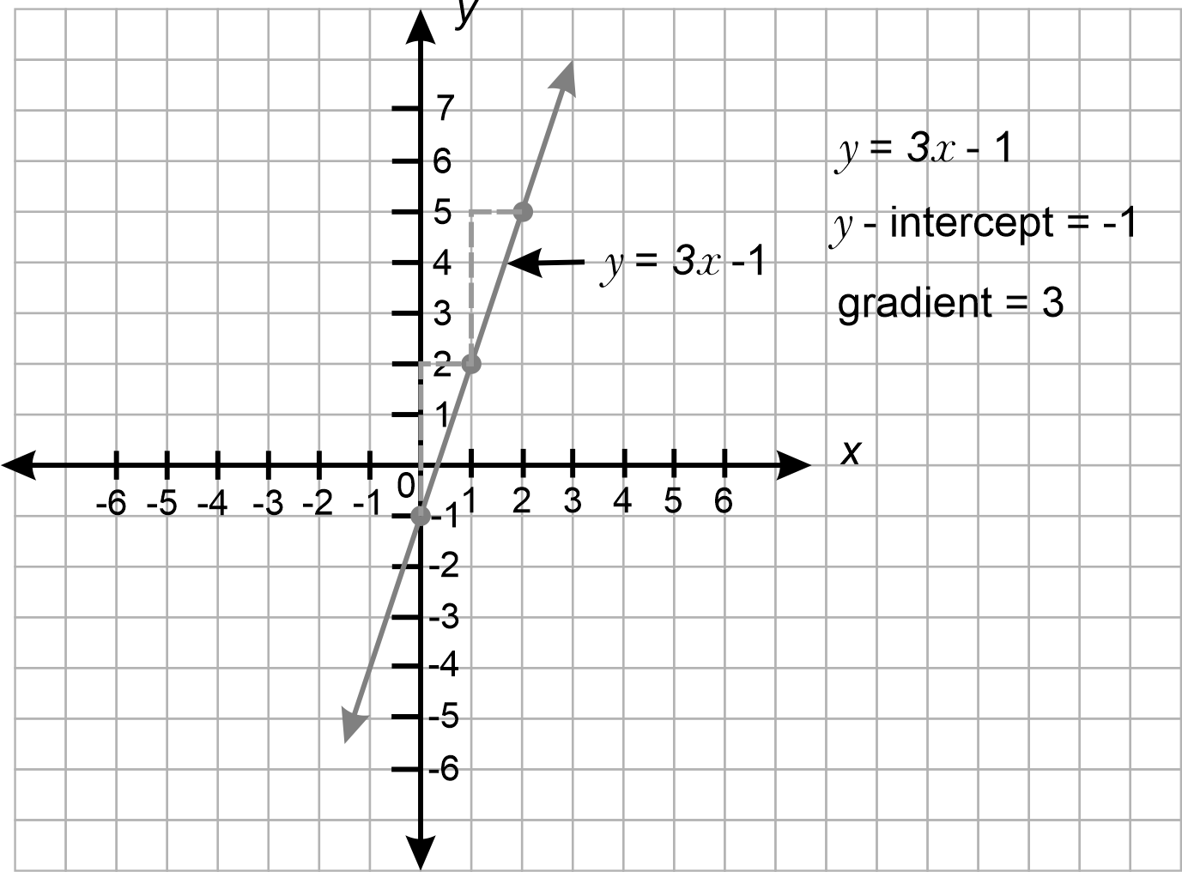
Image long description: Equation graphed on the Cartesian plane. The line slopes upwards, passes through (0, minus 1) and has a gradient of 3 and a y-intercept of minus 1.

- Determine the gradient and $$y$$-intercept of a straight line from its graph and apply these values to determine the equation of the line
Example(s):
Finding the gradient and $$y$$-intercept of the line below and then its equation.
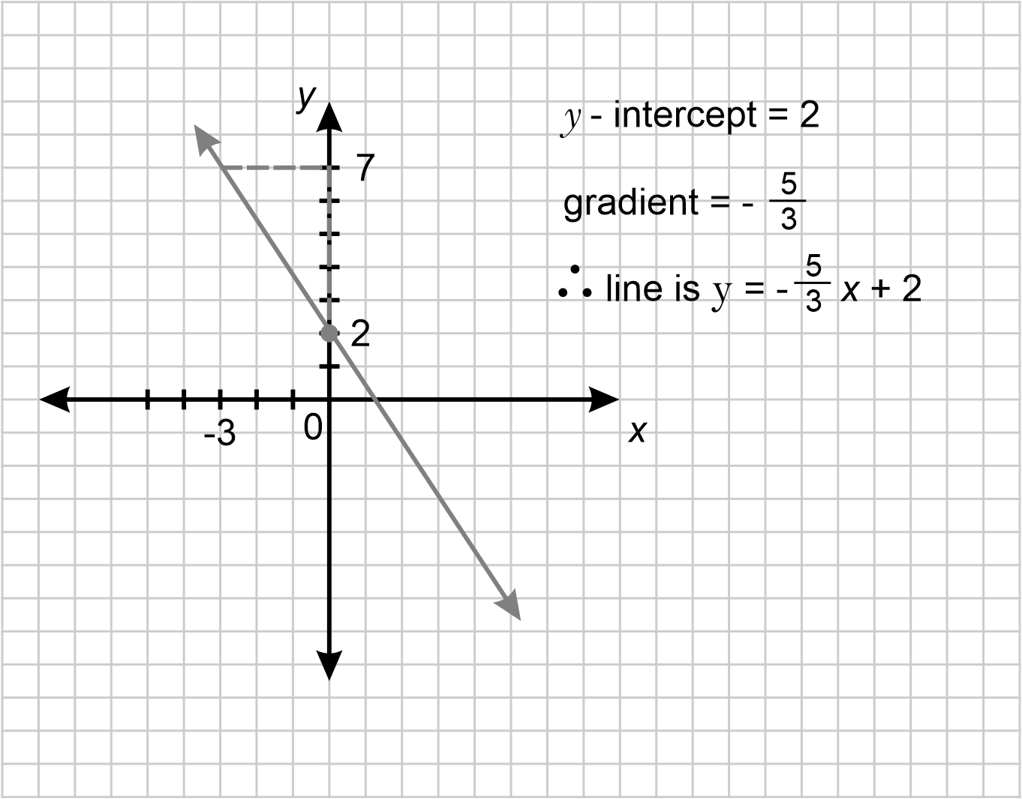
Image long description: Line slopes downwards, passes through (0,2) and has a gradient of minus 5 over 8.

- Explain the effect of increasing or decreasing the gradient with or without digital tools
Example(s):
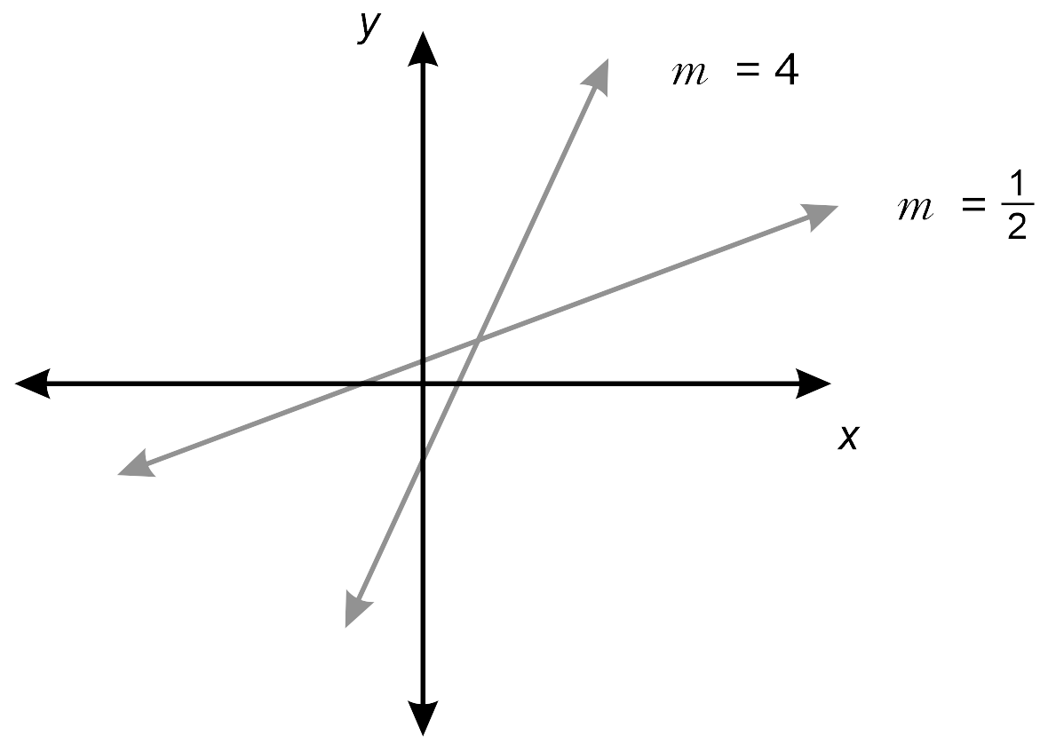
Image long description: The steeper line has a gradient of 4 and the flatter line has a gradient of a half.

- Recognise and describe linear relationships in real-life contexts
Example(s):
Determining what the gradient of the line represents in the context of the graph below and describing what a steeper or flatter line would represent.
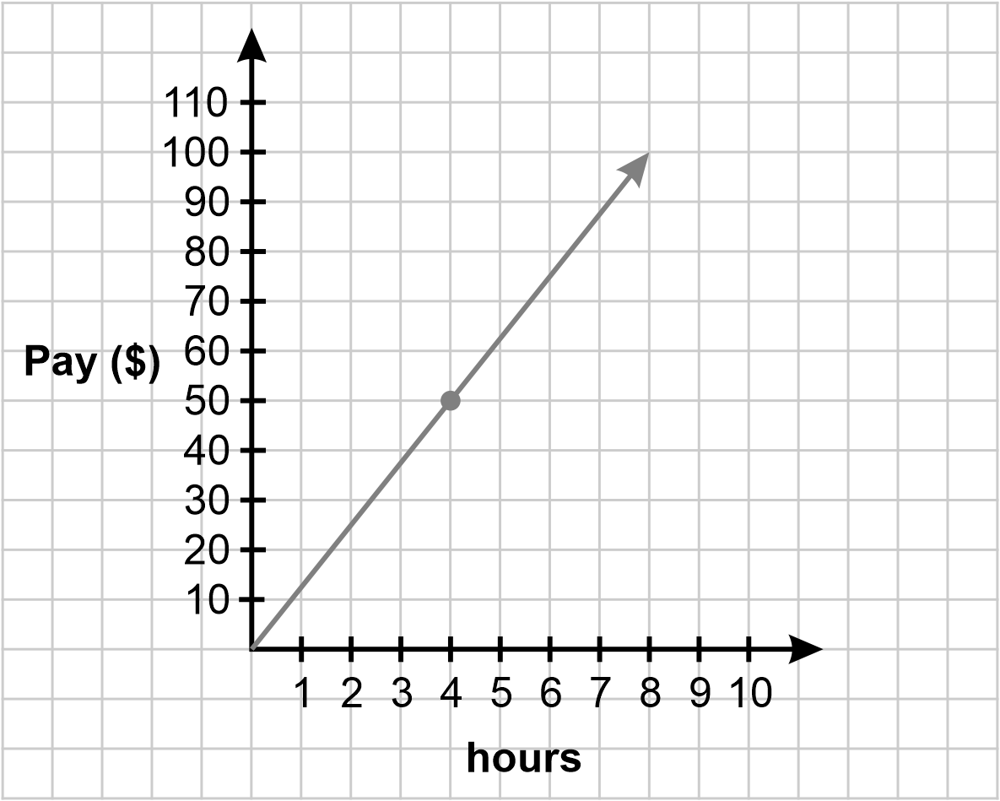

Find the equations of parallel and perpendicular lines
- Explain that 2 straight lines are perpendicular if the product of their gradients is −1
Example(s):
Using digital tools to verify that the angle between 2 lines with gradients of −3 and $$\frac{1}{3}$$ is 90°.

- Find the equation of a straight line that is parallel or perpendicular to another given line by applying $$y=mx+c$$

Non-linear relationships A

Outcomes
A student:
- develops understanding and fluency in mathematics through exploring and connecting mathematical concepts, choosing and applying mathematical techniques to solve problems, and communicating their thinking and reasoning coherently and clearly MAO-WM-01
- identifies connections between algebraic and graphical representations of quadratic and exponential relationships in various contexts MA5-NLI-C-01

Content

Examine the connection between algebraic and graphical representations of quadratics and exponentials
- Represent quadratic and exponential relationships using graphing applications
Example(s):
Using graphing applications to graph the equations below, and then describing and comparing their shapes and features:
$$y=x^{2}$$, $$y=-x^{2}$$, $$y=x^{2}+1$$and $$y=x^{2}-1$$.
$$y=2^{x}$$, $$y=3^{x}$$and $$y=4^{x}$$.

- Construct a table of values to graph non-linear relationships involving quadratics and exponentials
Example(s):
Graphing $$y=2^{x}$$ using a table of values.
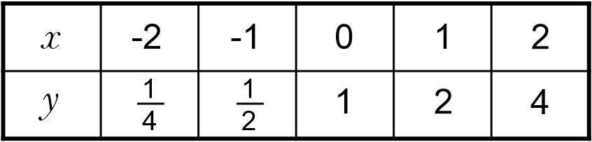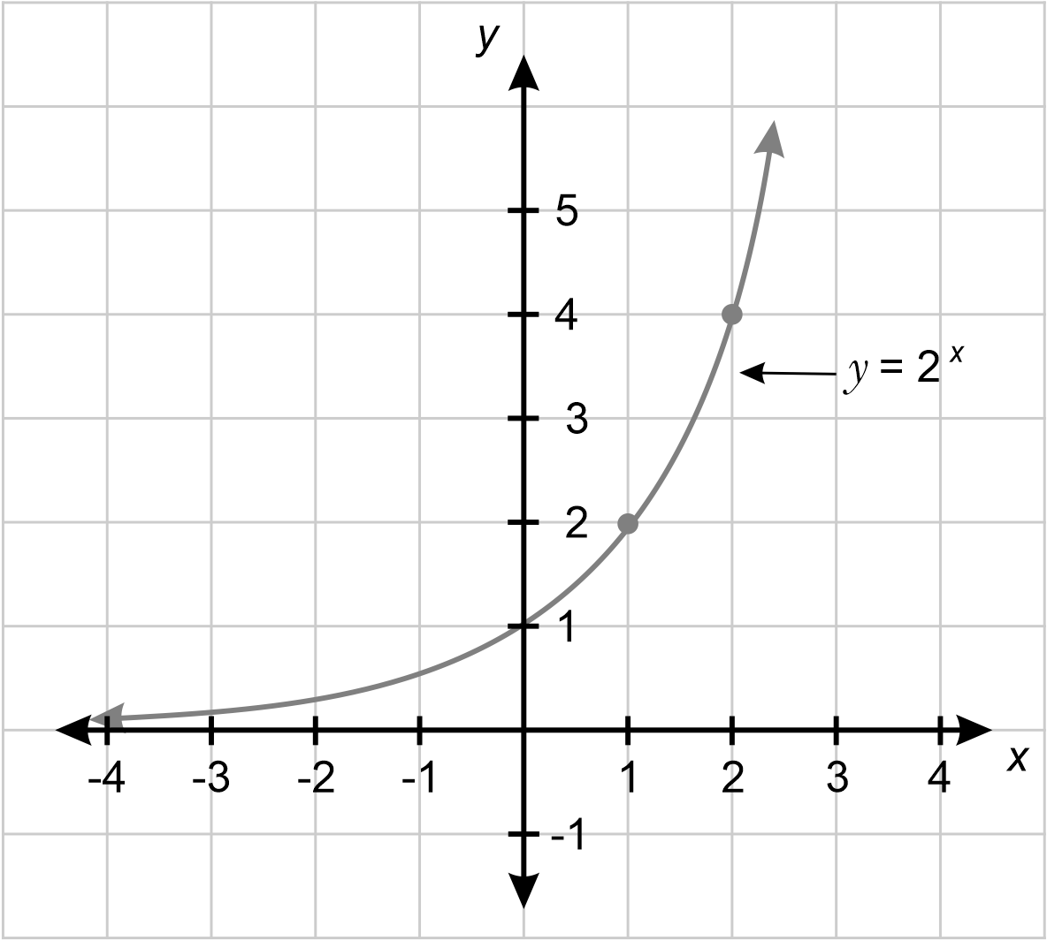
NPA8, NPA9
- Explain that quadratic relationships are represented by parabolas
- Identify graphs and equations of parabolas and exponential curves
NPA8
- Recognise quadratics and exponentials in real-life contexts
NPA8

Non-linear relationships B

Outcomes
A student:
- develops understanding and fluency in mathematics through exploring and connecting mathematical concepts, choosing and applying mathematical techniques to solve problems, and communicating their thinking and reasoning coherently and clearly MAO-WM-01
- identifies and compares features of parabolas and exponential curves in various contexts MA5-NLI-C-02

Content

Graph and examine quadratic relationships
- Graph and compare parabolas of the form $$y={kx}^{2}$$ and $$y={kx}^{2}+c$$ using graphing applications
Example(s):
Describing the effect of $$k$$ on the graph of $$y={kx}^{2}$$ for different values of $$k$$ (including $$k<0$$ and $$-1<k<1$$) or the effect of $$c$$ on the graph $${y=x}^{2}+c$$ (including $$c<0$$) using graphing applications.

- Identify and describe the key features of parabolas of the form $$y={kx}^{2}$$ and $$y={kx}^{2}+c$$ including the vertex, $$x$$- and $$y$$-intercepts, axis of symmetry and concavity
Example(s):
Using graphing applications, graph $$y=2x^{2}$$, $$y=x^{2}-1$$, $$y=-x^{2}$$, $$y=4-x^{2}$$, finding the axis of symmetry, $$x$$- and $$y$$-intercepts and stating the coordinates of the vertex of each graph.
Identifying which of the curves $$y=2x^{2}$$, $$y=x^{2}-1$$, $$y=-x^{2}$$, $$y=4-x^{2}$$ are concave up or concave down and explaining which feature of the equation determines the concavity of the parabola.

Graph and examine exponential relationships
- Graph and compare exponential curves of the form $$y=a^{x}$$ using graphing applications
- Describe features of exponential curves including the $$y$$-intercept, asymptote and the nature of the curve for very large and very small values of $$x$$
Example(s):
Using the equation $$y=2^{x}$$, find the $$y$$-value when $$x=0^{}$$ and explain that this is the $$y$$-intercept of an equation of the form $$y=a^{x}$$.
Explaining why the curve $$y=3^{x}$$ has no $$x$$-intercepts and the line $$y=0$$ is an asymptote to the curve $$y=3^{x}$$.

Distinguish between linear, quadratic and exponential relationships by examining their graphical representations
- Associate graphs of straight lines, parabolas and exponential curves with the appropriate equations
Example(s):
Identifying $$y=2x+3$$ as a straight line, $$y=x^{2}-1$$ as a parabola, and $$y=2^{x}$$ as an exponential curve.

- Recognise non-linear relationships in real-life contexts and solve related problems
Example(s):
Using a table of values to examine and graph the growth of a population according to the equation $$P=100×2^{t}$$, where $$t$$ is the time in hours and determine the initial population and the average growth rate per hour.

- Use graphing applications to solve a pair of simultaneous equations where one equation is non-linear and interpret the solution

Numbers of any magnitude

Outcomes
A student:
- develops understanding and fluency in mathematics through exploring and connecting mathematical concepts, choosing and applying mathematical techniques to solve problems, and communicating their thinking and reasoning coherently and clearly MAO-WM-01
- solves measurement problems by using scientific notation to represent numbers and rounding to a given number of significant figures MA5-MAG-C-01

Content

Identify and describe very small and very large measurements
- Identify and describe the meaning of common prefixes, such as milli, centi and kilo
UuM8, NPV9
- Establish the meaning of prefixes for very small or very large measurement units
Example(s):
Using light years to measure distances in space, finding the diameter of a red blood cell, or using milliseconds, microseconds and nanoseconds as examples of very small units of time.

Find absolute and percentage error
- Determine the precision of a measuring instrument by finding the smallest division on the instrument
- Find the absolute error of measuring instruments ($$absolute error=\frac{1}{2}×precision$$)
Example(s):
Explaining that a length recorded as 10.2 cm would have an absolute error of 0.05 cm and the true length could lie between 10.15 cm and 10.25 cm.

- Calculate the percentage error of a given measurement by applying the formula: $$percentage error=\frac{absolute error}{measurement}×100\%$$
PrT2

Estimate and round numbers to a specified degree of accuracy
- Apply the language of estimation appropriately, including the terms rounding, approximate and level of accuracy
NPV7, NPV8
- Round numbers to a specified number of significant figures
NPV8
- Examine the effect that truncating or rounding during calculations has on the accuracy of the results

Express numbers in scientific notation
- Recognise the need for notation to express very large or very small numbers
Example(s):
Reasoning that the mass of the sun in kilograms as a decimal would require following the 2 with 30 zeroes and explaining that this (approximate) measurement can be written simply as 2 × 10³⁰ kg using scientific notation.
Investigating counting systems and ways of expressing very large or very small numbers from other cultures.
NPV10, MuS10
- Represent numbers using scientific notation in practical contexts
NPV10, MuS10
- Order numbers expressed in scientific notation
Example(s):
Arranging, in ascending order, the masses of the planets in the solar system, expressed in scientific notation.
NPV10
- Represent numbers expressed in scientific notation as a decimal
NPV9, NPV10
- Estimate the value of calculations involving scientific notation by applying knowledge of index laws
Example(s):
Considering estimates like$$\left(3.12×{10}^{4}\right)×\left(4.2×{10}^{6}\right)≈12×{10}^{10}=1.2×{10}^{11}$$.
NPV10
- Solve problems with calculations involving scientific notation using digital tools
Example(s):
Determining how many iron atoms would fit on the top of a pinhead given the estimation for the diameter of an iron atom.
NPV10

Trigonometry A

Outcomes
A student:
- develops understanding and fluency in mathematics through exploring and connecting mathematical concepts, choosing and applying mathematical techniques to solve problems, and communicating their thinking and reasoning coherently and clearly MAO-WM-01
- applies trigonometric ratios to solve right-angled triangle problems MA5-TRG-C-01

Content

Demonstrate and explain the constancy of trigonometric ratios for a given angle in right-angled triangles
- Identify and label the hypotenuse, adjacent and opposite sides with respect to a given angle in a right-angled triangle in any orientation
- Define the sine, cosine and tangent ratios for angles in right-angled triangles and use trigonometric notation$$\sin{θ},\cos{θ},\tan{θ}$$
- Identify the sine, cosine and tangent ratios in a right-angled triangle
- Verify the constancy of the sine, cosine and tangent ratios for a given angle by applying knowledge of similar right-angled triangles
Example(s):
Creating a triangle and enlarging each side length by the same scale factor (eg 2) and verifying that the trigonometric ratios are constant for this enlarged triangle. Repeating with different scale factors of 3, 4 and 1.5 and verifying that the trigonometric ratios remain constant.
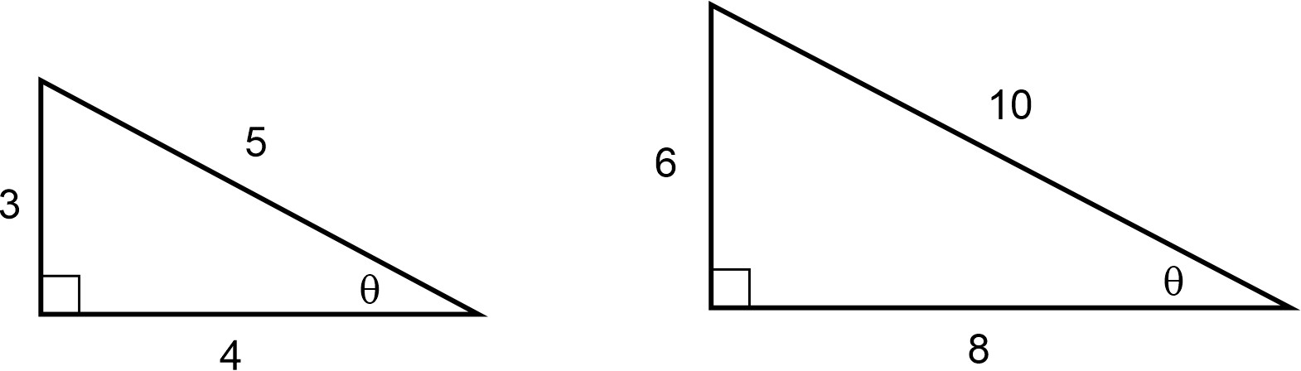

- Find approximations of the trigonometric ratios for a given angle
- Find the size of an angle given one of the trigonometric ratios for the angle using digital tools
Example(s):
Calculating $$θ$$ given $$\sin{θ}=\frac{4}{11}$$.

Apply trigonometry to solve right-angled triangle problems
- Apply trigonometry to find the lengths of unknown sides in right-angled triangles with a given angle including angles in degrees and minutes
UuM10, UGP7
- Apply trigonometry to find the size of unknown angles in right-angled triangles including in degrees and minutes
UuM10, UGP7
- Solve a variety of practical problems involving trigonometric ratios in right-angled triangles

Trigonometry B

Outcomes
A student:
- develops understanding and fluency in mathematics through exploring and connecting mathematical concepts, choosing and applying mathematical techniques to solve problems, and communicating their thinking and reasoning coherently and clearly MAO-WM-01
- applies trigonometry to solve problems, including bearings and angles of elevation and depression MA5-TRG-C-02

Content

Solve right-angled triangle problems involving angles of elevation and depression
- Identify and describe angles of elevation and depression
- Solve practical problems involving angles of elevation and depression
Example(s):
Using a clinometer and measuring tape, measure the angle of elevation and the distance from a point to the base of a tree and estimate the height of the tree.
Examining the way Aboriginal and/or Torres Strait Islander Peoples use celestial navigation – the sun, moon, stars and horizon – to navigate and identify location and distance.
UGP7

Solve right-angled triangle problems involving bearings
- Identify and interpret true bearings and compass bearings
- Explain the difference between true bearings and compass bearings and convert between them
Example(s):
Demonstrating that the compass bearing N$$30°$$W is the same as the true bearing $$330°$$T, discussing the advantages of each type of bearing.

- Solve practical problems involving bearings
Example(s):
Finding the distance between the port and Boat B if Boat A leaves a port on a bearing of $$030°$$T and sails 15 km until it is due east of Boat B and Boat B is due north of the port.
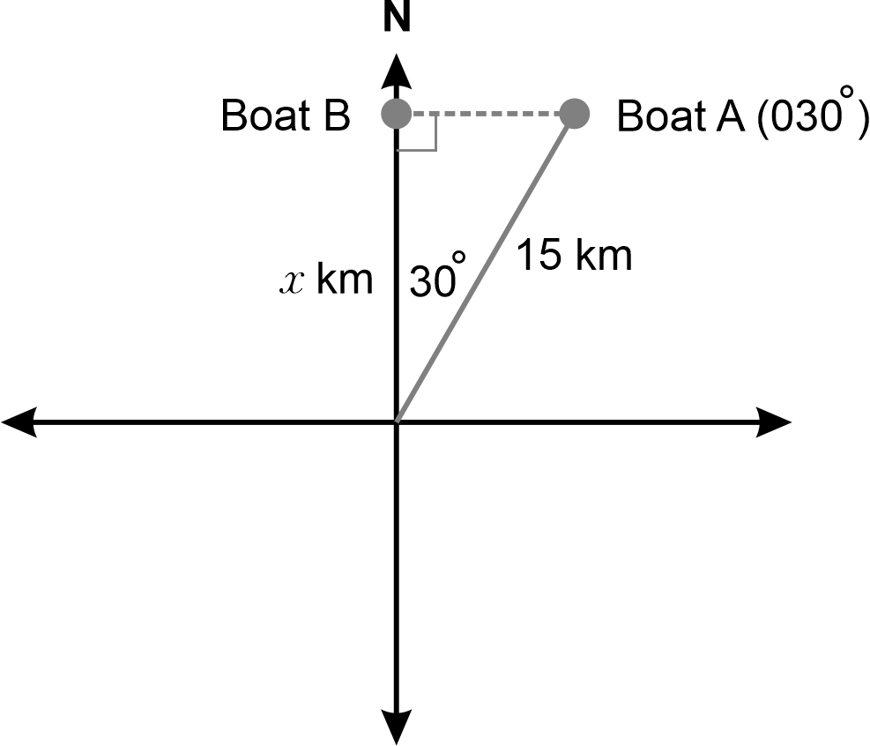
Image long description: A compass showing Boat A on a bearing of 030 degrees and due east of Boat B. Boat A is 15 km from the centre of the compass and Boat B is x km from the centre of the compass.

Area and surface area A

Outcomes
A student:
- develops understanding and fluency in mathematics through exploring and connecting mathematical concepts, choosing and applying mathematical techniques to solve problems, and communicating their thinking and reasoning coherently and clearly MAO-WM-01
- solves problems involving the surface area of right prisms and practical problems involving the area of composite shapes and solids MA5-ARE-C-01
Related Life Skills outcomes: MALS-ARE-01

Content

Solve problems involving areas and surface areas
- Solve practical problems involving the areas of composite shapes
Example(s):
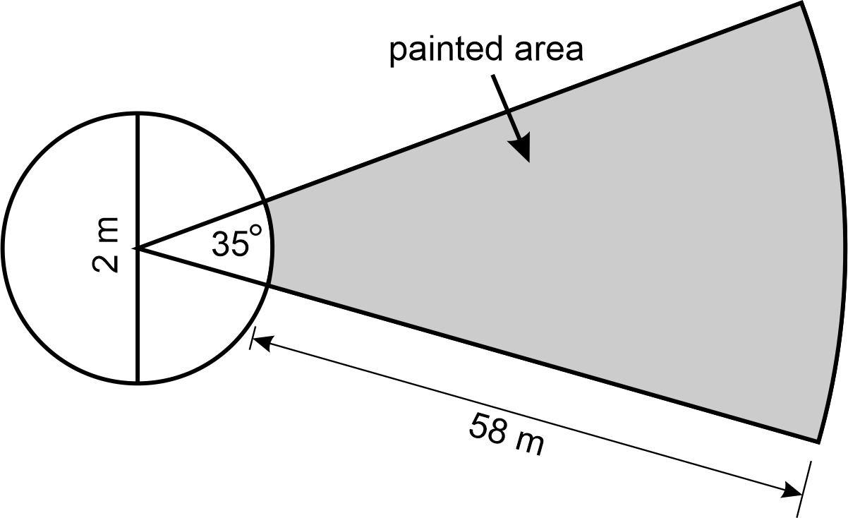
Image long description: A circle with a diameter of 2 metres. The vertex of a sector with an internal angle of 35 degrees and has a radius of 58 metres is attached to the centre of the circle. The part of the sector that is outside the circle is shaded.
Creating your name using composite shapes to a maximum of 50 cm².
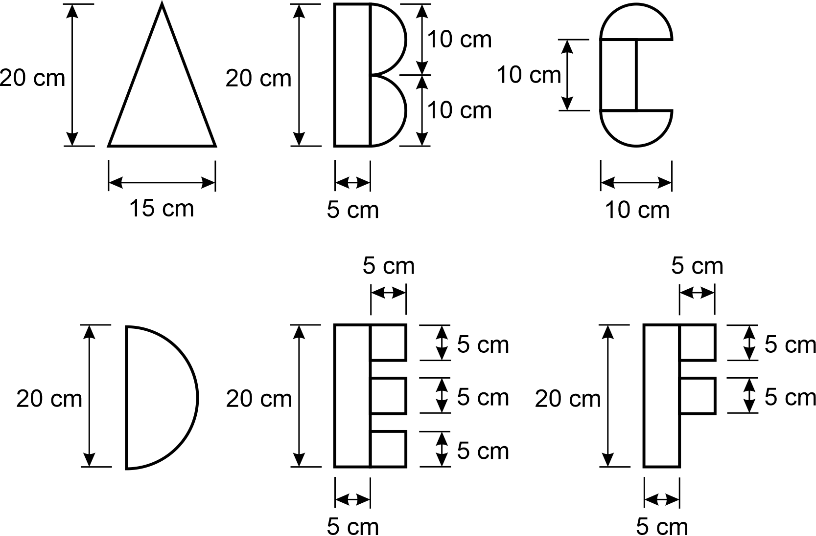
Image long description: The letters A to F made up of simple rectangles and semicircles. Each shape has dimensions varying between 5 cm and 20 cm. For example, the letter C is composed of a rectangle 10 cm long and 2 semicircles with a diameter of 10 cm.
UuM10, NPA8, UGP6
- Identify the edge lengths and the faces making up the surface area of prisms
Example(s):
Using digital tools to examine and construct various right prisms and their corresponding nets, and identifying the edge lengths and faces making up the surface area of the relevant prism.
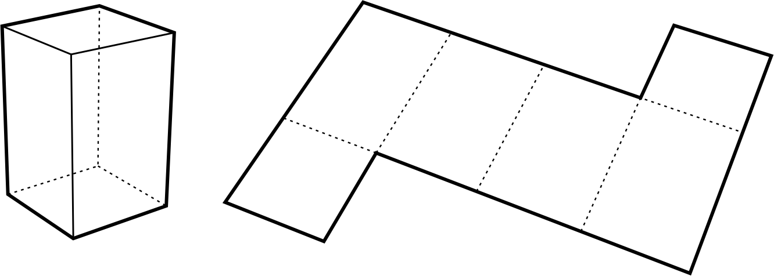

- Recognise and justify whether a diagram represents a net of a right prism
- Create and rearrange nets of right prisms
- Find the surface areas of prisms, given their nets, excluding curved surfaces
Example(s):
Finding the surface area of a triangular prism.
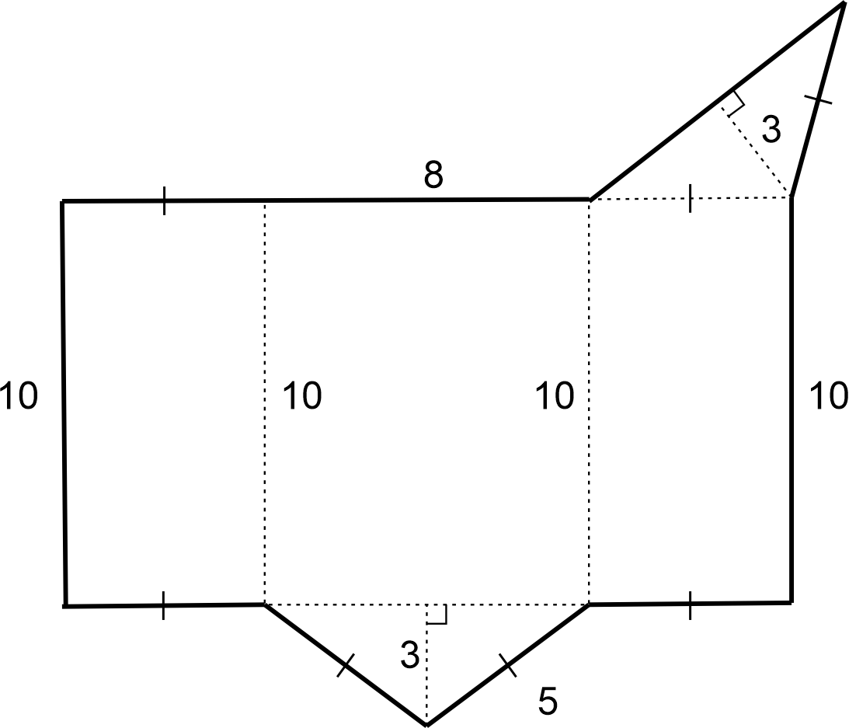

- Solve problems involving surface areas of prisms, excluding curved surfaces
Example(s):
Finding the amount of paint needed to paint the walls and ceiling of this room if 1 litre covers 10 square metres.
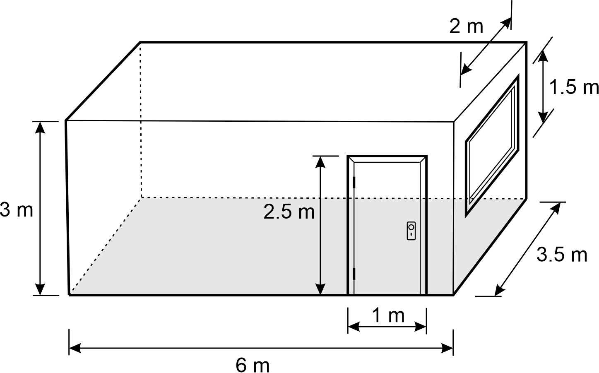
Image long description: A rectangular room that is 6 metres long, 3.5 metres wide and 3 metres high. A rectangular door that is 2.5 metres high and 1 metre wide and rectangular window that is 2 metres long and 1.5 metres high.

Develop and apply the formula for surface areas of cylinders
- Recognise the curved surface of a cylinder as a rectangle and apply this knowledge to calculate the area of the curved surface
- Develop and apply the formula to find the surface area of a closed cylinder: $$A=2{πr}^{2}+2πrh,$$ where $$r$$ is the length of the radius and $$h$$ is the perpendicular height
Example(s):
Applying the surface area formula for a variety of yidaki (didgeridoo), identifying different tones the instrument makes based on the surface area of the yidaki.
Examining the effects on the surface area of cylinders of equal height when the radius is changed.

Solve problems involving surface areas of cylinders and related composite solids
- Solve problems involving surface areas of cylinders and related composite solids
Example(s):
Calculating the surface area in square metres of the outside of a large mailbox that requires painting.
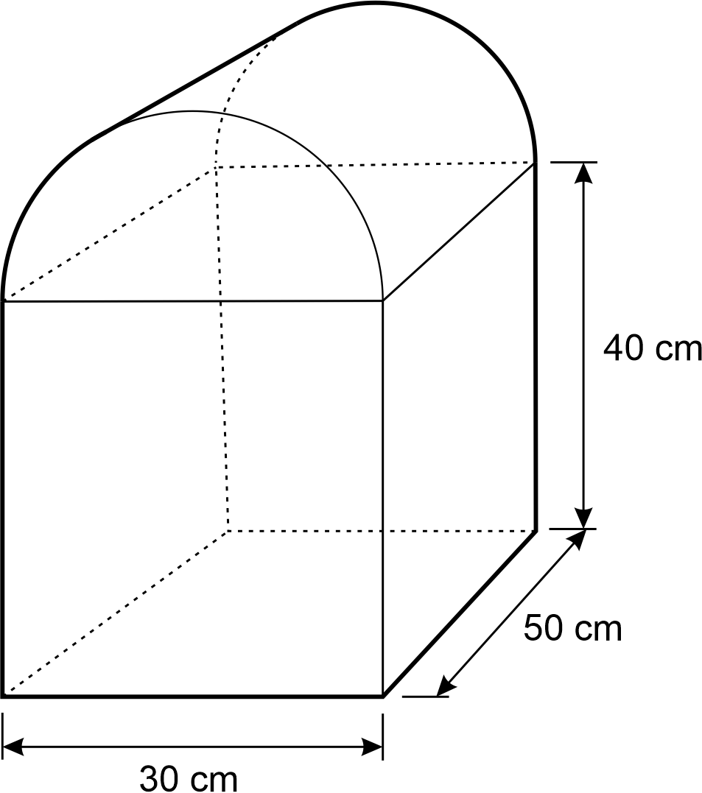
Image long description: A composite prism with a front face of half a cylinder on top of a rectangle. The rectangular prism is 30 cm wide, 50 cm long and 40 cm high.
Calculating the surface area of an emu caller, clapsticks or a warup drum from the Torres Strait Islands.

Volume A

Outcomes
A student:
- develops understanding and fluency in mathematics through exploring and connecting mathematical concepts, choosing and applying mathematical techniques to solve problems, and communicating their thinking and reasoning coherently and clearly MAO-WM-01
- solves problems involving the volume of composite solids consisting of right prisms and cylinders MA5-VOL-C-01
Related Life Skills outcomes: MALS-VOL-01

Content

Solve problems involving composite solids consisting of right prisms and cylinders
- Find the volumes of composite right prisms with uniform cross-sections that may be dissected into triangles and quadrilaterals
Example(s):
Calculating the volume of earth that must be excavated so that the pool shell below fits exactly into the hole.
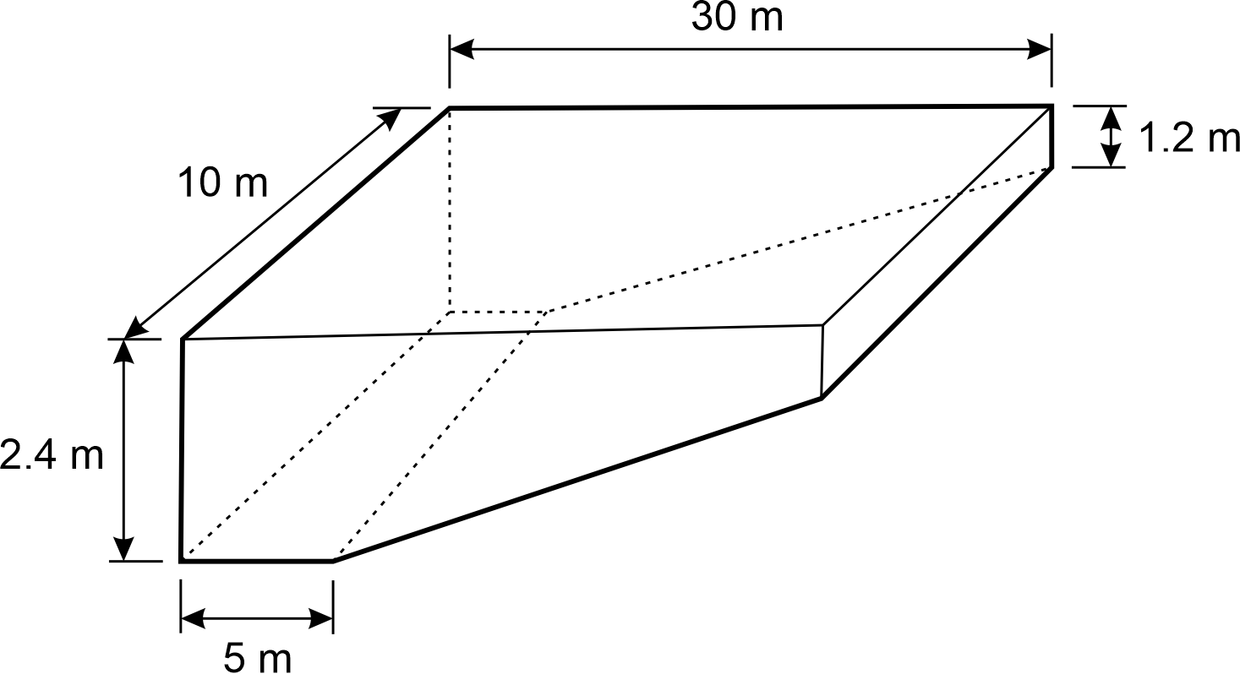
Image long description: A composite prism with a rectangle and trapezium as the face and a depth of 10 m. The rectangle is 2.4 m long and 5 m wide and the trapezium has parallel sides of 1.2 m and 2.4 m and a perpendicular of 25 m.
UuM10, UGP6, NPA8
- Find the volumes of right prisms that have uniform cross-sections in the form of sectors, semicircles and quadrants
UuM9, UGP6, NPA8
- Calculate volumes of composite solids consisting of right prisms and cylinders
UuM10, UGP6, NPA8
- Solve practical problems related to the volumes and capacities of composite solids
UuM10

Properties of geometrical figures A

Outcomes
A student:
- develops understanding and fluency in mathematics through exploring and connecting mathematical concepts, choosing and applying mathematical techniques to solve problems, and communicating their thinking and reasoning coherently and clearly MAO-WM-01
- identifies and applies the properties of similar figures and scale drawings to solve problems MA5-GEO-C-01
Related Life Skills outcomes: MALS-GEO-01

Content

Identify and describe the properties of similar figures
- Describe similar figures as having the same shape but not necessarily the same size
- Verify and explain that in similar polygons, the corresponding angles are equal and the corresponding side lengths are in the same proportion
Example(s):
Using the enlargement transformation and measurement to determine that the size of matching angles and the ratio of matching sides are preserved in similar polygons.

- Name the vertices in matching order when using the similar symbol ($$\sim )$$ in a similarity statement
- Match the corresponding sides and angles of similar polygons

Solve problems using ratio and scale factors in similar figures
- Apply an appropriate scale to enlarge or reduce a diagram
Example(s):
Using a grid to create a rectangle and reduce its dimensions by half.
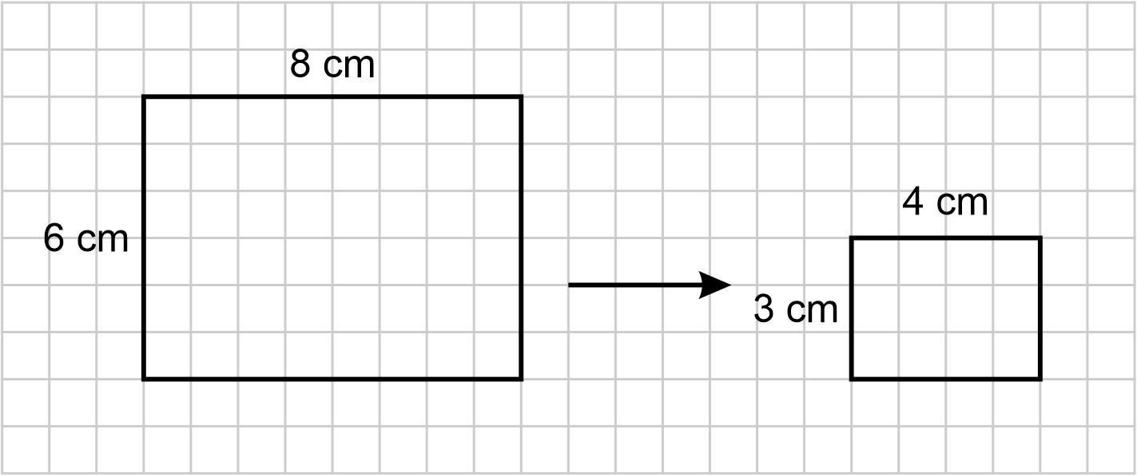
Image long description: 2 rectangles demonstrating reduction. The first rectangle is 8 cm long and 6 cm wide and this leads to a rectangle that is 4 cm long and 3 cm wide.

- Determine the scale factor for pairs of similar polygons and circles
Example(s):
Calculating the scale factor from shape A to shape B for the following pairs of shapes:
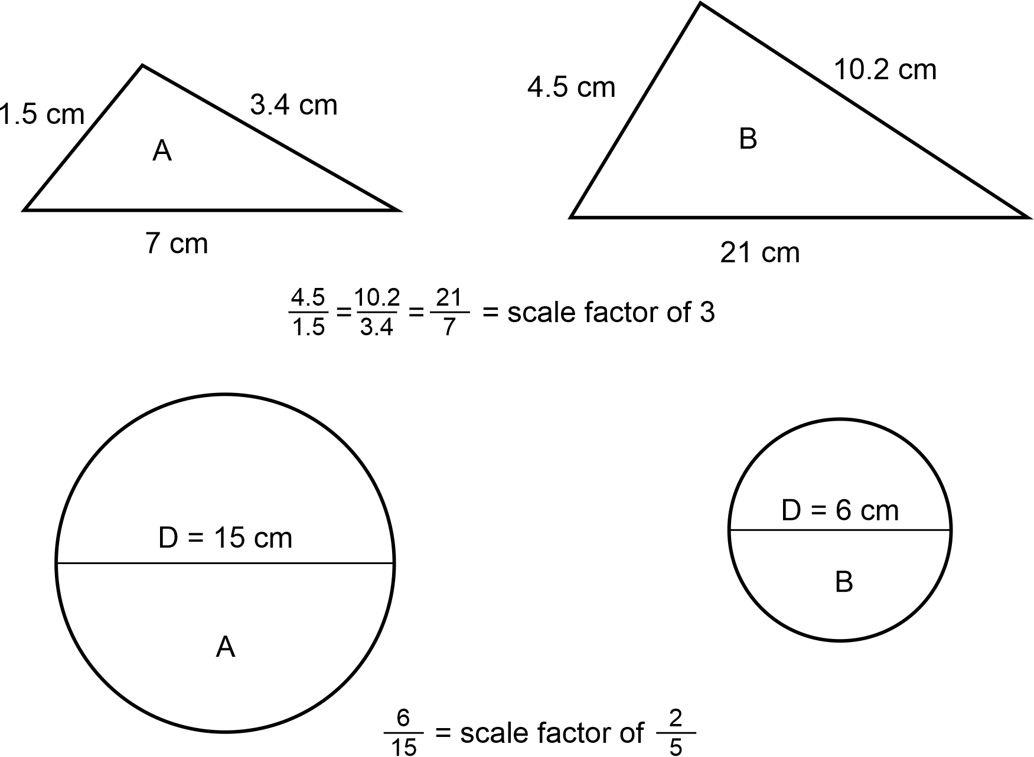
Image long description: 2 triangles show a scale factor of 3. Triangle A has sides 1.5 cm, 3.4 cm and 7 cm. Triangle B has corresponding sides 4.5 cm, 10.2 cm and 21 cm. In a second example, 2 circles demonstrate a scale factor of 2 over 5. Circle A has a diameter of 15 cm whereas Circle B has a diameter of 6 cm.

- Apply knowledge of scale factor to find unknown sides in similar polygons
- Solve problems involving unknown lengths and scale factors of similar figures and related practical problems
Example(s):
Exploring scale in photographs, maps, plans and drawings found in texts and online sources.

- Solve problems involving scale drawings, with or without digital tools
Example(s):
Using digital tools to see an aerial view of a school, identifying the scale (eg 2 cm = 20 m, ∴ the scale is 1:1000) and using it to find out approximately how far it is from the library to a classroom.
Using digital tools to identify Aboriginal and/or Torres Strait Islander Languages maps or topographical artworks, analysing the scale and finding distances between points.

Data analysis A

Outcomes
A student:
- develops understanding and fluency in mathematics through exploring and connecting mathematical concepts, choosing and applying mathematical techniques to solve problems, and communicating their thinking and reasoning coherently and clearly MAO-WM-01
- compares and analyses datasets using summary statistics and graphical representations MA5-DAT-C-01
Related Life Skills outcomes: MALS-DAT-02

Content

Examine standard deviation as a measure of spread
- Identify standard deviation as a measure of spread
IRD5
- Calculate the standard deviation of a small dataset using digital tools
- Compare small datasets using standard deviation

Determine quartiles and interquartile range
- Determine the 5-number summary for sets of numerical data
Example(s):
Determining the 5-number summary (minimum and maximum values, median, and upper and lower quartiles) for the datasets below:
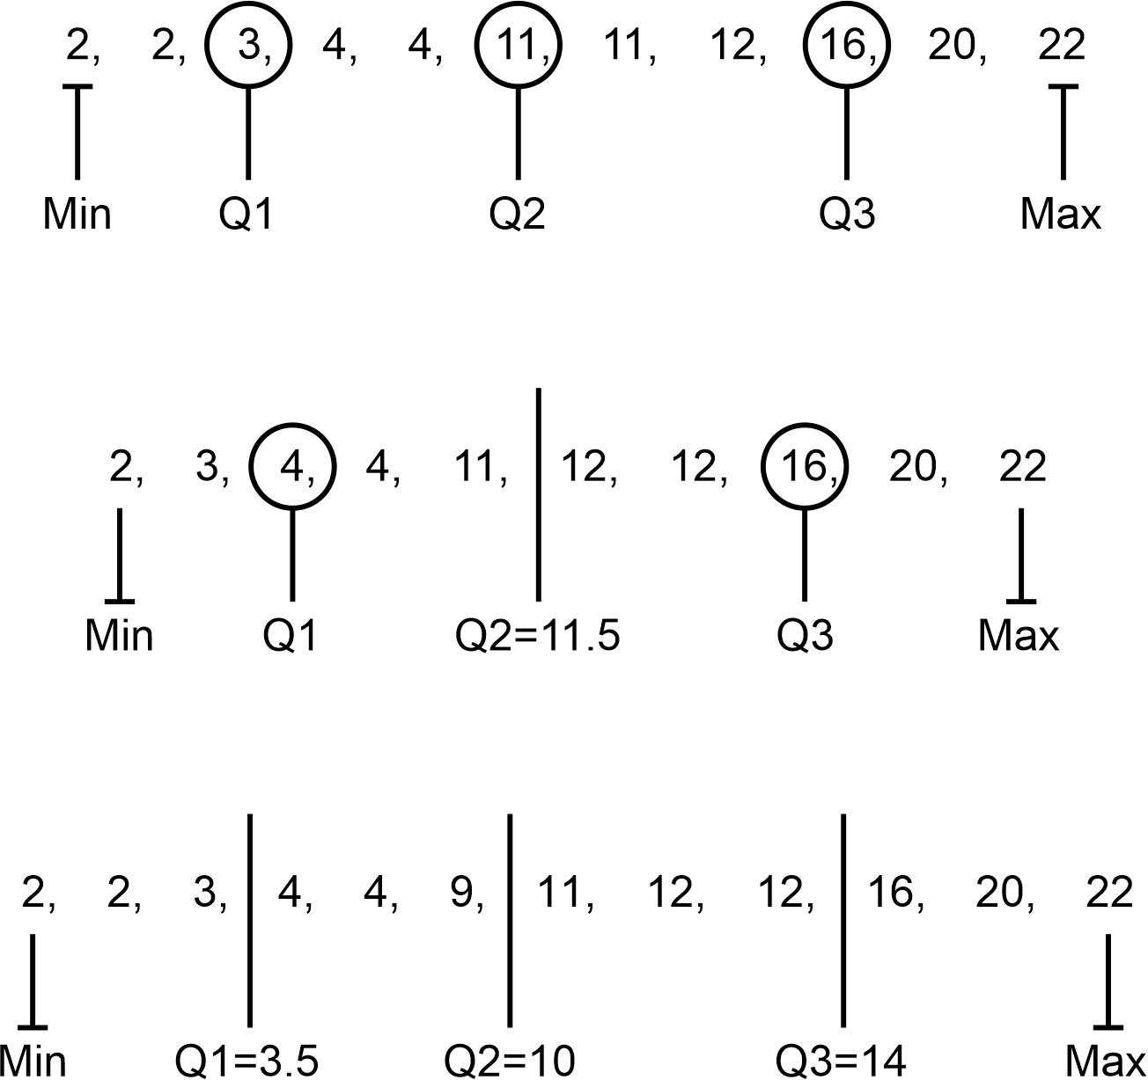
Image long description: The first dataset containing the numbers 2, 2, 3, 4, 4, 11, 11, 12, 16, 20 and 22. The minimum is 2, Q1 is 3, Q2 is 11, Q3 is 16 and the maximum is 22. The second dataset contains the numbers 2, 3, 4, 4, 11, 12, 12, 16 and 20. 22. The minimum is 2, Q1 is 4, Q2 is 11.5, Q3 is 16 and the maximum is 22. The third dataset contains the numbers 2, 2, 3, 4, 4, 9, 11, 12, 12, 16, 20, 22. The minimum is 2, Q1 is 3.5, Q2 is 10, Q3 is 14 and the maximum is 22.
IRD5
- Determine the 5-number summary from graphical representations
Example(s):
Determining the 5-number summary from a dot plot:
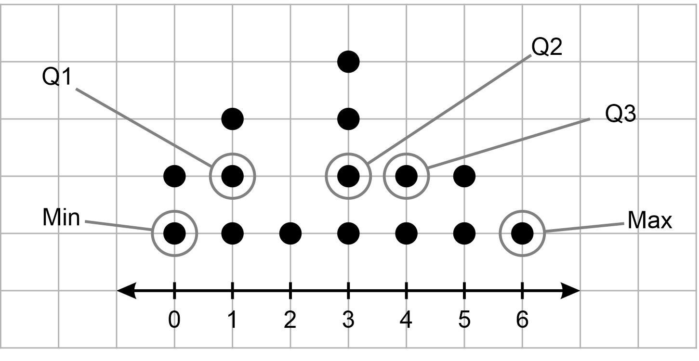
Image long description: A dot plot with 15 scores plotted. Indicated scores include a minimum of 0, Q1 as 1, Q2 as 3, Q3 as 4 and a maximum of 6.
IRD5
- Determine the interquartile range (IQR) for datasets
IRD5
- Compare and explain the relative merits of range and IQR as measures of spread
IRD5

Represent datasets using box plots and use them to compare datasets
- Represent numerical datasets using a box plot to display the median, upper and lower quartiles, and maximum and minimum values
IRD5
- Compare 2 or more numerical datasets using parallel box plots drawn on the same scale
Example(s):
Comparing the range, median and IQR for Class A and Class B using the following parallel box plot:
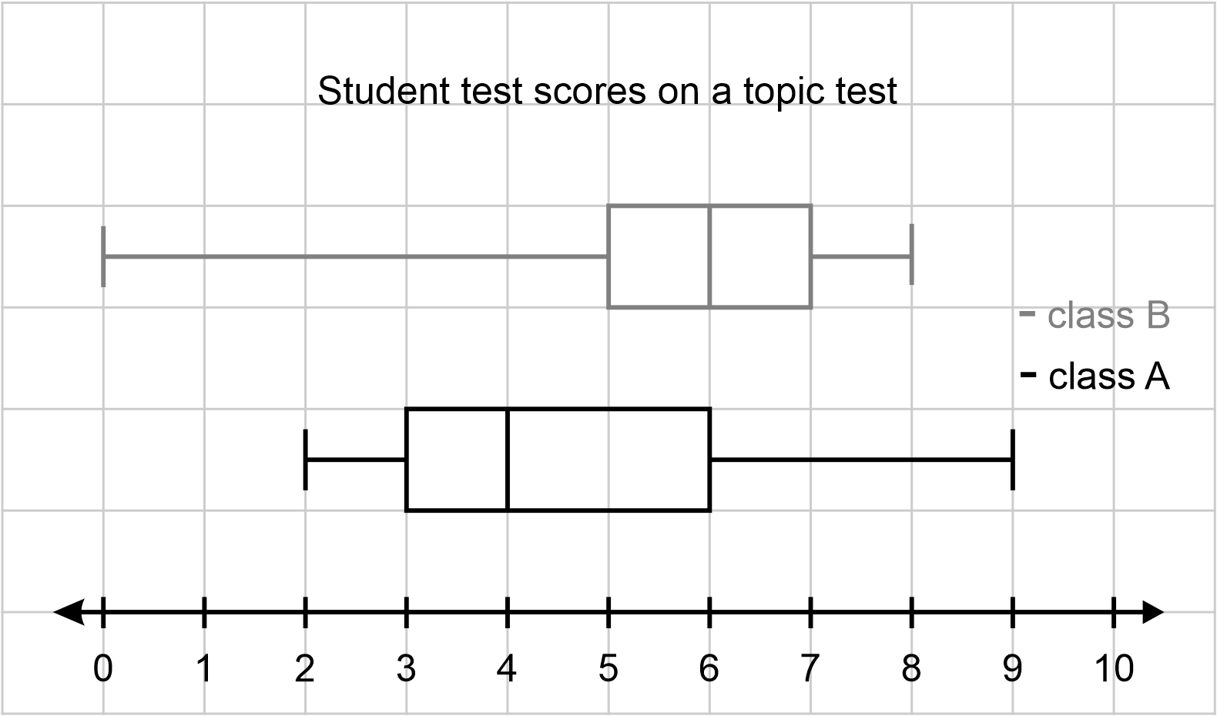
Image long description: Class A has a minimum of 2, Q1 of 3, median of 3, Q3 of 6 and maximum of 9. Class B has a minimum of 0, Q1 of 5, median of 6, Q3 of 7 and maximum of 8.
IRD5
- Compare and contrast the centres, spreads and shapes of 2 or more numerical datasets, using box plots and numerical statistics, including the 5-number summary
- Determine quartiles from datasets displayed in histograms and dot plots, and represent these as a box plot
IRD6
- Identify and describe skewness or symmetry of datasets displayed in histograms, dot plots and box plots
Example(s):
Analysing a negatively skewed distribution where the mean is smaller than the median and comparing it with a positively skewed distribution where the mean is larger than the median.
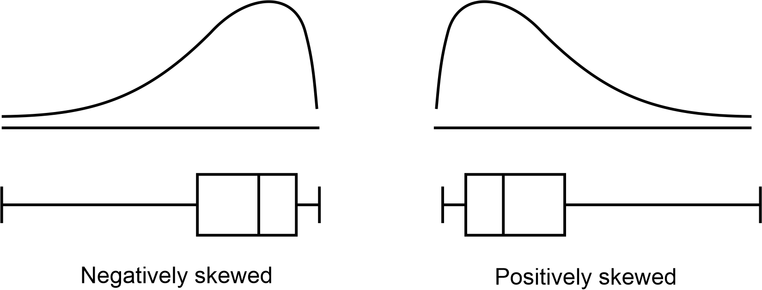
Image long description: Negatively skewed data has the curve highest to the right with the box to the right, and positively skewed data has the curve highest to the left with the box to the left.
IRD6
- Interpret box plots to draw conclusions and make inferences about the dataset
IRD6

Data analysis B

Outcomes
A student:
- develops understanding and fluency in mathematics through exploring and connecting mathematical concepts, choosing and applying mathematical techniques to solve problems, and communicating their thinking and reasoning coherently and clearly MAO-WM-01
- displays and interprets datasets involving bivariate data MA5-DAT-C-02
Related Life Skills outcomes: MALS-DAT-02

Content

Identify and describe numerical datasets involving 2 variables
- Distinguish between situations involving 1-variable and 2-variable (bivariate) data and explain when each is needed
Example(s):
Studying a group of students to find out the amount of time spent studying and their mathematics scores involves 2 variables (time studying and mathematics scores). Studying a group of students to find out their time taken to complete a 100 m race involves only 1 variable.

- Explain the difference between variables that have an association and variables that have a causal relationship
Example(s):
Describing the causal relationship between an increase in temperature during the day and the number of ice creams sold.
Describing the association between a person’s height and their arm span.

- Identify and describe the independent variable and dependent variable in relationships with possible cause and effect
Example(s):
Examining the question ‘How does watching television before bedtime affect your sleep?’, the independent variable would be the amount of time spent watching television before bedtime and the dependent variable would be the number of hours of sleep or the number of hours of quality sleep.

Represent datasets involving 2 numerical variables, using a scatter plot and a line of best fit, by eye
- Gather data on a topic of interest involving 2 numerical variables
- Represent the data using a scatter plot
- Create a line of best fit, by eye, on an existing scatter plot
Example(s):
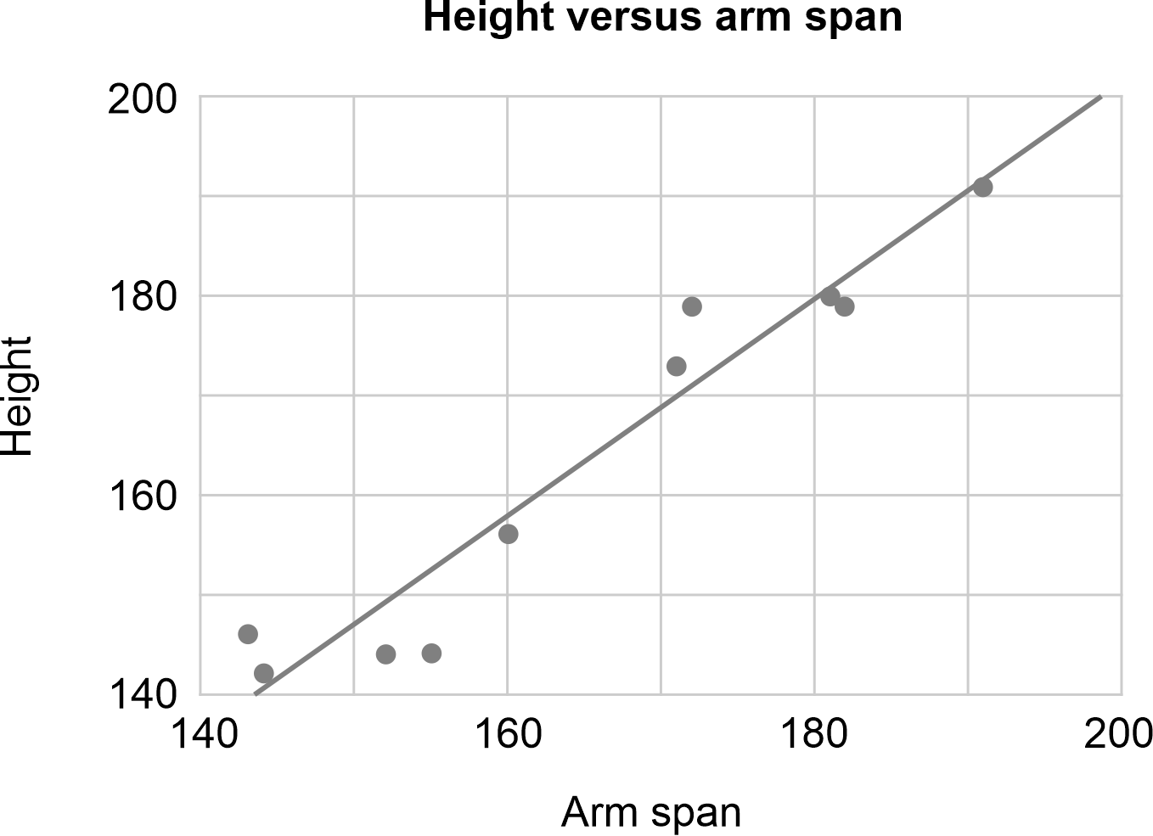

Interpret data involving 2 numerical variables, using graphical representations
- Describe informally the association between 2 numerical variables and apply terminology about form (linear), strength (strong, moderate or weak) and direction (positive or negative)
- Use the line of best fit, by eye, to make predictions between known data values (interpolation) and what might happen beyond known data values (extrapolation)
Example(s):
Using the line of best fit below, how old is a typical male when he reaches a height of 170 cm? Using the line of best fit below and extending the line to the vertical axis, what height would a typical 10-year-old male be?
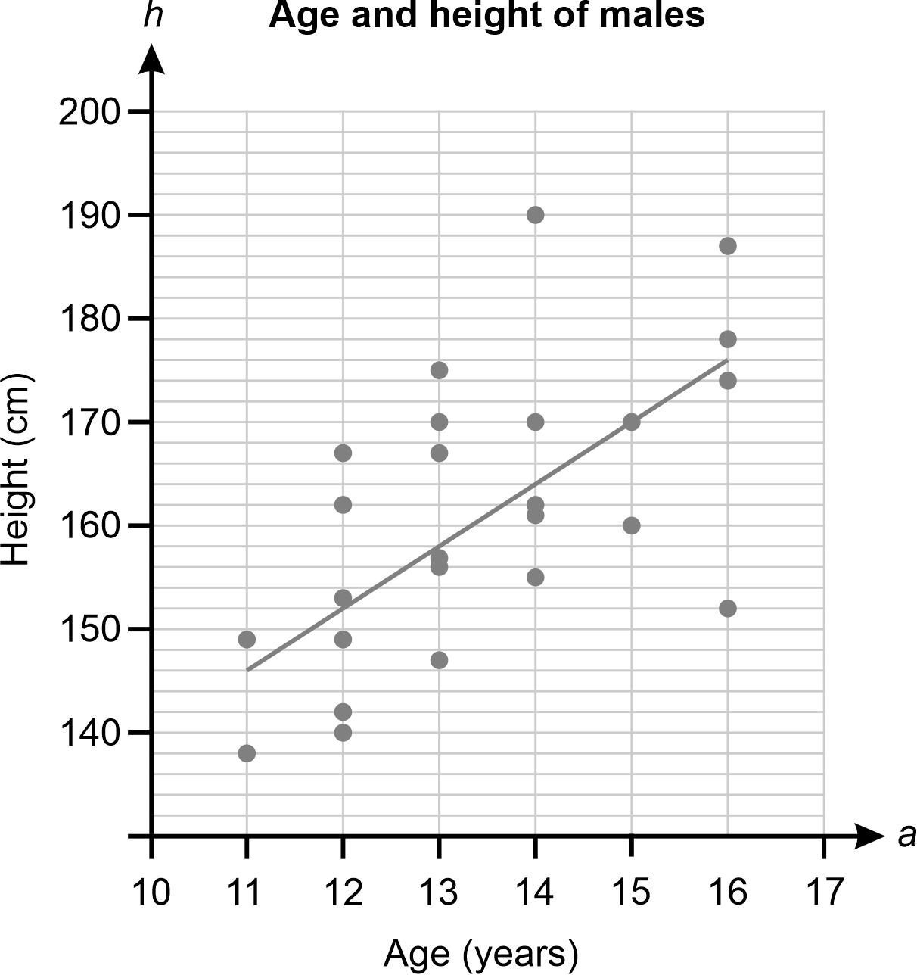

- Explain the limitations of the model when making predictions
Example(s):
Reasoning why a scatter plot may not be useful for predicting the height of a typical 45-year-old male.

Probability A

Outcomes
A student:
- develops understanding and fluency in mathematics through exploring and connecting mathematical concepts, choosing and applying mathematical techniques to solve problems, and communicating their thinking and reasoning coherently and clearly MAO-WM-01
- solves problems involving probabilities in multistage chance experiments and simulations MA5-PRO-C-01
Related Life Skills outcomes: MALS-PRO-01

Content

Describe multistage chance experiments involving independent and dependent events
- Explain the difference between dependent and independent events in experiments involving 2 stages
UnC5
- Explain how the probability of independent and dependent events differs in relation to replacement
Example(s):
Calculating the probability that a green marble is chosen on the second draw if a bag contains 2 red marbles and 5 green marbles and a person draws 1 marble at a time out of the bag without replacing it. Examining the difference when the marble is replaced before drawing the second marble.
UnC5

Solve problems for multistage chance experiments
- Record all possible outcomes for multistage chance experiments
Example(s):
Representing all possible heads (H) and tails (T) outcomes for tossing 2 coins using a tree diagram and an array.
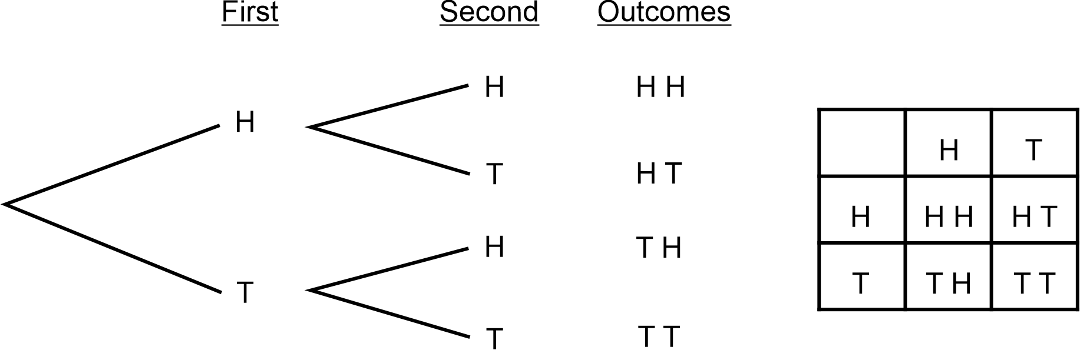
Image long description: The tree diagram originates with H and T as the options for the first coin, and H and T stemming from each of those options for the second coin. The table has H and T on the top row and H and T on the first column. The outcomes are HH, HT, TH and TT.
UnC5
- Determine the probabilities of outcomes for multistage independent events using $$P\left(A and B\right)=P\left(A\right)×P\left(B\right),$$ where necessary
Example(s):
Determining the probability of tossing a head and a tail in any order when 2 unbiased coins are tossed.
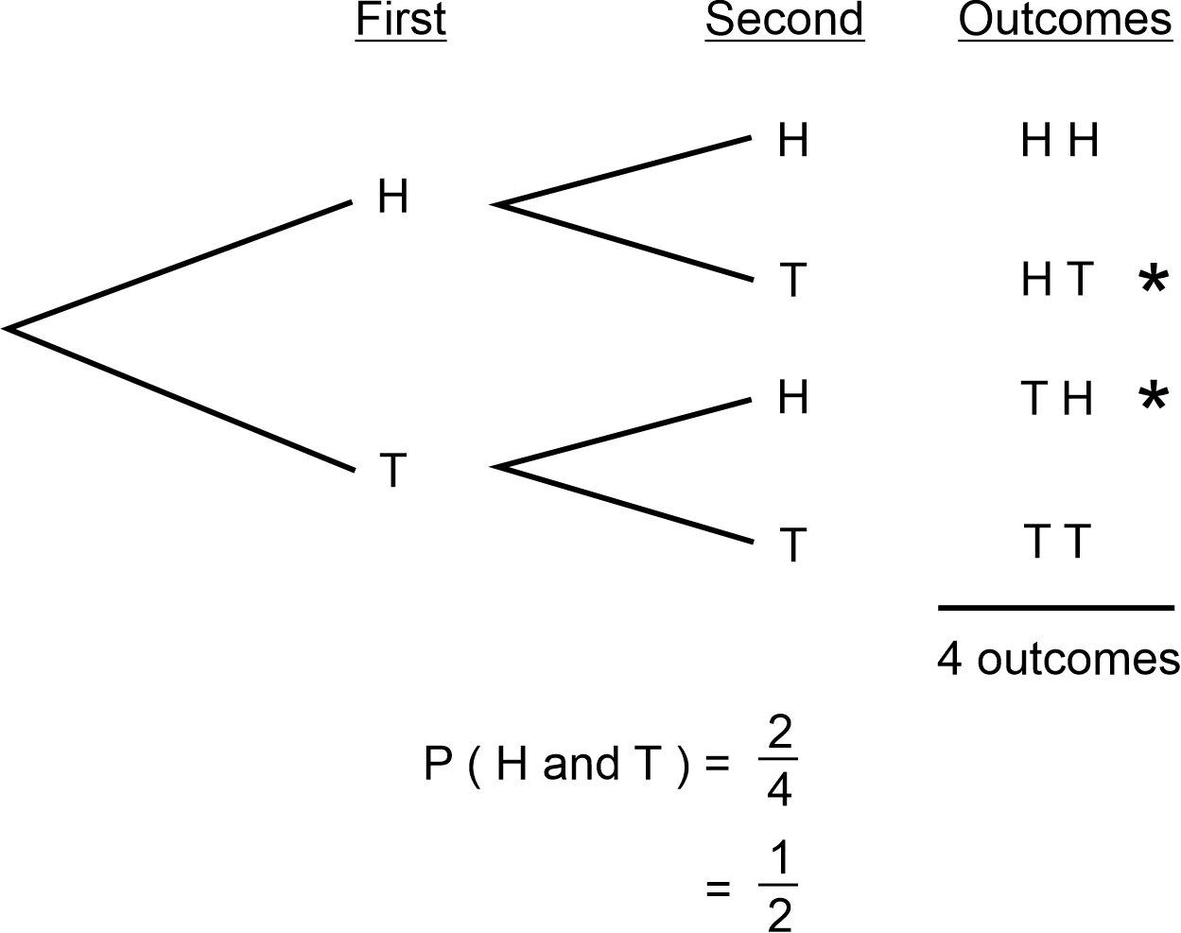
Image long description: The tree diagram originates with H and T as the options for the first coin, and H and T stemming from each of those options for the second coin. HT and TH are highlighted, leading to the probability of H and T equal to a half.

- Determine the probabilities of outcomes for multistage dependent events
Example(s):
Representing an experiment where 2 discs are selected without replacement from a bag of identical discs containing 8 red discs and 8 blue discs and calculating the probability of selecting one red disc and one blue disc.
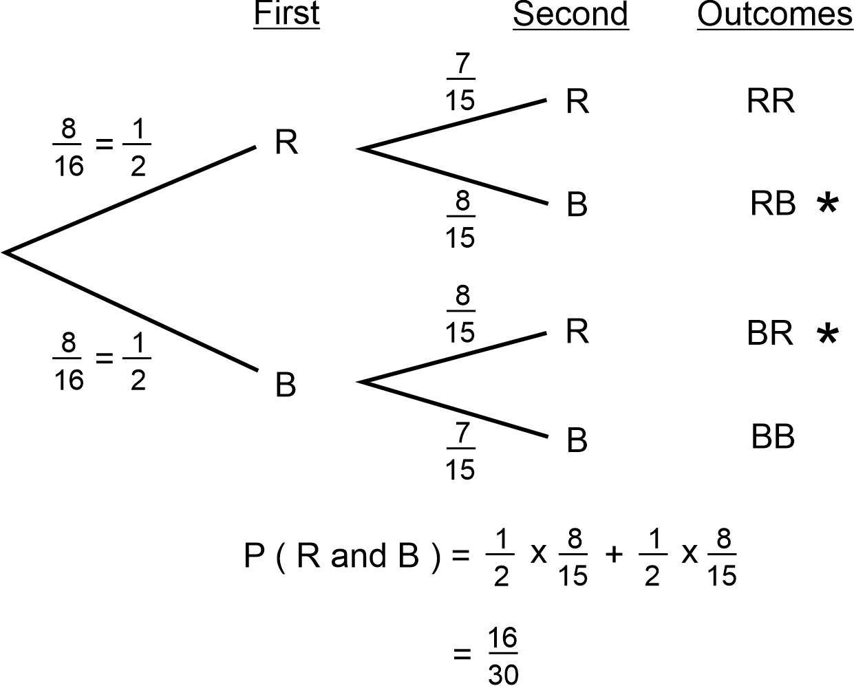
Image long description: The tree diagram originates with R and B as the options for the first disc, and R and B stemming from each of those options for the second disc. The probability of R for the first disc is 1 over 2 and the probability of B for the first disc is 1 over 2. The probability of R for the second if R is chosen first is 7 over 15, and the probability of B for the second if R is chosen first is 8 over 15. The probability of R for the second if B is chosen first is 8 over 15, and the probability of B for the second if B is chosen first is 7 over 15. RB and BR are highlighted. The probability of R and B is 1 over 2 multiplied by 8 over 15 plus 1 over 2 multiplied by 8 over 15 which equals 16 over 30.

- Associate complementary events with probabilities in multistage chance experiments
UnC6

Design and use simulations to model and examine situations involving probability
- Design and conduct a probability simulation, modelling probabilities of events, using digital tools
- Record and use the results of a probability simulation to predict future events
UnC5
- Apply reasoning to evaluate the simulation and its related outcomes

Variation and rates of change A (Path)

Outcomes
A student:
- develops understanding and fluency in mathematics through exploring and connecting mathematical concepts, choosing and applying mathematical techniques to solve problems, and communicating their thinking and reasoning coherently and clearly MAO-WM-01
- identifies and solves problems involving direct and inverse variation and their graphical representations (Path: Stn, Adv) MA5-RAT-P-01

Content
Stn (Standard), Adv (Advanced) and Ext (Extension) have been used to suggest paths for related Stage 6 courses.

Identify and describe problems involving direct and inverse variation
- Describe typical examples of direct variation/proportion
Example(s):
Describing the circumference of a circle as directly proportional to its radius, with a constant of variation $$2π$$.
PrT6
- Apply the language of direct variation to everyday contexts: $$y$$ is directly proportional to $$x, y$$ is proportional to $$x, y$$ varies directly as $$x$$
PrT6
- Identify and represent direct variation/proportion as $$y∝x$$ ($$y$$ is proportional to $$x$$) or $$y=kx,$$where $$k$$ is the constant of variation
Example(s):
Examining distance being in direct proportion to time, $$∴$$ $$d∝t$$. Travelling at a constant speed of 60 km/h results in the relationship $$d=60 t$$ where 60 is the constant of variation.
PrT7
- Describe typical examples of inverse (indirect) variation
Example(s):
Analysing situations where, as speed increases, the time taken to travel a distance decreases, or where more people are picking up rubbish in a stadium, the less time it will take to clean the stadium.
PrT6
- Apply the language of inverse variation to everyday contexts: $$y$$ is inversely proportional to $$x$$, $$y$$ is proportional to the reciprocal of $$x$$, $$y$$ varies inversely as $$x$$
PrT6, NPA8
- Identify and represent inverse variation/proportion as$$y∝\frac{1}{x}$$ ($$y$$ is inversely proportional to $$x$$) or $$y=\frac{k}{x},$$where $$k$$is the constant of variation
Example(s):
Establishing that $$W=\frac{1568}{D}$$ or $$WD=1568$$ if the number of workers on a worksite (W) is inversely proportional to the number of days it takes to complete the job (D) and it takes 56 workers 28 days to complete the job.
Note that this can also be written in the form $$xy=k$$; that is, the product of each $$x$$ value and the corresponding $$y$$ value is constant.
PrT7, NPA8

Identify and describe graphs involving direct and inverse variation
- Recognise and describe direct variation from graphs, noting that the graph of $$y=kx$$ is a straight line passing through the origin, with its gradient $$k$$ being the constant of variation
Example(s):
Describe the graphical relationship between H and P where the number of hours a casual employee works (H) is directly proportional to the amount of pay (P) that employee receives, where the employee receives $45 for 3 hours of work.
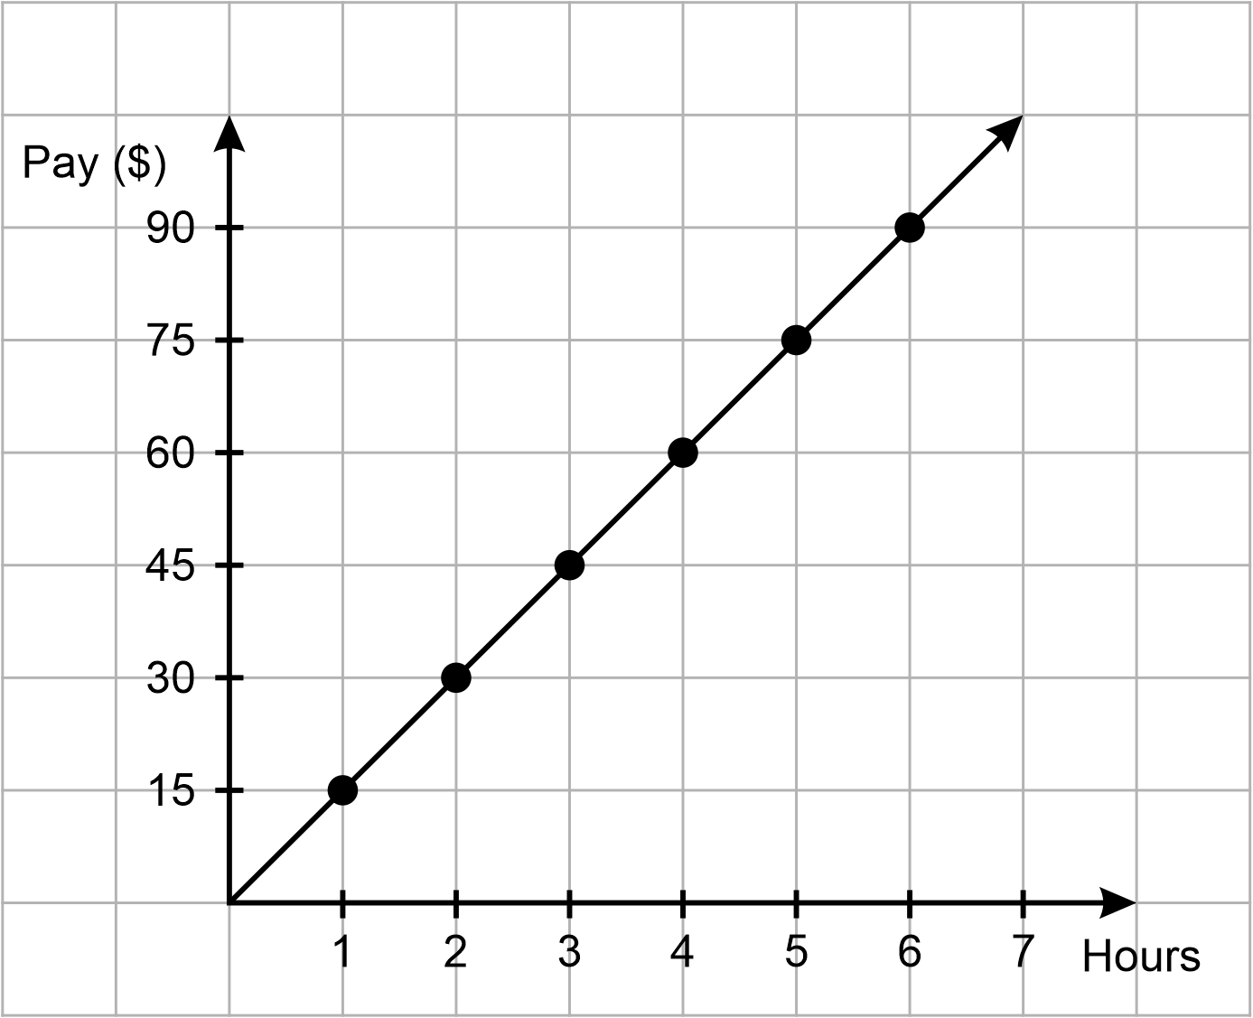
NPA8, NPA9
- Recognise and describe inverse variation from graphs, noting that the graph of $$y=\frac{k}{x}$$ is a curve
Example(s):
Describe the graphical relationship between H and P where the number of hours to paint a wall (H) is inversely proportional to the number of painters (P), where it takes 2 painters 4 hours to paint a wall.
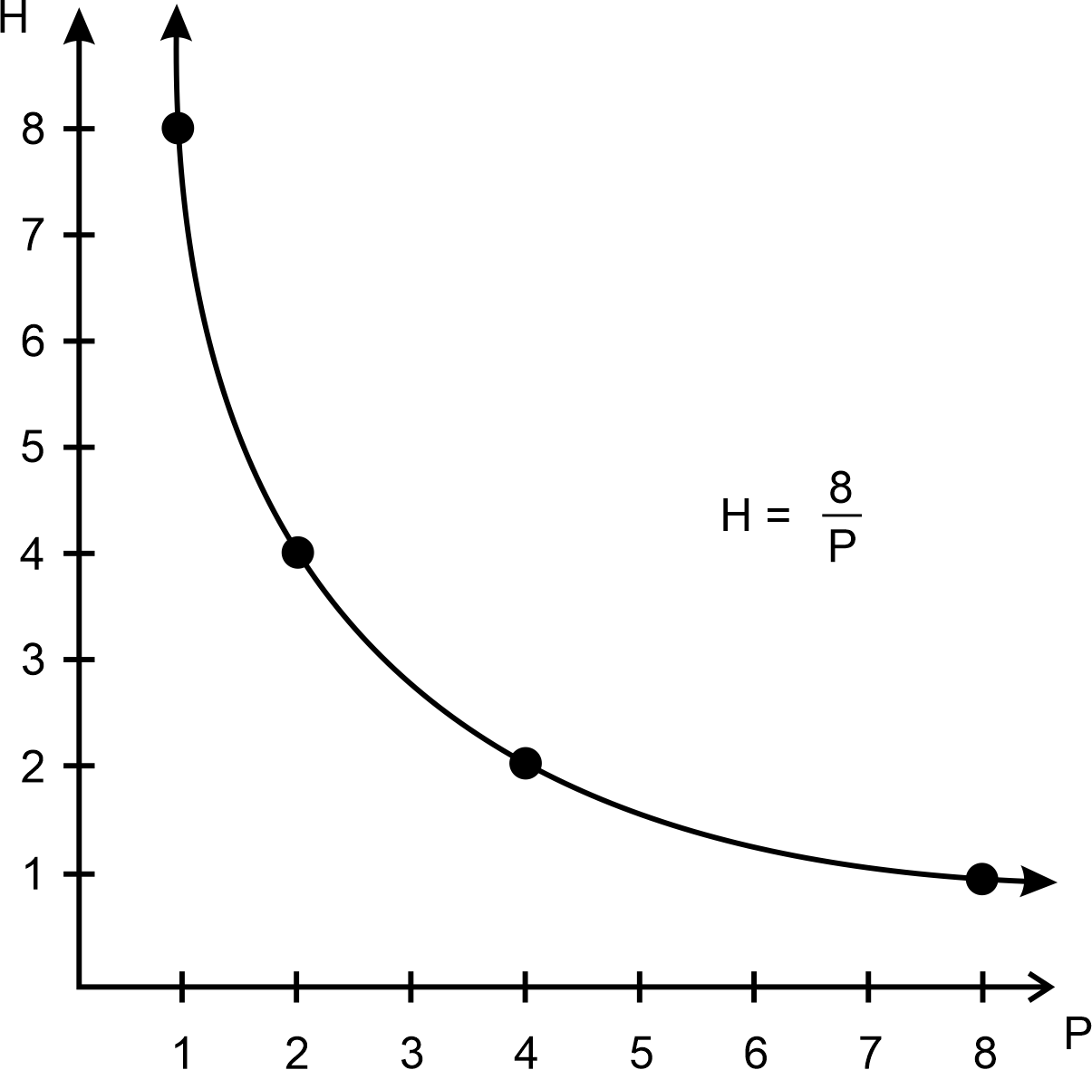
Image long description: The graph of H equals 8 over P is drawn with H on the vertical axis and P on the horizontal axis. The downward sloping curve is drawn through the points (1,8) (2,4) (4,2) and (8,1).
NPA8, NPA9

Solve problems involving direct and inverse variation and examine the relationship between graphs and equations corresponding to proportionality
- Solve problems involving direct or inverse variation using an equation
Example(s):
Finding the value of the constant of variation if $$a$$ varies directly as $$b$$ and $$a=2$$ when $$b=7$$.
PrT7, NPA8
- Use linear conversion graphs to convert from one unit to another
Example(s):
Using the graph to convert 50 US dollars to Australian dollars and interpreting the slope of the line as the exchange rate in this context.
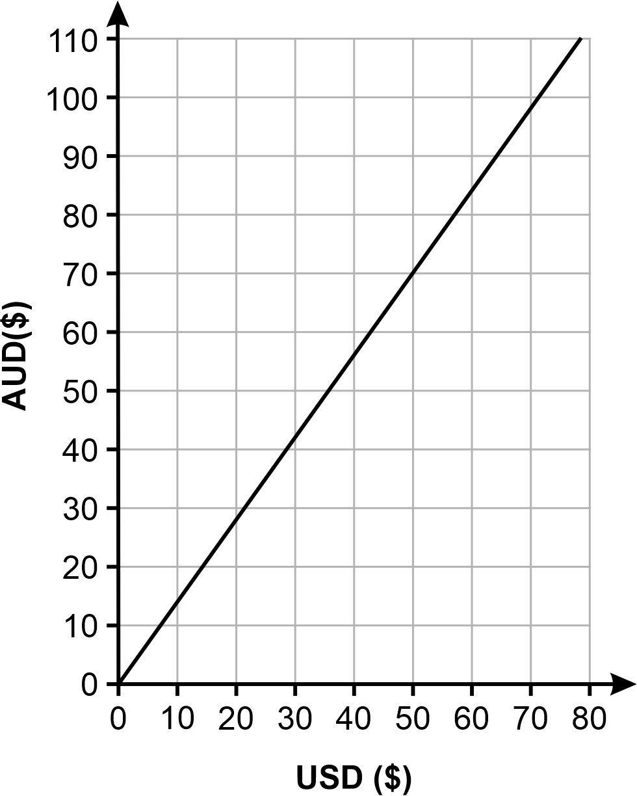
NPA9
- Graph equations representing direct variation, with or without digital tools
NPA8

Variation and rates of change B (Path)

Outcomes
A student:
- develops understanding and fluency in mathematics through exploring and connecting mathematical concepts, choosing and applying mathematical techniques to solve problems, and communicating their thinking and reasoning coherently and clearly MAO-WM-01
- analyses and constructs graphs relating to rates of change (Path: Stn, Adv) MA5-RAT-P-02

Content
Stn (Standard), Adv (Advanced) and Ext (Extension) have been used to suggest paths for related Stage 6 courses.

Analyse graphs that are decreasing or increasing at a constant rate
- Describe direct variation graphs as increasing at a constant rate and interpret the gradient of the line as the rate of change
- Interpret and analyse further graphs that exhibit a constant rate of change, including those that are decreasing at a constant rate

Analyse the relationship between graphs and variable rates of change
- Interpret distance–time graphs when the speed is variable, describing the rate of increase or decrease, the initial and final points, constant relationships represented by straight lines and variable relationships represented by curved lines
Example(s):
Interpreting distance–time graphs with curved segments, representing speeding up or slowing down.
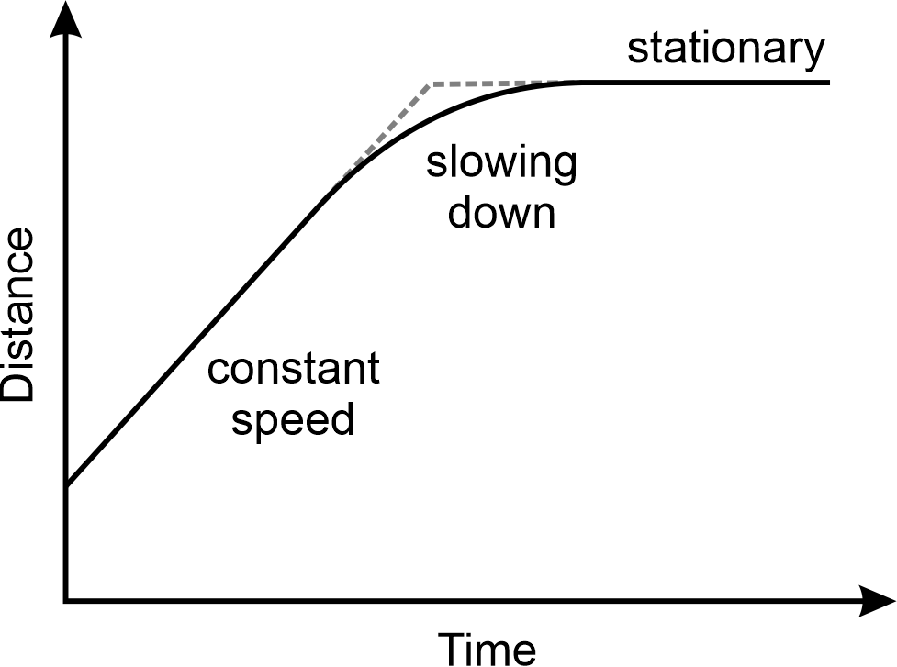

- Describe the rate of change between variables in a variety of contexts including direct and inverse variation
- Describe qualitatively the rate of change of a graph, using terms such as increasing at a decreasing rate
Example(s):
Examining situations where a quantity is decreasing at an increasing rate, decreasing at a decreasing rate, increasing at a decreasing rate, increasing at an increasing rate.
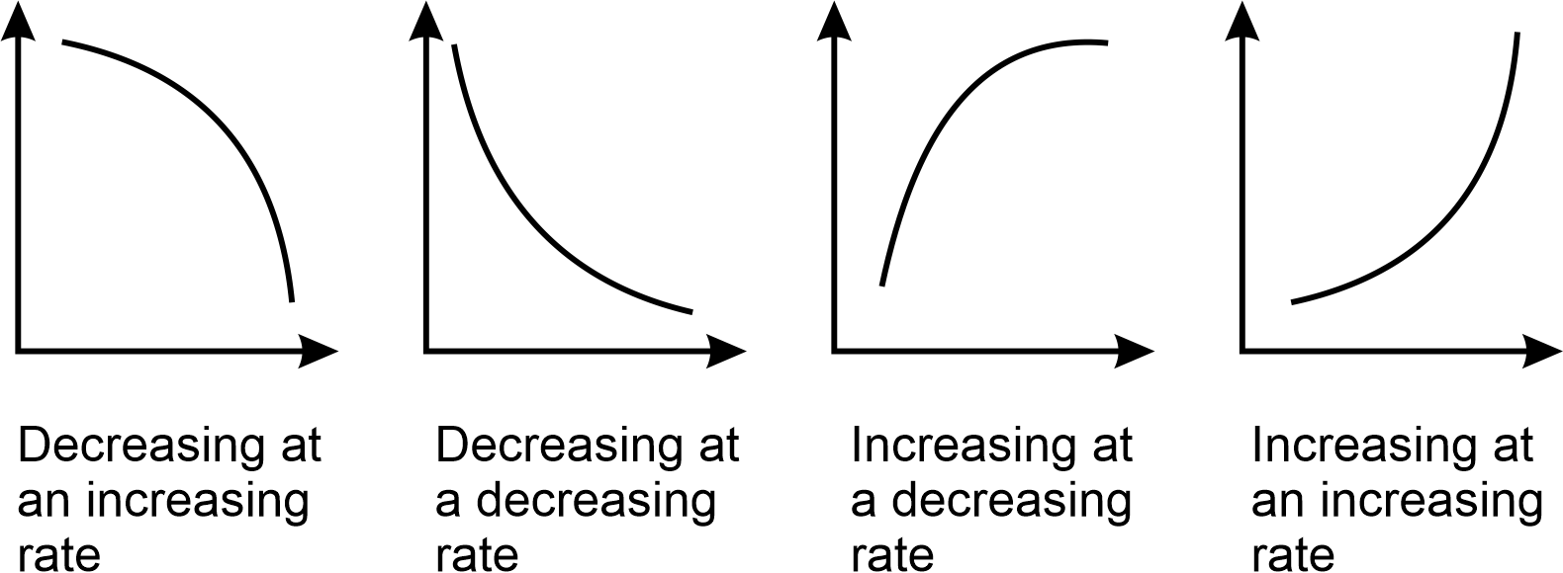
Image long description: 2 downward sloping curves showing decreasing at an increasing rate and decreasing at a decreasing rate and 2 upward sloping curves showing increasing at a decreasing rate and increasing at an increasing rate.

Construct graphical representations of rates of change
- Represent a given description of a variable rate of change of one quantity over time
Example(s):
Representing the situation where a car moves at a steady speed, accelerates to pass another car and then brakes, decelerates and stops at a set of traffic lights before accelerating again.
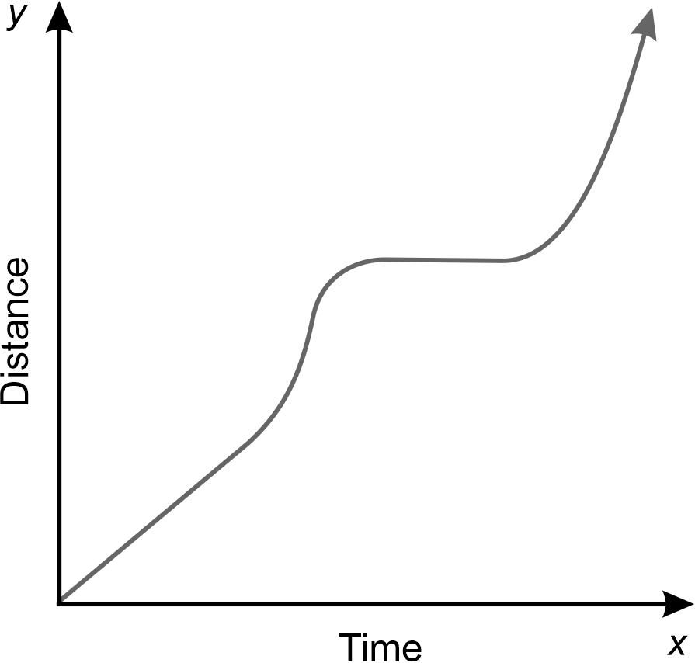
Image long description: A graph with distance on the y (vertical axis) and time on the x (horizontal) axis. Line on the graph shows the stop, start movements of the car.

Algebraic techniques B (Path)

Outcomes
A student:
- develops understanding and fluency in mathematics through exploring and connecting mathematical concepts, choosing and applying mathematical techniques to solve problems, and communicating their thinking and reasoning coherently and clearly MAO-WM-01
- simplifies algebraic fractions involving indices, and expands and factorises algebraic expressions (Path: Adv) MA5-ALG-P-01

Content
Stn (Standard), Adv (Advanced) and Ext (Extension) have been used to suggest paths for related Stage 6 courses.

Apply the 4 operations involving algebraic fractions with pronumerals in the denominator
- Simplify algebraic fractions, including those involving indices
Example(s):
Simplifying $$\frac{10a^{4}}{5a^{2}}$$, $$\frac{9a^{2}b}{3ab}$$, $$\frac{3ab}{9a^{2}b}$$.

- Simplify expressions that involve operations with algebraic fractions, including algebraic fractions that involve pronumerals in the denominator and/or indices
Example(s):
Simplifying these algebraic expressions with single term denominators : $$\frac{2ab}{3}×\frac{6}{2b}$$, $$\frac{3x^{2}}{{8y}^{5}}÷\frac{15x^{3}}{4y}$$, $$\frac{a^{2}b^{4}}{6}×\frac{9}{a^{2}b^{2}}$$, $$\frac{3}{x}-\frac{1}{2x}$$.

Factorise algebraic expressions by taking out a common algebraic factor
- Factorise algebraic expressions, including those involving indices, by determining the highest common factors (HCF) including negative coefficients/pronumerals

Expand binomial products and factorise monic quadratic expressions
- Expand binomial products
Example(s):
Expanding $$\left(3x-2\right)\left(2x+4\right)$$ or $$\left(x+y\right)\left(2x-3y\right)$$.

- Factorise monic quadratic trinomial expressions
Example(s):
Factorising $$x^{2}+7x+12, x^{2}-7x+12, x^{2}-x-12 and x^{2}+x-12$$.

- Solve problems involving expansion and factorisation of algebraic expressions

Algebraic techniques C (Path)

Outcomes
A student:
- develops understanding and fluency in mathematics through exploring and connecting mathematical concepts, choosing and applying mathematical techniques to solve problems, and communicating their thinking and reasoning coherently and clearly MAO-WM-01
- selects and applies appropriate algebraic techniques to operate with algebraic fractions, and expands, factorises and simplifies algebraic expressions (Path: Adv) MA5-ALG-P-02

Content
Stn (Standard), Adv (Advanced) and Ext (Extension) have been used to suggest paths for related Stage 6 courses.

Operate with algebraic fractions involving binomial numerators and numerical denominators
- Add and subtract algebraic fractions with binomial numerators and numerical denominators
Example(s):
Simplifying $$\frac{2x + 5}{6}+\frac{x - 4}{3}$$ and $$\frac{x}{3}-\frac{x + 1}{5}$$.

Expand, factorise and simplify algebraic expressions including special products
- Prove and apply these special products $$\left(a-b\right)\left(a+b\right)=a^{2}-b^{2}$$, $${\left(a+b\right)}^{2}=a^{2}+2ab+b^{2}$$, $${\left(a-b\right)}^{2}=a^{2}-2ab+b^{2}$$
Example(s):
Expanding $$\left(3a+1\right)\left(3a-1\right)$$, $$\left(x-2y\right)\left(x+2y\right)$$, $${\left(3x+7\right)}^{2}$$ and $${\left(5-6x\right)}^{2}$$by recognising the special products, in this instance the difference of 2 squares and perfect squares.

- Expand and simplify a variety of algebraic expressions including binomial products and the special products
Example(s):
Expanding and simplifying $$\left(3x+1\right)\left(2-x\right)+2x+4$$, $${\left(x+y\right)}^{2}-{\left(x-y\right)}^{2}$$ and $$18-4{\left(x-2\right)}^{2}$$.

- Factorise algebraic expressions involving the special products and strategies, including common factors, grouping in pairs for 4-term expressions and quadratic trinomials (monic and non-monic)
Example(s):
Factorising $${3d}^{3}-3d$$ , $${2a}^{2}-6ab-3a+9$$ and $$2a^{2}-7a-15$$ and verifying the result by expansion.

- Simplify algebraic expressions involving algebraic fractions using factorisation
Example(s):
Simplifying $$\frac{x^{2} + 3x + 2}{x + 2}$$ , $$\frac{4}{x^{2} + x}-\frac{3}{x^{2} - 1}$$ , $$\frac{3m - 6}{4}×\frac{8m}{m^{2} - 2m}$$ and $$\frac{4}{x^{2} - 9}+\frac{2}{3x + 9}$$.

Indices B (Path)

Outcomes
A student:
- develops understanding and fluency in mathematics through exploring and connecting mathematical concepts, choosing and applying mathematical techniques to solve problems, and communicating their thinking and reasoning coherently and clearly MAO-WM-01
- applies the index laws to operate with algebraic expressions involving negative-integer indices (Path: Adv) MA5-IND-P-01

Content
Stn (Standard), Adv (Advanced) and Ext (Extension) have been used to suggest paths for related Stage 6 courses.

Apply index laws to algebraic expressions involving negative-integer indices
- Apply index notation, patterns and index laws to establish $$a^{-1}=\frac{1}{a}$$, $$a^{-2}=\frac{1}{a^{2}}$$, $$a^{-3}=\frac{1}{a^{3}}$$ and $$a^{-n}=\frac{1}{a^{n}}$$
Example(s):
Explaining the difference between $$x^{-2}$$, $$-x^{2}$$ and $$-2x$$ by first examining the differences numerically using a calculator.

- Represent expressions involving negative-integer indices as expressions involving positive-integer indices and vice versa
Example(s):
Examining expressions such as $$x^{-3}=\frac{1}{x^{3}}$$ , $${2x}^{-1}=\frac{2}{x^{1}}=\frac{2}{x}$$ , $$\frac{4}{x}=\frac{4}{x^{1}}={4x}^{-1}$$ and $$\frac{1}{x^{2}}=x^{-2}$$.

- Apply the index laws to simplify algebraic products and quotients involving negative-integer indices
Example(s):
Justifying why the following statements of equality are true or false:
$$\frac{9x^{5}}{{3x}^{-5}}={3x}^{10}$$
$$9x^{-7}÷3x^{5}=3x^{2}$$
$$a^{-5}×a^{3}=a^{8}$$
$$a^{5}×a^{-7}=a^{-2}$$

- Describe and use $$x^{-1}$$ as the reciprocal of $$x$$ and generalise this relationship to expressions of the form $${\left(\frac{a}{b}\right)}^{-1}$$
- Use knowledge of the reciprocal to simplify expressions of the form $${\left(\frac{a}{b}\right)}^{-n}$$
Example(s):
Simplifying $${\left(\frac{2x^{2}}{3}\right)}^{-2}$$ and expressing without a negative index.

Indices C (Path)

Outcomes
A student:
- develops understanding and fluency in mathematics through exploring and connecting mathematical concepts, choosing and applying mathematical techniques to solve problems, and communicating their thinking and reasoning coherently and clearly MAO-WM-01
- describes and performs operations with surds and fractional indices (Path: Adv) MA5-IND-P-02

Content
Stn (Standard), Adv (Advanced) and Ext (Extension) have been used to suggest paths for related Stage 6 courses.

Describe surds
- Describe a real number as a number that can be represented by a point on the number line
- Examine the differences between rational and irrational numbers and recognise that all rational and irrational numbers are real
- Convert between recurring decimals and their fractional form using digital tools
- Describe the term surd as referring to irrational expressions of the form $$\sqrt[n]{x}$$ where $$x$$ is a rational number and $$n$$ is an integer such that $$n≥2$$, and $$x>0$$ when $$n$$ is even
- Recognise that a surd is an exact value that can be approximated by a rounded decimal
- Demonstrate that $$\sqrt{x}$$ is undefined for $$x<0$$ and that $$\sqrt{x}=0$$ when $$x=0$$ using digital tools
Example(s):
Explaining why an error occurs when attempting to find a value of $$\sqrt{-4}$$ as opposed to $$\sqrt{4}$$.

- Describe $$\sqrt{x}$$ as the positive square root of $$x$$ for $$x>0$$ and $$\sqrt{0}=0$$
Example(s):
Reasoning why the negative solution of the relevant quadratic equation is not feasible when solving problems involving Pythagoras’ theorem.

Apply knowledge of surds to solve problems
- Establish and apply the following results for $$x>0$$ and $$y>0$$: $${\left(\sqrt{x}\right)}^{2}=x=\sqrt{x^{2}}$$,$$\sqrt{xy}=\sqrt{x}×\sqrt{y}$$ and $$\sqrt{\frac{x}{y}}=\frac{\sqrt{x}}{\sqrt{y}}$$
- Apply the 4 operations to simplify expressions involving surds
Example(s):
Demonstrating why $$\sqrt{6}+\sqrt{8}$$ and $$\sqrt{14}$$ are different.

- Expand and simplify expressions involving surds
Example(s):
Expanding and simplifying: $$\left(\sqrt{15}+2\sqrt{3}\right)\left(5\sqrt{8}-\sqrt{10}\right)$$
$$=5\sqrt{120}-\sqrt{150}+10\sqrt{24}-2\sqrt{30}$$
$$=5\sqrt{4×30}-\sqrt{25×6}+10\sqrt{4×6}-2\sqrt{30}$$
$$=10\sqrt{30}-5\sqrt{6}+20\sqrt{6}-2\sqrt{30}$$
$$=8\sqrt{30}+15\sqrt{6}$$

- Rationalise the denominators of surds of the form $$\frac{a\sqrt{b}}{c\sqrt{d}}$$
Example(s):
Rationalising the denominator of $$\frac{2\sqrt{3}}{3\sqrt{5}}$$ by multiplying the numerator and denominator by $$\sqrt{5}$$.

Describe and use fractional indices
- Apply index laws to describe fractional indices as: $$a^{\frac{1}{n}}=\sqrt[n]{a}$$ and$${ a}^{\frac{m}{n}}=\sqrt[n]{a^{m}}={\left(\sqrt[n]{a}\right)}^{m}$$
Example(s):
Explaining why finding the square root of an expression is the same as raising the expression to the power of a half by considering that if $${\left(\sqrt{9}\right)}^{2}=9$$ and $${\left(9^{\frac{1}{2}}\right)}^{2}=9,$$ then $$\sqrt{9}=9^{\frac{1}{2}}$$.

- Translate expressions in surd form to expressions in index form and vice versa
- Evaluate numerical expressions involving fractional indices including using digital tools

Equations B (Path)

Outcomes
A student:
- develops understanding and fluency in mathematics through exploring and connecting mathematical concepts, choosing and applying mathematical techniques to solve problems, and communicating their thinking and reasoning coherently and clearly MAO-WM-01
- solves monic quadratic equations, linear inequalities and cubic equations of the form $${ax}^{3}=k$$ (Path: Adv) MA5-EQU-P-01

Content
Stn (Standard), Adv (Advanced) and Ext (Extension) have been used to suggest paths for related Stage 6 courses.

Solve monic quadratic equations
- Solve quadratic equations of the form $$ax^{2}+bx+c=0$$, limited to $$a=1$$, using factors

Solve cubic equations
- Determine that for any value of $$k$$ there is a unique value of $$x$$ that solves a cubic equation of the form $$ax^{3}=k$$ where $$a≠0$$
- Solve cubic equations of the form $$ax^{3}=k$$, leaving answers in exact form and as decimal approximations

Solve linear inequalities and graph their solutions on a number line
- Represent inequalities on a number line
Example(s):
Representing inequalities such as $$x<2$$, $$x≥-1,$$or $$-1<x≤3$$ on the number line.
NPV9
- Solve linear inequalities, including those with negative numbers, and graph the solutions
Example(s):
Demonstrating that solving $$1-4y≤5$$ leads to $$-4y≤4, ∴y≥-1$$.
NPV9
- Recognise that an inequality has an infinite number of solutions unless other restrictions are introduced
Example(s):
Solving $$3-\frac{x}{5}<8$$ if $$x$$ is a negative integer.

Equations C (Path)

Outcomes
A student:
- develops understanding and fluency in mathematics through exploring and connecting mathematical concepts, choosing and applying mathematical techniques to solve problems, and communicating their thinking and reasoning coherently and clearly MAO-WM-01
- solves linear equations of more than 3 steps, monic and non-monic quadratic equations, and linear simultaneous equations (Path: Adv) MA5-EQU-P-02

Content
Stn (Standard), Adv (Advanced) and Ext (Extension) have been used to suggest paths for related Stage 6 courses.

Solve linear equations involving algebraic fractions and equations of more than 3 steps
- Solve linear equations involving more than 3 steps
- Solve equations that involve 2 or more fractions
Example(s):
Solving $$\frac{2x - 5}{3}-\frac{x + 7}{5}=2$$.

Rearrange literal equations
- Change the subject of a formula
Example(s):
Changing the subject of the formula $$b=\frac{t - u}{a}$$ to $$u$$.

Solve quadratic equations using a variety of methods
- Solve equations of the form $${ax}^{2}+bx+c=0$$ by factorisation and by completing the square
Example(s):
Solving $$x^{2}+10x-16=0$$ by completing the square:
$$∴x^{2}+10x=16$$
$$x^{2}+10x+25=16+25$$
$${\left(x+5\right)}^{2}=41$$
$$x+5=±\sqrt{41}$$
$$x=-5±\sqrt{41}$$

- Apply the quadratic formula $$x=\frac{-b±\sqrt{b^{2} - 4ac}}{2a}$$ to solve quadratic equations
- Apply the most appropriate method to solve a variety of quadratic equations
- Use substitution to verify solutions to quadratic equations
Example(s):
Solving $$x^{2}+2x-8=0$$ and verifying solutions:
$$\left(x+4\right)\left(x-2\right)=0$$
$$x+4=0$$ and $$x-2=0$$
$$x=-4$$and $$x=2$$
verifying $$x=-4$$:
LHS $$={\left(-4\right)}^{2}+2\left(-4\right)-8$$
$$=16-8-8$$
$$=0$$
$$=$$ RHS
verifying $$x=2$$:
LHS $$={\left(2\right)}^{2}+2\left(2\right)-8$$
$$=4+4-8$$
$$=0$$
$$=$$ RHS

- Identify whether a given quadratic equation has real solutions, and if there are real solutions, whether or not they are equal
Example(s):
Evaluating the expression $$b^{2}-4ac$$ (from the quadratic formula) and describing the significance of this value for the equation $${2x}^{2}-5x-20=0$$ and the relationship between this value and the number of distinct solutions to the quadratic equation. Verifying this result graphically using digital tools.

- Solve quadratic equations resulting from substitution into formulas in various contexts
- Model and solve word problems using quadratic equations in various contexts
Example(s):
Evaluating the length of the shorter side of a rectangle if the rectangle has one side 3 cm longer than the other and an area of $$28 {\text{cm}}^{2}$$.

- Solve equations that are reducible to quadratics
Example(s):
Solving $$x^{4}-13x^{2}+36=0$$ by substituting $$u$$ for $$x^{2}$$.

Solve linear simultaneous equations, both algebraically and graphically
- Solve linear simultaneous equations by finding the point of intersection of their graphs
Example(s):
Graphing the linear equations $$y=x+2$$ and $$y=-2x-1$$, and solving the simultaneous equations by finding their point of intersection.
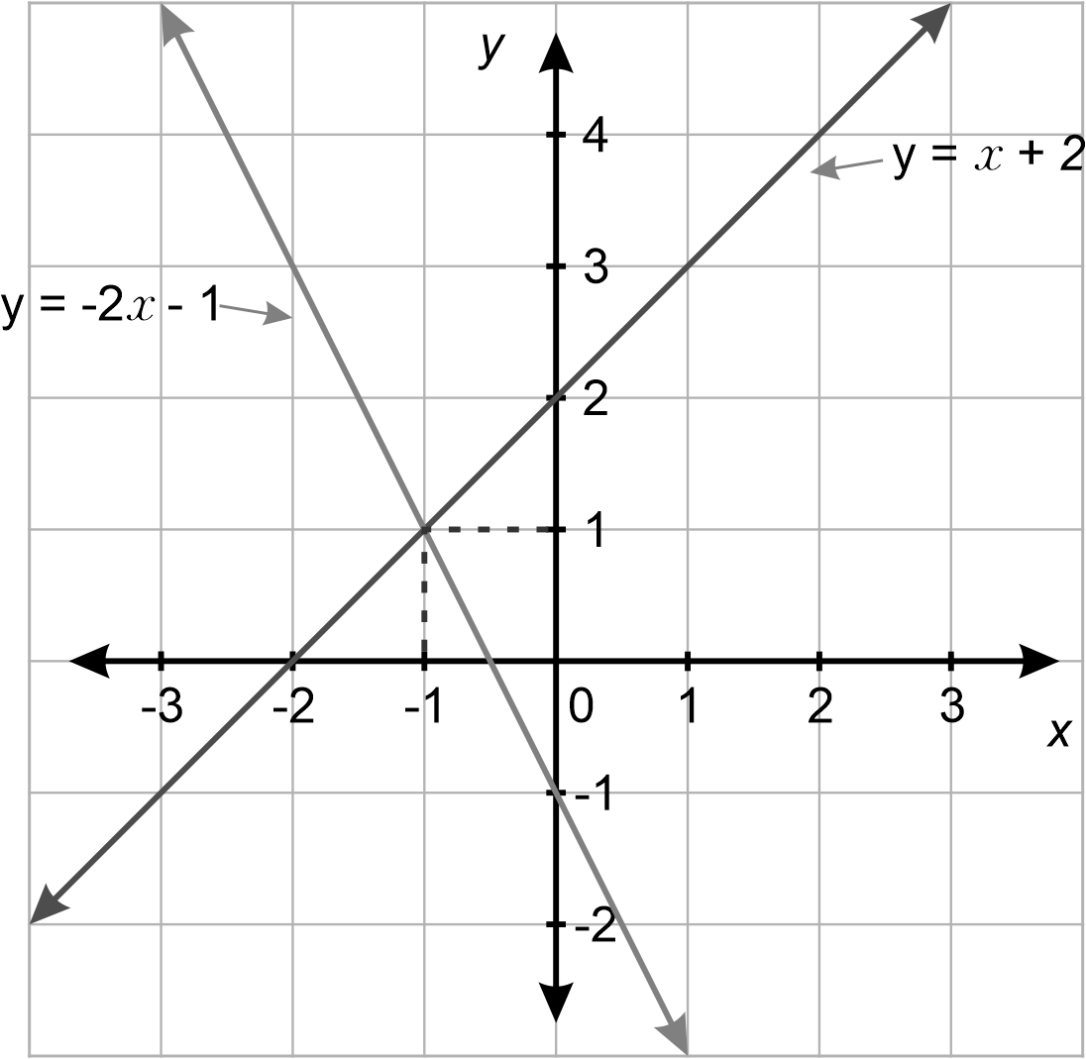
Image long description: A Cartesian plane with y on the vertical axis and x on the horizontal axis. The line y equals x plus 2 slopes upwards. The line y equals minus $$2x$$ minus 1 slopes downwards. They intersect at the point (minus 1,1).

- Solve linear simultaneous equations using algebraic techniques including substitution and elimination methods
- Model and solve word problems using simultaneous equations and interpret their solutions
- Describe an identity as an equation that is true for all values of the pronumeral and relate the identity to coincident lines
Example(s):
Examining and describing $$2x+3=3+2x$$ as an identity as it holds true for all values of $$x$$ and verifying that the graphs of $$y=2x+3$$ and $$y=3+2x$$ are the same (coincident lines).

- Describe a contradiction as an equation that has no solutions and relate the contradiction to parallel lines
Example(s):
Examining and describing $$2x-3=2x+3$$ as a contradiction as it has no solution and verifying that the graphs of $$y=2x-3$$ and $$y=2x+3$$ are parallel and never intersect, resulting in no solution.

Linear relationships C (Path)

Outcomes
A student:
- develops understanding and fluency in mathematics through exploring and connecting mathematical concepts, choosing and applying mathematical techniques to solve problems, and communicating their thinking and reasoning coherently and clearly MAO-WM-01
- describes and applies transformations, the midpoint, gradient/slope and distance formulas, and equations of lines to solve problems (Path: Adv) MA5-LIN-P-01

Content
Stn (Standard), Adv (Advanced) and Ext (Extension) have been used to suggest paths for related Stage 6 courses.

Apply formulas to find the midpoint and gradient/slope of an interval on the Cartesian plane
- Apply the formula to find the midpoint of the interval joining 2 points on the Cartesian plane:
$$M\left(x,y\right)=\left(\frac{x_{1}+x_{2}}{2},\frac{y_{1}+y_{2}}{2}\right)$$
- Use the relationship $$m=\frac{rise}{run}$$ to establish the formula for the gradient/slope ($$m)$$ of the interval joining the 2 points $$\left(x_{1}, y_{1}\right)$$ and $$\left(x_{2},y_{2}\right)$$ on the Cartesian plane: $$m=\frac{y_{2} - y_{1}}{x_{2} -{ x}_{1}}$$
Example(s):
Explaining why the formula $$m=\frac{y_{1 }- y_{2}}{x_{1} - x_{2}}$$ gives the same value for the gradient as $$m=\frac{y_{2 }- y_{1}}{x_{2} - x_{1}}$$.

- Apply the gradient formula to find the gradient of the interval joining 2 points on the Cartesian plane

Apply the distance formula to find the distance between 2 points located on the Cartesian plane
- Apply knowledge of Pythagoras’ theorem to establish the formula for the distance ($$d)$$ between the 2 points $$\left(x_{1}, y_{1}\right)$$ and $$\left(x_{2},y_{2}\right)$$ on the Cartesian plane: $$d=\sqrt{{\left(x_{2}-x_{1}\right)}^{2}+{\left(y_{2}-y_{1}\right)}^{2}}$$
Example(s):
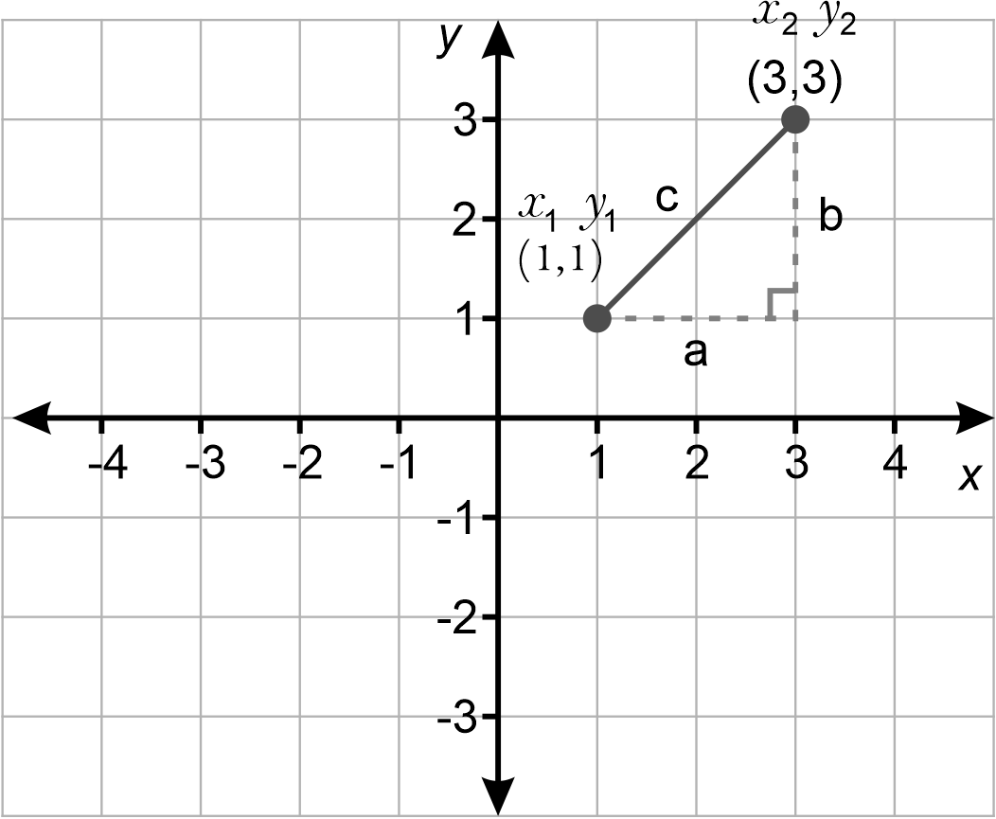
Image long description: A Cartesian plane with y on the vertical axis and x on the horizontal axis. An interval of length c is drawn from (1,1) and (3,3). A right-angled triangle is formed with b as the vertical side and a as the horizontal side.
$$c^{2}=a^{2}+b^{2}$$
$$d^{2}={\left(x_{2}-x_{1}\right)}^{2}+{\left(y_{2}-y_{1}\right)}^{2}$$
$$d=\sqrt{{\left(x_{2}-x_{1}\right)}^{2}+{\left(y_{2}-y_{1}\right)}^{2}}$$

- Apply the distance formula to find the distance between 2 points on the Cartesian plane
Example(s):
Justifying why the formula $$d=\sqrt{{\left(x_{2}-x_{1}\right)}^{2}+{\left(y_{2}-y_{1}\right)}^{2}}$$ gives the same result as using $$d=\sqrt{{\left(x_{1}-x_{2}\right)}^{2}+{\left(y_{1}-y_{2}\right)}^{2}}$$.

Use various forms of the equation of a straight line
- Rearrange linear equations from gradient–intercept form $$\left(y=mx+c\right)$$ to general form $$(ax+by+c=0)$$ and vice versa
Example(s):
Demonstrating that $$y=-\frac{3}{4}x+2$$ in general form is $$3x+4y-8=0$$.

- Find the $$x$$- and $$y$$-intercepts of a straight line in any form
- Graph the equation of a straight line in any form
- Use the point–gradient form ($$y-y_{1}=m\left(x-x_{1}\right)$$) or the gradient–intercept form ($$y=mx+c$$) to find the equation of a line passing through a point $$\left(x_{1}, y_{1}\right)$$, with a given gradient $$m$$
- Use the gradient and the point–gradient form to find the equation of a line passing through 2 points
- Find the equation of a line that is parallel or perpendicular to a given line in any form
Example(s):
Finding the equation of a line that is perpendicular to $$3x+2y=6$$ and passes through $$\left(-1,2\right)$$.

- Determine and justify whether 2 given lines are parallel or perpendicular
Example(s):
Determining whether the lines $$y=-3x+1$$ and $$x-3y-1=0$$ are parallel or perpendicular and justifying the result.

Solve problems by applying coordinate geometry formulas
- Solve problems including those involving geometrical figures by applying coordinate geometry formulas
Example(s):
Proving that the points $$\left(1, -1\right)$$, $$\left(-1, 1\right)$$ and $$\left(-\sqrt{3}, -\sqrt{3}\right)$$ form an equilateral triangle.

Identify line and rotational symmetries
- Identify lines (axes) and rotational symmetry in plane shapes
- Identify line and rotational symmetry in various linear and non-linear graphs

Describe translations, reflections in an axis, and rotations through multiples of 90 degrees on the Cartesian plane, using coordinates
- Apply the notation $$P'$$ to name the image resulting from applying a transformation to a point $$P$$ on the Cartesian plane
- Determine and plot the coordinates for $$P'$$ resulting from translating $$P$$ one or more times
Example(s):
Translating point $$P(2,1)$$ to the left 4 units and down 3 units and finding the coordinates of $$P'$$.

- Determine and plot the coordinates for $$P'$$ resulting from reflecting $$P$$ in either the $$x$$- or $$y$$-axis
Example(s):
Recognising that if $$P(3,2)$$ is reflected in the 𝑥-axis, $$P'$$ has the same 𝑥-coordinate, and its 𝑦-coordinate has the same magnitude but opposite sign, then the coordinate $$P'$$ is $$(3, -2)$$.

- Determine and plot the coordinates for $$P'$$ resulting from rotating $$P$$ by a multiple of $${90}^{°}$$ about the origin

Non-linear relationships C (Path)

Outcomes
A student:
- develops understanding and fluency in mathematics through exploring and connecting mathematical concepts, choosing and applying mathematical techniques to solve problems, and communicating their thinking and reasoning coherently and clearly MAO-WM-01
- interprets and compares non-linear relationships and their transformations, both algebraically and graphically (Path: Adv) MA5-NLI-P-01

Content
Stn (Standard), Adv (Advanced) and Ext (Extension) have been used to suggest paths for related Stage 6 courses.

Graph parabolas and describe their features and transformations
- Use graphing applications to compare parabolas of the form $$y={kx}^{2}$$,$$y={kx}^{2}+c, y=k{\left(x-b\right)}^{2}$$ and $$y=k{\left(x-b\right)}^{2}+c$$, and describe their features and transformations
- Find $$x$$- and $$y$$-intercepts algebraically, where appropriate, for the graph of $$y={ax}^{2}+bx+c$$, given $$a,b$$ and $$c$$
- Determine the equation of the axis of symmetry of a parabola using either the formula $$x=-\frac{b}{2a}$$ or the midpoint of the $$x$$-intercepts
- Find the coordinates of a parabola’s vertex using a variety of methods
Example(s):
Finding the vertex for the graph $$y=x^{2}+2x-3$$. Completing the square to find the vertex:
$$y=k{\left(x-b\right)}^{2}+c$$ where the vertex is located at $$\left(b, c\right)$$.
$$∴y=\left(x^{2}+2x+1\right)-3-1$$
$$y={\left(x+1\right)}^{2}-4$$
$$∴$$ equating $$y=k{\left(x-b\right)}^{2}+c$$ with $$y={\left(x+1\right)}^{2}-4$$, the vertex is located at $$\left(-1, -4\right)$$.

- Graph quadratic relationships of the form $$y={ax}^{2}+bx+c$$ by identifying and applying features of parabolas and their equations without graphing software

Graph exponentials and describe their features and transformations
- Use graphing applications to graph exponential relationships of the form $$y= k{\left(a\right)}^{x}+c$$ and $$y=k{\left(a\right)}^{-x}+c$$for integer values of $$k$$, $$a$$ and $$c$$ (where $$a>0$$ and $$a≠1$$), and compare and describe any relevant features
Example(s):
Graphing $$y=3(2^{x})-1$$ and $$y=3(2^{-x})-1$$, determining the equation of the asymptotes, the coordinates of the $$y$$-intercepts and describe similarities and differences.
NPA9

Graph hyperbolas and describe their features and transformations
- Use graphing applications to graph, compare and describe hyperbolic relationships of the form $$y=\frac{k}{x}$$ for integer values of $$k$$
Example(s):
Explaining what happens to the $$y$$-values of the points on the hyperbola $$y=\frac{k}{x}$$ as the $$x$$-values become very large or closer to zero.

- Use graphing applications to graph and describe a variety of hyperbolas, including where the equation is given in the form $$y=\frac{k}{x}+c$$ or $$y=\frac{k}{x - b}$$ for integer values of $$k, b$$ and $$c$$
Example(s):
Identifying features of hyperbolas from their equations to help sketch their graphs, including identifying asymptotes, orientation, and $$x$$- and/or $$y$$-intercepts where they exist.

Graph circles and describe their features and transformations
- Derive the equation of a circle $$x^{2}+y^{2}=r^{2}$$ with centre $$\left(0, 0\right)$$ and radius $$r$$ using the distance formula
- Identify and describe equations that represent circles with centre at the origin and radius of the circle $$r$$
Example(s):
Identifying $$x^{2}+y^{2}=5$$ as a circle with centre (0,0) and radius $$\sqrt{5}$$ units.

- Graph circles of the form $$x^{2}+y^{2}=r^{2}$$, where $$r$$ is the radius of the circle using graphing applications
- Establish the equation of the circle with centre $$\left(a,b\right)$$ and radius $$r$$, and graph equations of the form $${\left(x-a\right)}^{2}+{\left(y-b\right)}^{2}=r^{2}$$
Example(s):
Establishing the equation of a circle with centre $$\left(a, b\right)$$ and radius $$r$$using the distance formula: $$r^{2}={\left(x-a\right)}^{2}+{\left(y-b\right)}^{2}$$.
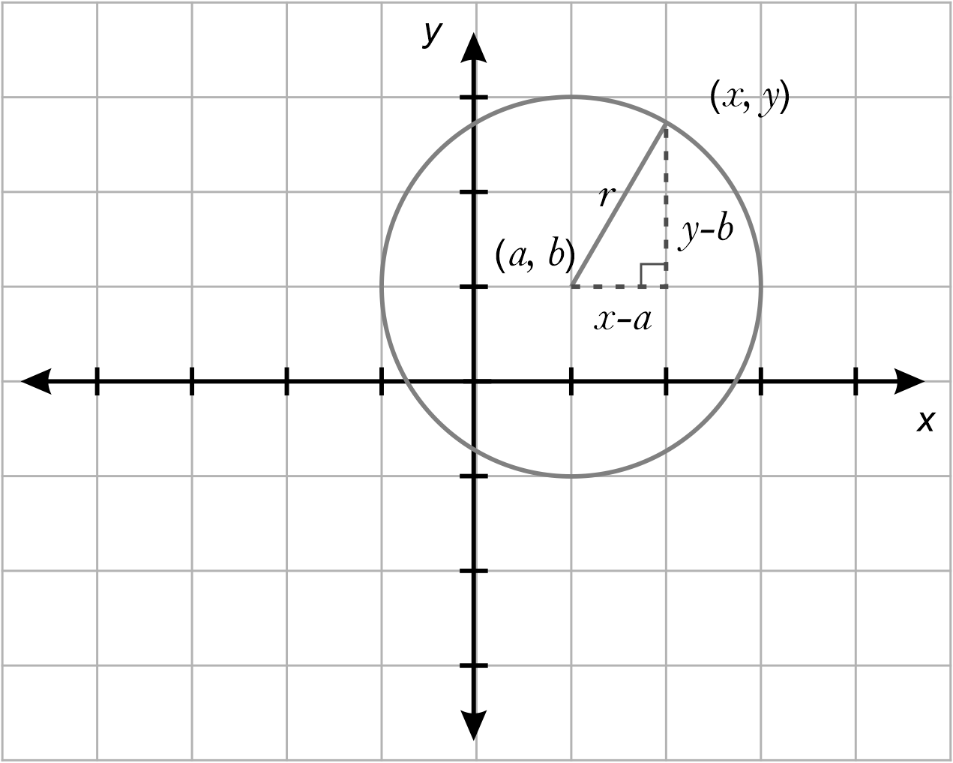
Image long description: The radius is drawn from centre a, b to the edge of the circle at the point x, y. A right-angled triangle is formed with sides y minus b and x minus a.

- Find the centre and radius of a circle with the equation in the form $$x^{2}+y^{2}+ax+by+c=0$$ by completing the square

Distinguish between different types of graphs by examining their algebraic and graphical representations and solve problems
- Identify and describe features of different types of graphs based on their equations
- Identify a possible equation from a graph and verify using graphing applications
Example(s):
Comparing and contrasting the different types of graphs shown below and determining possible equations from the key features in each graph.
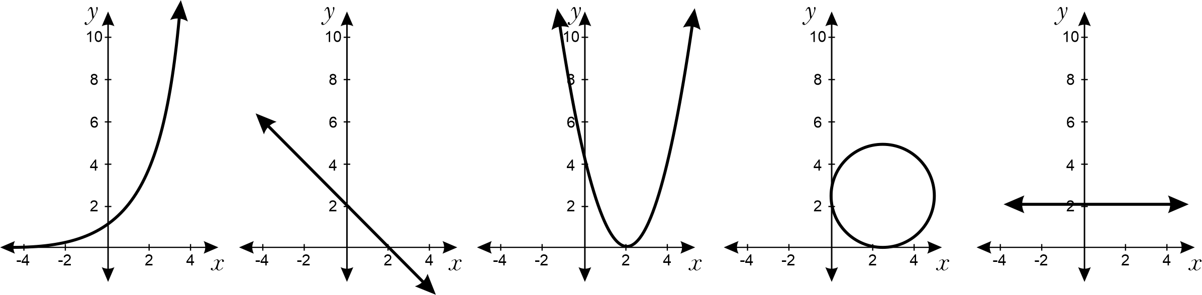
Image long description: An upward sloping exponential graph that cuts the y-axis at 1, a downward sloping straight-line graph, a parabola with vertex at 0, 2 that cuts the y-axis at 4, a circle with radius of 2 and centre (2, 2), and a horizontal graph cutting the y-axis at 2.

- Find points where a line intersects with a parabola, hyperbola or circle, both graphically and algebraically
Example(s):
Comparing methods of finding points of intersection of curves and justifying the choice of method for a particular pair of curves.

Graph and compare polynomial curves and describe their features and transformations
- Use graphing applications to graph and compare features of cubic equations of the form $$y=ax^{3}+c$$, where $$a$$ and $$c$$ are integers
- Use graphing applications to graph a variety of equations of the form $$y={kx}^{n}$$, where $$n$$ is an integer and $$n≥2$$, and describe the effect on the shape of the curve where $$n$$ is an odd or an even number
Example(s):
Using graphing applications, graph $$y=x^{2}$$, $$y=x^{3}$$, $$y=x^{4}$$, $$y=x^{5}$$ and $$y=x^{6}$$, comparing the shape of each of these curves and analysing the connection between the value of $$n$$ in $$y=x^{n}$$ and the effect on the shape of the curve.

- Use graphing applications to graph curves of the form $$y={kx}^{n}+c$$ and $$y=k{\left(x-b\right)}^{n}$$ where $$n$$ is an integer and $$n≥2,$$ and describe the transformations from $$y={kx}^{n}$$

Polynomials (Path)

Outcomes
A student:
- develops understanding and fluency in mathematics through exploring and connecting mathematical concepts, choosing and applying mathematical techniques to solve problems, and communicating their thinking and reasoning coherently and clearly MAO-WM-01
- defines, operates with and graphs polynomials and applies the factor and remainder theorems to solve problems (Path: Adv, Ext) MA5-POL-P-01

Content
Stn (Standard), Adv (Advanced) and Ext (Extension) have been used to suggest paths for related Stage 6 courses.

Define and operate with polynomials
- Recognise a polynomial expression $$a_{n}x^{n}+a_{n - 1}x^{n - 1}+…+a_{2}x^{2}+a_{1}x+a_{0}$$ where $$n=0, 1, 2…$$ and $$a_{0}, a_{1}, a_{2},…,a_{n}$$ are real numbers
- Describe polynomials using terms such as degree, leading term, coefficient and leading coefficient, constant term, monic and non-monic
Example(s):
Recognising that the polynomial $$x-3x^{2}+4x^{3}-7$$ has the leading term $$4x^{3}$$, leading coefficient of 4, constant term -7 and degree 3.

- Define a monic polynomial as having a leading coefficient of one
- Apply the notation $$P(x)$$ for polynomials and $$P(c)$$ to indicate the value of $$P(x)$$ for $$x=c$$
Example(s):
Using $$P\left(x\right)=3x^{3}+2x^{2}+1$$ to evaluate $$P\left(3\right)$$ and $$P\left(-2\right)$$.

- Add, subtract and multiply polynomials
Example(s):
Evaluating $$P\left(x\right)+Q\left(x\right)$$ and $$P\left(x\right)-Q\left(x\right)$$ and $$P\left(x\right)×Q\left(x\right)$$, if $$P\left(x\right)=3x^{3}+2x^{2}+1$$ and $$Q\left(x\right)=2x^{2}-3x-4$$.

Divide polynomials
- Identify the dividend, divisor, quotient and remainder in numerical division
- Divide a polynomial by a linear polynomial to find the quotient and remainder
- Express a polynomial in the form $$P\left(x\right)=D(x)Q\left(x\right)+R(x)$$, where $$D(x)$$ is the divisor, $$Q(x)$$ is the quotient and $$R\left(x\right)$$ is the remainder

Apply the factor and remainder theorems to solve problems
- Verify the remainder theorem and use it to find factors of polynomials and solve related problems
Example(s):
Finding the values of $$a$$ and $$b$$ given the cubic polynomial $$x^{3}+2x^{2}+ax+b$$ has a remainder 15 when divided by $$x-3$$and remainder $$-3$$ when divided by $$x+1$$.

- Develop and apply the factor theorem to factorise particular polynomials completely and solve related problems
Example(s):
Finding the values of $$a$$ and $$b$$ if the polynomial $$P\left(x\right)=3x^{6}-5x^{3}+ax^{2}+bx+10$$ is divisible by $$x+1$$ and $$x-2$$.

- Apply the factor theorem and division to find the zeroes of a polynomial $$P(x)$$ and solve $$P\left(x\right)=0$$ (degree$$≤4$$)
Example(s):
Justifying that $$g\left(x\right)=\left(x+1\right)\left(x^{2}-x+3\right)$$ only has one zero.

- State the maximum number of zeroes a polynomial of degree $$n$$ can have

Graph polynomials
- Graph polynomials in factored form
Example(s):
Graphing $$y=P\left(x\right)$$ by finding the zeroes of $$P\left(x\right)=x\left(x-4\right)\left(x+2\right)$$.

- Graph quadratic, cubic and quartic polynomials by factorising and finding the zeroes
- Relate the term zeroes to polynomial functions and roots to polynomial equations
- Use graphing applications to determine the effect of single, double and triple roots of a polynomial equation $$P\left(x\right)=0$$ on the shape of the graph for $$y=P\left(x\right)$$
- Graph polynomials using the sign of the leading term and the multiplicity of roots for the equation $$P\left(x\right)=0$$
Example(s):
Graphing $$P\left(x\right)=-\left(x-1\right){\left(x+2\right)}^{2}$$.

- Use graphing applications to compare the graphs of $$y=-P\left(x\right)$$, $$y=P\left(-x\right)$$, $$y=P\left(x\right)+c$$ and $$y=kP\left(x\right)$$ to the graph of $$y=P\left(x\right)$$
Example(s):
Using graphing applications to examine the differences between the graphs for $$y=P\left(x\right)$$, $$y=-P\left(x\right)$$ and $$y=P\left(-x\right)$$ for $$P\left(x\right)=x\left(x-1\right)\left(x+1\right)$$.

Logarithms (Path)

Outcomes
A student:
- develops understanding and fluency in mathematics through exploring and connecting mathematical concepts, choosing and applying mathematical techniques to solve problems, and communicating their thinking and reasoning coherently and clearly MAO-WM-01
- establishes and applies the laws of logarithms to solve problems (Path: Adv) MA5-LOG-P-01

Content
Stn (Standard), Adv (Advanced) and Ext (Extension) have been used to suggest paths for related Stage 6 courses.

Examine logarithms both numerically and graphically
- Define the term logarithm: the logarithm of a number to any positive base $$a$$ is the index to which $$a$$ is raised to give this number
- Recognise equivalence where $$y=a^{x}$$ is equivalent to $$x=\log_{a}{y}$$ where $$a>0$$and $$a≠1$$
- Translate statements expressing a number in index form into equivalent statements expressing the logarithm of the number
Example(s):
Translating the following from index form into equivalent logarithmic form: $$9=3^{2}$$, $$∴\log_{3}{9}=2$$ and $$4^{\frac{3}{2}}=8$$, $$∴\log_{4}{8}=\frac{3}{2}$$.

- Use graphing applications to compare and contrast graphs for the functions $$y=a^{x}$$ and $$y=\log_{a}{x}$$
Example(s):
Graphing $$y=2^{x}$$ and $$y=\log_{2}{x}$$ on the same axes and discussing the importance of a common scale for the $$x$$ and $$y$$-axes to show they are symmetrical in $$y=x$$.

- Generalise that $$y=\log_{a}{x}$$ is an increasing function when $$a>1$$ and decreasing when $$0<a<1$$

Establish and apply the laws of logarithms to solve problems
- Deduce laws of logarithms from laws of indices
Example(s):
Laws of logarithms
$$\log_{a}{m}+\log_{a}{n}=\log_{a}{(mn)}$$
$$\log_{a}{m}-\log_{a}{n}=\log_{a}\left(\frac{m}{n}\right)$$
$$\log_{a}\left(m^{n}\right)=n\log_{a}{m}$$
Examining the restrictions on $$x$$ for $$\log\left(x^{2}\right)=2\log\left(x\right)$$.

- Establish and use a variety of logarithmic results
Example(s):
Logarithmic results
$$\log_{a}{a}=1$$
$$\log_{a}{1}=0$$
$$\log_{a}{\frac{1}{x}}=-\log_{a}{x}$$
$$\log_{a}{b}=\frac{\log_{c}{b}}{\log_{c}{a}}$$

- Apply the laws of logarithms to evaluate and simplify expressions
Example(s):
Evaluating $$\log_{a}{18}$$ given $$\log_{a}{2}=0.431$$ and $$\log_{a}{3}=0.683$$

- Solve simple equations that involve exponents or logarithms
Example(s):
Solving $$2^{t}=8$$, $$4^{t + 1}=\frac{1}{8\sqrt{2}}$$, $$\log_{27}{3}=x$$ and $$\log_{4}{x}=-2$$.

- Examine logarithmic scales and explain their use in various contexts
Example(s):
Describing the Richter scale, measuring sound levels in decibels and f-stops for ratios of photographic exposure as logarithmic scales.

Functions and other graphs (Path)

Outcomes
A student:
- develops understanding and fluency in mathematics through exploring and connecting mathematical concepts, choosing and applying mathematical techniques to solve problems, and communicating their thinking and reasoning coherently and clearly MAO-WM-01
- uses function notation to describe and graph functions of one variable and graphs inequalities in one and 2 variables (Path: Adv) MA5-FNC-P-01

Content
Stn (Standard), Adv (Advanced) and Ext (Extension) have been used to suggest paths for related Stage 6 courses.

Define relations and functions, and use function notation
- Define a relation over 2 sets as an association between the elements of one set to the elements of another set
Example(s):
Describing a relation as an association between the elements of one set to the elements of another set.
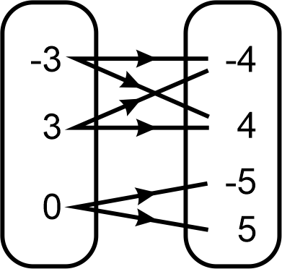
Image long description: Minus 3, 3 and 0 are in the first set, and minus 4, 4, minus 5 and 5 are in the second set. Minus 3 is connected to minus 4 and 4. 3 is connected to minus 4 and 4. 0 is connected to minus 5 and 5.

- Notate relations as a set of ordered pairs $$\left(x,y\right)$$ of real numbers
- Define a function as a relation over 2 sets where each element of the first set is associated with exactly one element in the second set
Example(s):
Describing a function as a relation with the property that for each input value there is only one output value.
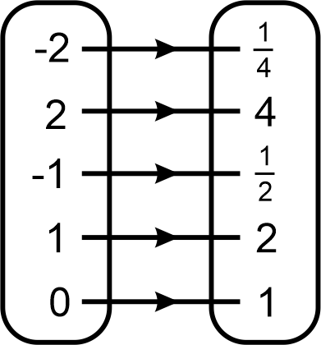
Image long description: Minus 2, 2, minus 1, 1 and 0 are in the first set, and 1 over 4, 4, 1 over 2, 2 and 1 are in the second set. Minus 2 is connected to 1 over 4. 2 is connected to 4. Minus 1 is connected to 1 over 2, 1 is connected to 2, and 0 is connected to 1.

- Apply the vertical line test on a graph to decide whether it represents a function
- Use the notation $$f\left(x\right)$$ when expressing a function
Example(s):
Expressing the function $$y=x^{2}+1$$ as $$f\left(x\right)=x^{2}+1$$.

- Use the notation $$f\left(c\right)$$ to determine the value of $$f\left(x\right)$$ when $$x=c$$

Find the domain and range of a function and graph functions
- Define the domain as the set of all allowable values of $$x$$
- Define the range as the set of possible $$y$$-values as $$x$$ varies over the domain of the function
Example(s):
Recognising and proving that the range of $$y=2-x^{2}$$ is $$y≤2$$.

- Determine and describe the domain and range for a variety of functions
- Use graphing applications to graph and compare functions of the form $$y=f\left(x\right), y=f\left(x\right)+c$$, $$y=f(x-b)$$, $$y=kf\left(x\right)$$ and $$y=f\left(ax\right)$$, and describe their transformations
Example(s):
Using graphing applications, show that the graph of $$y=f\left(x\right)+5$$ is a vertical translation of the graph of $$y=f(x)$$.

Graph regions corresponding to linear inequalities in one and 2 variables
- Graph linear inequalities of the form $$ax+by>c$$, testing whether the points satisfy the given inequality and shading appropriate regions
Example(s):
Graphing $$2x+3y<24$$ and verifying the region using a test point such as $$\left(0,0\right)$$.

Trigonometry C (Path)

Outcomes
A student:
- develops understanding and fluency in mathematics through exploring and connecting mathematical concepts, choosing and applying mathematical techniques to solve problems, and communicating their thinking and reasoning coherently and clearly MAO-WM-01
- applies Pythagoras’ theorem and trigonometry to solve 3-dimensional problems and applies the sine, cosine and area rules to solve 2-dimensional problems, including bearings (Path: Stn, Adv) MA5-TRG-P-01

Content
Stn (Standard), Adv (Advanced) and Ext (Extension) have been used to suggest paths for related Stage 6 courses.

Solve 3-dimensional problems involving right-angled triangles
- Apply Pythagoras’ theorem to solve problems involving the lengths of the edges and diagonals of rectangular prisms and other 3-dimensional objects
Example(s):
Finding the longest pencil that fits in a rectangular box measuring 5 cm × 6 cm × 8 cm.

- Apply trigonometry to solve problems involving right-angled triangles in 3 dimensions, including using bearings and angles of elevation and depression

Apply the sine, cosine and area rules to any triangle and solve related problems
- Use graphing applications to verify the sine rule $$\frac{a}{\sin{A}}=\frac{b}{\sin{B}}=\frac{c}{\sin{C}}$$ and that the ratios of a side to the sine of the opposite angle is a constant
- Apply the sine rule in a given triangle $$ABC$$to find the value of an unknown side
- Apply the sine rule in a given triangle $$ABC$$to find the value of an unknown angle (ambiguous case excluded): $$\frac{\sin{A}}{a}=\frac{\sin{B}}{b}=\frac{\sin{C}}{c}$$
- Use graphing applications to verify the cosine rule $$c^{2}=a^{2}+b^{2}-2ab\cos{C}$$.
- Apply the cosine rule to find the unknown sides for a given triangle $$ABC$$.
- Rearrange the formula to deduce that $$\cos{C}=\frac{a^{2}+ b^{2}- c^{2}}{2ab}$$ and use this to find an unknown angle
Example(s):
Rearranging to make $$\cos{C}$$ the subject of the formula $$c^{2}=a^{2}+b^{2}-2ab\cos{C}$$.

- Use graphing applications to verify the area rule $$A=\frac{1}{2}ab\sin{C}$$.
- Apply the formula $$A=\frac{1}{2}ab\sin{C}$$, where $$a$$ and $$b$$ are the sides that form angle $$C$$ to find the area of a given triangle $$ABC$$
- Solve problems involving finding unknown angles or sides in triangles (excluding right-angled triangles) by selecting and applying the appropriate rule

Trigonometry D (Path)

Outcomes
A student:
- develops understanding and fluency in mathematics through exploring and connecting mathematical concepts, choosing and applying mathematical techniques to solve problems, and communicating their thinking and reasoning coherently and clearly MAO-WM-01
- establishes and applies the properties of trigonometric functions and finds solutions to trigonometric equations (Path: Adv) MA5-TRG-P-02

Content
Stn (Standard), Adv (Advanced) and Ext (Extension) have been used to suggest paths for related Stage 6 courses.

Use the unit circle to define trigonometric functions and represent them graphically
- Redefine the sine and cosine ratios in terms of the unit circle
Example(s):
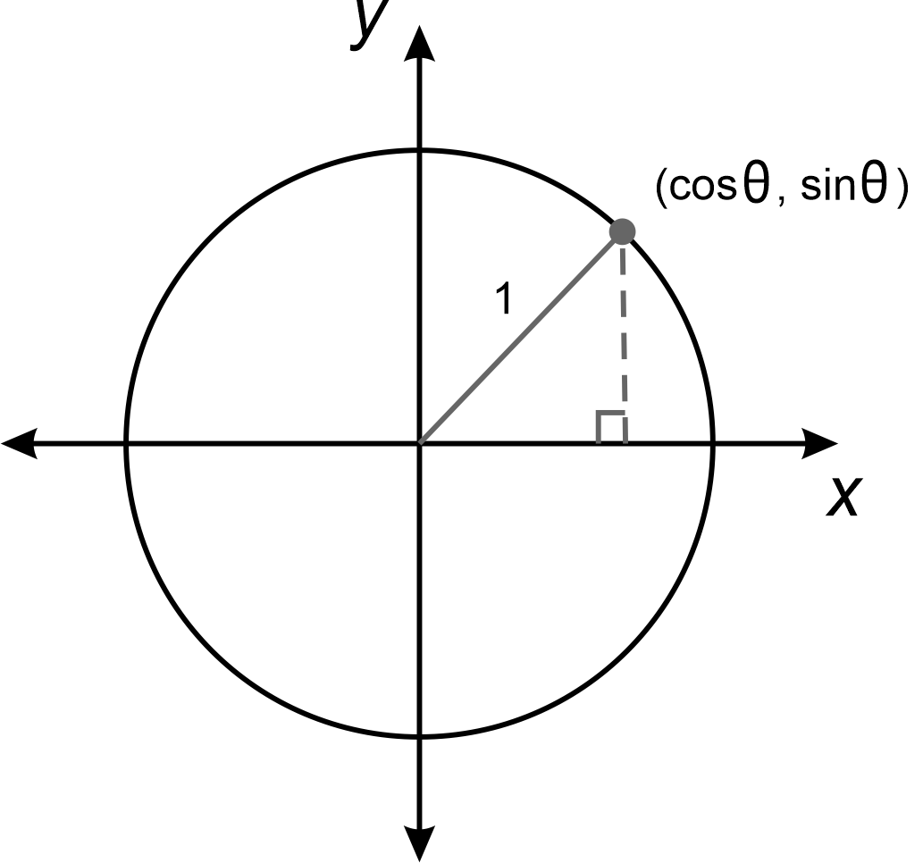
Image long description: A circle with radius 1 drawn is plotted on a Cartesian plane. The radius in the first quadrant touches the circle at cos theta, sin theta. A right-angled triangle is formed with the radius as the longest side.

- Verify that the tangent ratio can be expressed as a ratio of the sine and cosine ratios
Example(s):
Using the unit circle to establish:
Since $$\sin{θ}=\frac{opposite}{hypotenuse}=y$$ and $$\cos{θ}=\frac{adjacent}{hypotenuse}=x$$
$$\frac{\sin{θ}}{\cos{θ}}=\frac{\frac{opposite}{hypotenuse}}{\frac{adjacent}{hypotenuse}}=\frac{y}{x}$$
$$\frac{\sin{θ}}{\cos{θ}}=\frac{y}{x}=\frac{opposite}{adjacent}=\tan{θ}$$.

- Use graphing applications to examine the sine, cosine and tangent ratios for (at least) $$0^{°}≤x≤{360}^{°}$$, and graph the results
Example(s):
Using graphing applications to graph the sine, cosine and tangent curves, comparing their features including periodicity and symmetry, and describing how the value of each trigonometric ratio changes as the angle increases from $$0^{°}$$ to $${360}^{°}.$$

- Use graphing applications to examine graphs of the sine, cosine and tangent functions for angles of any magnitude, including negative angles
Example(s):
Using graphing applications, graph the sine, cosine and tangent curves, examining the periodic nature of trigonometric graphs.

- Use the unit circle or graphs of trigonometric functions to establish and apply the relationships $$\sin{A=sin}\left(180°-A\right)$$, $$\cos{A=-cos}\left(180°-A\right)$$, and $$\tan{A=-tan}\left(180°-A\right)$$ for obtuse angles when $$0°≤A≤90°$$
- Establish and apply the relationship $$m=\tan{θ},$$where $$m$$ is the gradient of the line and $$θ$$ is the angle of inclination of a line with the $$x$$ -axis on the Cartesian plane
Example(s):
Using the diagram below to verify the relationship $$m=\tan{θ},$$applying the fact that: $$m=\frac{rise}{run}$$, $$m=2\sqrt{3}$$ and $$\text{tan }θ=2\sqrt{3}$$.
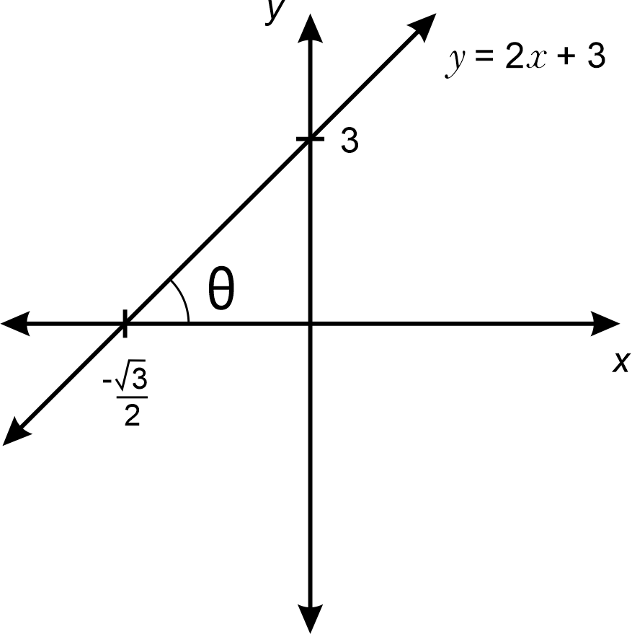
Image long description: A Cartesian plane with the upward sloping line y equals 2$$x$$ plus 3 graphed, cutting the $$x$$-axis at minus root 3 over 2 and the y-axis at 3. The line forms angle theta with the $$x$$-axis.

Solve trigonometric equations using exact values and the relationships between supplementary and complementary angles
- Derive and apply the exact sine, cosine and tangent ratios for angles of $$30°$$, $$45°$$ and $$60°$$
Example(s):
Deriving the exact sine, cosine and tangent ratios for the angles of $$30°$$, $$45°$$ and $$60°$$ using the following triangles.
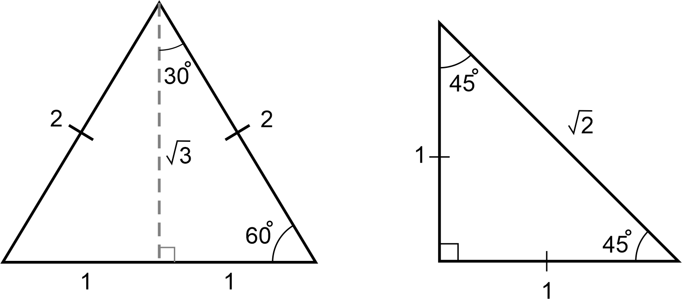
Image long description: 2 triangles, one is an equilateral triangle that is split into 2 equal right-angled triangles with sides 1, root 3 and hypotenuse of 2. The second triangle is a 45-degree isosceles triangle with sides of 1, 1 and a hypotenuse of root 2.

- Verify and use the relationships between the sine and cosine ratios of complementary angles in right-angled triangles: $$\sin{A}=\cos{(90°-A)}$$ and $$\cos{A}=\sin\left(90°-A\right)$$
Example(s):
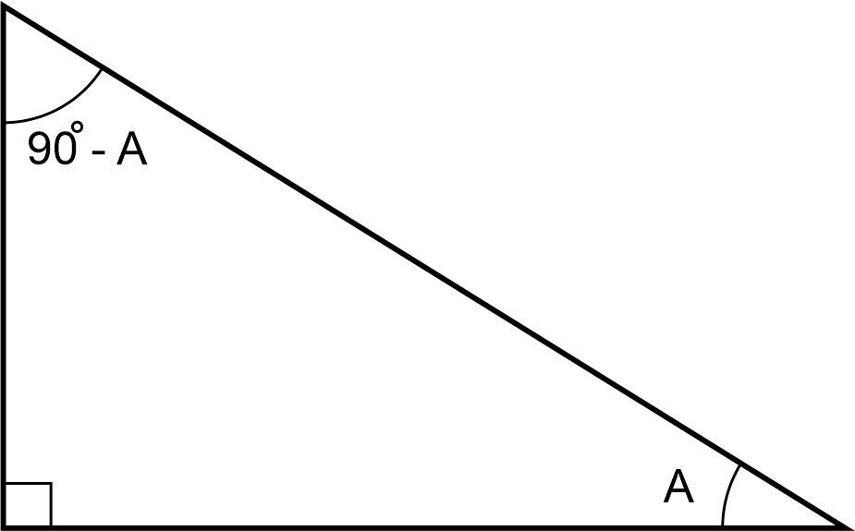

- Find the possible acute and/or obtuse angles, given a trigonometric ratio
- Apply the sine rule and area rule to find angles involving the ambiguous case
Example(s):
Finding the possible sizes of $$∠ACB$$, given $$AB=10 cm$$, $$AC=6 cm$$ and $$∠ABC={35}^{°}$$ and demonstrating that 2 solutions are possible.
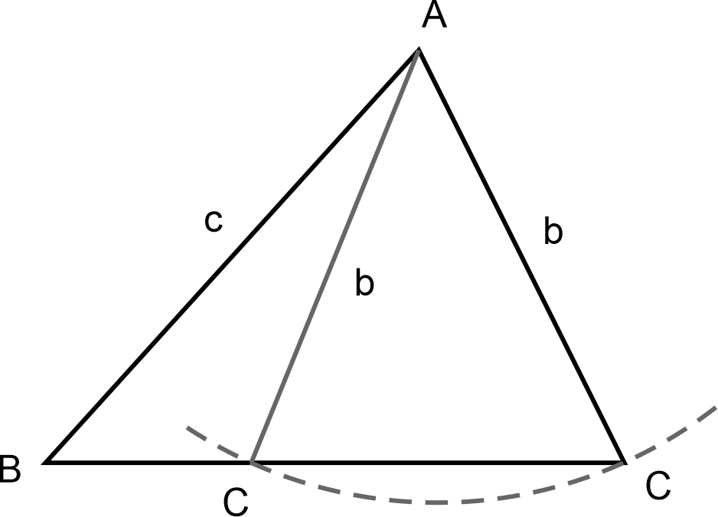

Area and surface area B (Path)

Outcomes
A student:
- develops understanding and fluency in mathematics through exploring and connecting mathematical concepts, choosing and applying mathematical techniques to solve problems, and communicating their thinking and reasoning coherently and clearly MAO-WM-01
- applies knowledge of the surface area of right pyramids and cones, spheres and composite solids to solve problems (Path: Stn, Adv) MA5-ARE-P-01
Related Life Skills outcomes: MALS-ARE-01

Content
Stn (Standard), Adv (Advanced) and Ext (Extension) have been used to suggest paths for related Stage 6 courses.

Solve problems involving surface areas
- Identify the perpendicular heights and slant heights of right pyramids and right cones
Example(s):
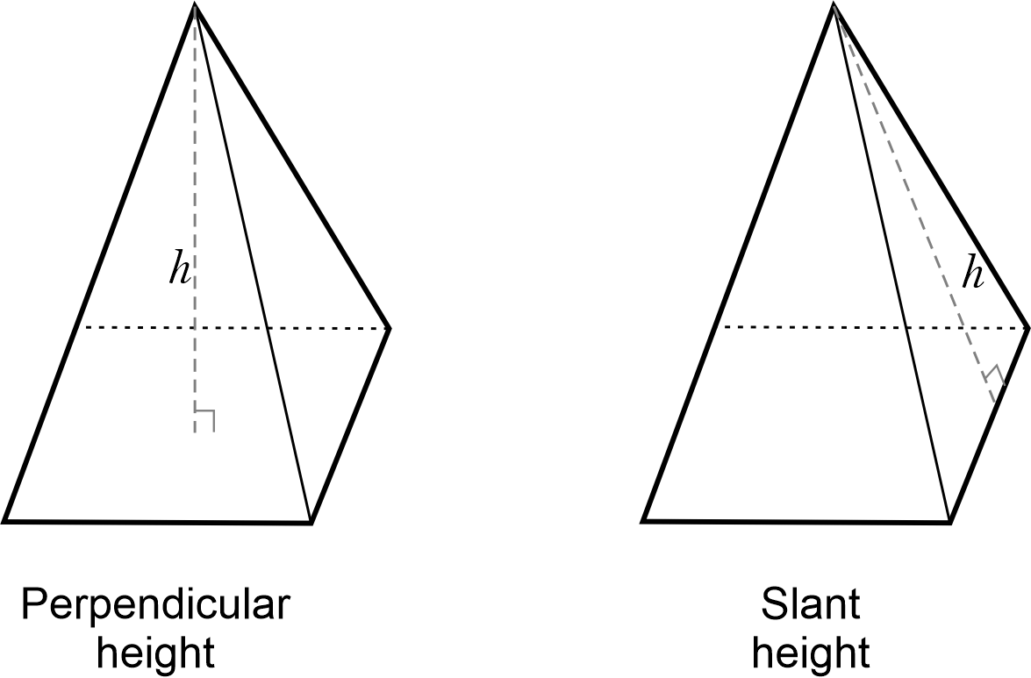
Image long description: Two pyramids showing the difference between perpendicular height and slant height. Perpendicular height is drawn from the apex of the pyramid straight down the centre of the pyramid. Slant height is drawn from the apex of the pyramid to the middle of the side face.

- Apply Pythagoras’ theorem to find the slant heights, base lengths and perpendicular heights of right pyramids and right cones
- Solve problems involving the surface areas of right pyramids and compare methods of solution
Example(s):
Drawing the net of a pyramid and describing the surface area as the sum of the areas of the triangular faces and the base shape.
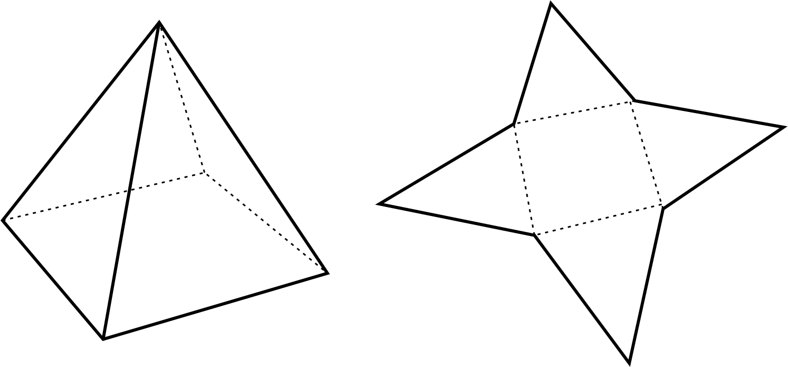
UuM10
- Apply the formula to find the curved surface area of right cones: $$A=πrl$$, where $$r$$ is the length of the radius and $$l$$ is the slant height
Example(s):
Examining how the formula for the curved surface area of a cone is developed from the area of a circle, using concrete materials, digital tools or algebraic techniques.
UuM10
- Apply the formula to find the surface area of spheres: $$A= {4πr}^{2}$$, where $$r$$ is the length of the radius
- Solve problems involving the surface area of solids in a variety of contexts including composite solids
Example(s):
Finding the surface area of a solid composed of a cone with a radius of 3 cm, slant height of 10 cm and a hemisphere attached to the base.
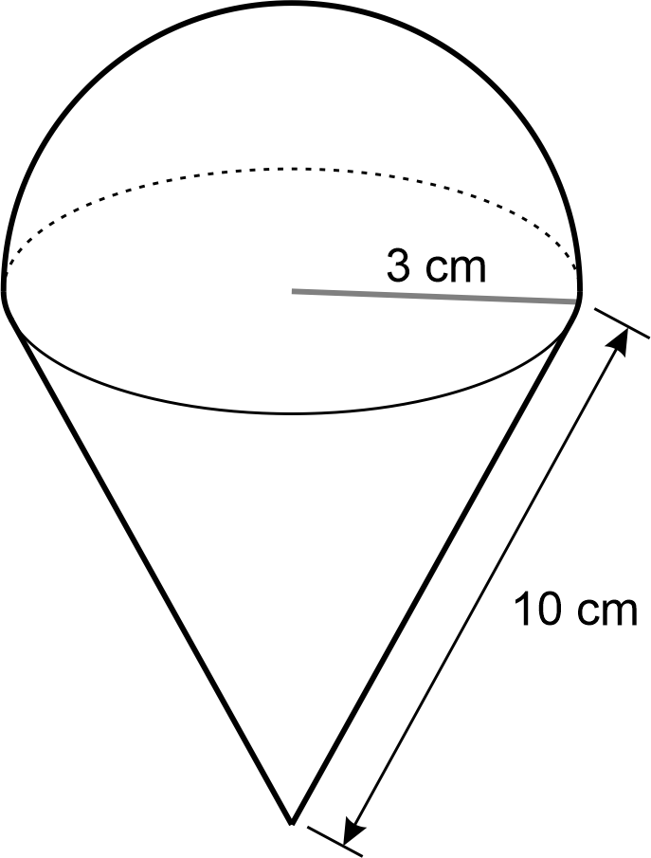

Volume B (Path)

Outcomes
A student:
- develops understanding and fluency in mathematics through exploring and connecting mathematical concepts, choosing and applying mathematical techniques to solve problems, and communicating their thinking and reasoning coherently and clearly MAO-WM-01
- applies knowledge of the volume of right pyramids, cones and spheres to solve problems involving related composite solids (Path: Stn, Adv) MA5-VOL-P-01

Content
Stn (Standard), Adv (Advanced) and Ext (Extension) have been used to suggest paths for related Stage 6 courses.

Solve problems involving volumes
- Find the volume of right pyramids and right cones by using an appropriate formula: volume of pyramid or cone $$V=\frac{1}{3}Ah$$, where $$A$$ is the base area and $$h$$ is the perpendicular height
- Find the volume of spheres by using an appropriate formula: volume of sphere $$V=\frac{4}{3}πr^{3}$$, where $$r$$ is the length of the radius
- Apply knowledge of right pyramids, right cones and hemispheres to solve problems involving composite solids
- Solve practical problems related to the volumes and capacities of solids including right pyramids, right cones and spheres
Example(s):
Determining the volume and capacity (in litres) of the hopper bin funnel below.
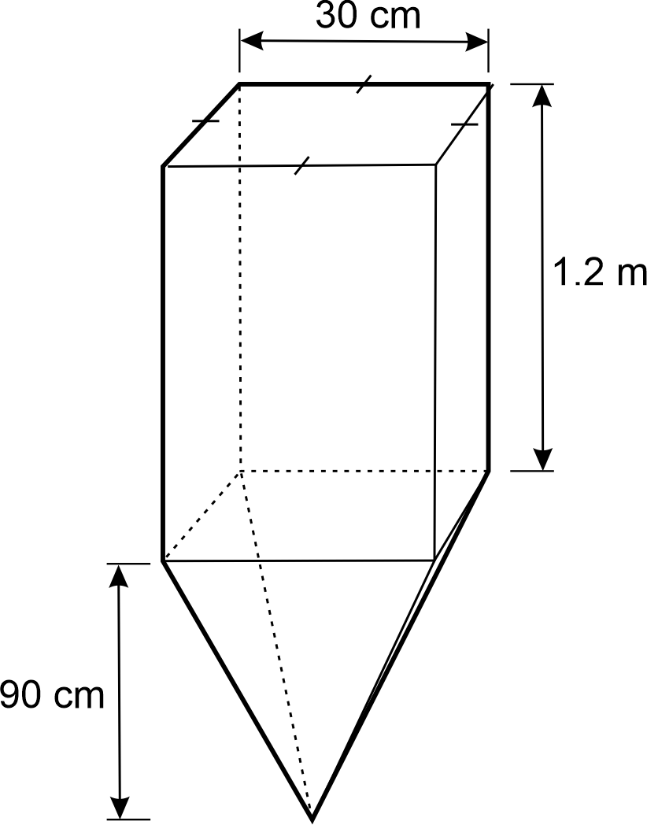
Image long description: A rectangular prism of length and width of 30 cm and a height of 1.2 m. A square pyramid of perpendicular height 90 cm is attached to one end of the rectangular prism.
UuM10

Properties of geometrical figures B (Path)

Outcomes
A student:
- develops understanding and fluency in mathematics through exploring and connecting mathematical concepts, choosing and applying mathematical techniques to solve problems, and communicating their thinking and reasoning coherently and clearly MAO-WM-01
- establishes conditions for congruent triangles and similar triangles and solves problems relating to properties of similar figures and plane shapes (Path: Ext) MA5-GEO-P-01

Content
Stn (Standard), Adv (Advanced) and Ext (Extension) have been used to suggest paths for related Stage 6 courses.

Identify and explain congruence
- Identify figures as congruent figures if translations, reflections and rotations can move one figure exactly on top of another
Example(s):
Recognising congruent figures in tessellations, art and designs.

- Match the sides and angles of 2 congruent polygons
- Indicate 2 polygons are congruent using the symbol $$(≡)$$ and name the vertices in matching order
- Determine that having equal radii is the condition for 2 circles to be congruent

Develop and use the conditions for congruent triangles
- Establish the 4 congruence tests for triangles (SSS, SAS, AAS and RHS)
Example(s):
Examining and reasoning why SSA and AAA are not valid congruency tests.
UGP7
- Use the congruence tests to identify a pair of congruent triangles from a selection of 2 or more triangles
Example(s):
Identifying which 2 triangles are congruent from the following set:
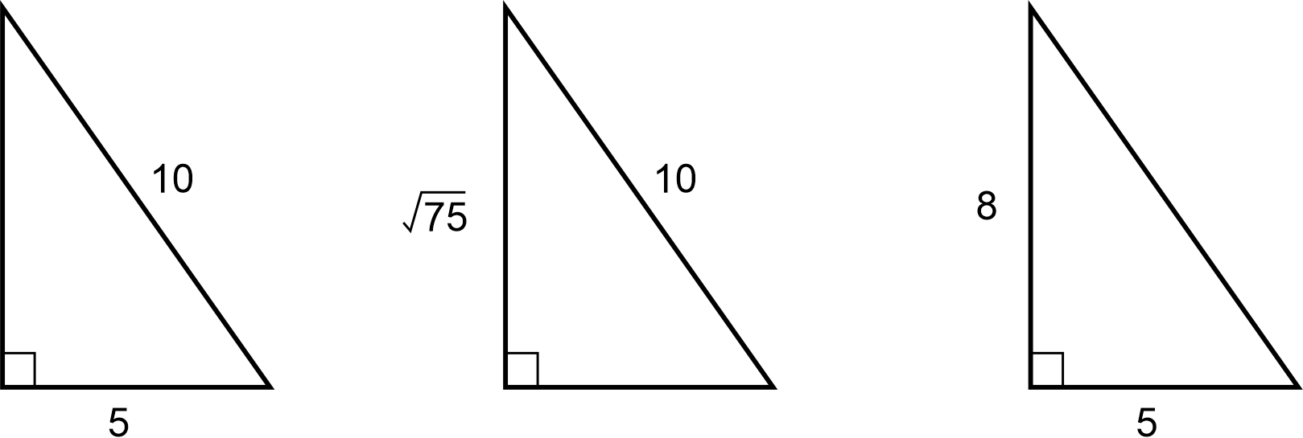
Image long description: First triangle has longest side at 10 and shortest side at 5. Second triangle has longest side 10 and other side root 75. Third triangle has shortest side 5 and other side 8.

Develop and apply the minimum conditions for triangles to be similar
- Examine the minimum conditions needed and establish the 4 tests for 2 triangles to be similar
Example(s):
Tests to establish whether 2 triangles are similar
If 3 sides of a triangle are proportional to 3 sides of another triangle, then they are similar.
If 2 sides of a triangle are proportional to 2 sides of another triangle, and the included angles are equal, then they are similar.
If 2 angles of a triangle are equal to 2 angles of another triangle, then they are similar (equiangular).
If the hypotenuse and a second side of a right-angled triangle are proportional to the hypotenuse and a second side of another right-angled triangle, then they are similar.
UGP7
- Apply the minimum conditions needed and determine whether 2 triangles are similar using an appropriate test

Establish and apply properties of similar shapes and solids
- Establish for 2 similar figures with similarity ratio $$a:b$$ that their areas are in the ratio $$a^{2}:b^{2}$$ and their volumes are in the ratio $$a^{3}:b^{3}$$
- Solve problems involving areas and volumes of similar shapes and solids
UGP7, UuM10

Apply logical reasoning to numerical problems involving plane shapes
- Apply geometrical facts, properties and relationships to find the sizes of unknown sides and angles of plane shapes in diagrams, providing appropriate reasons
Example(s):
Explaining why the longest side of a triangle is always opposite the largest angle.
Explaining why the sum of the lengths of 2 sides of a triangle must be greater than the length of the third side.
UGP6
- Define the exterior angle of a convex polygon
Example(s):
Representing exterior angles of a convex polygon using a diagram:
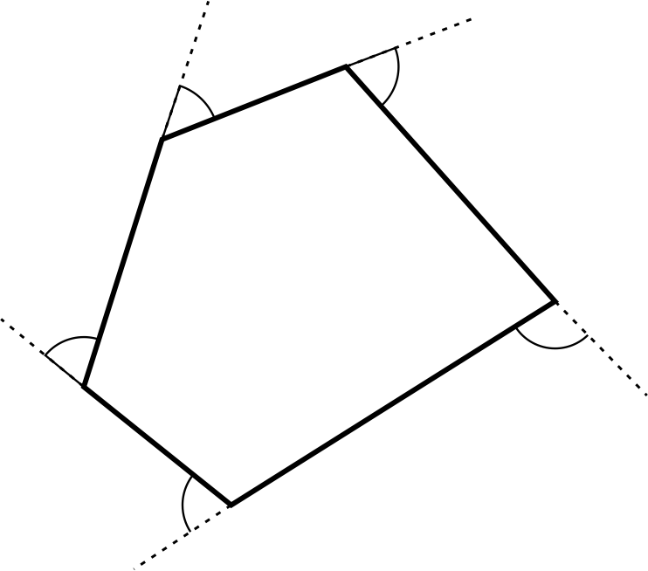

- Establish the sum of the exterior angles of any convex polygon is $$360°$$ and verify this result
Example(s):
Establishing a pattern by observing regular polygons and examining the sum of the exterior angles.
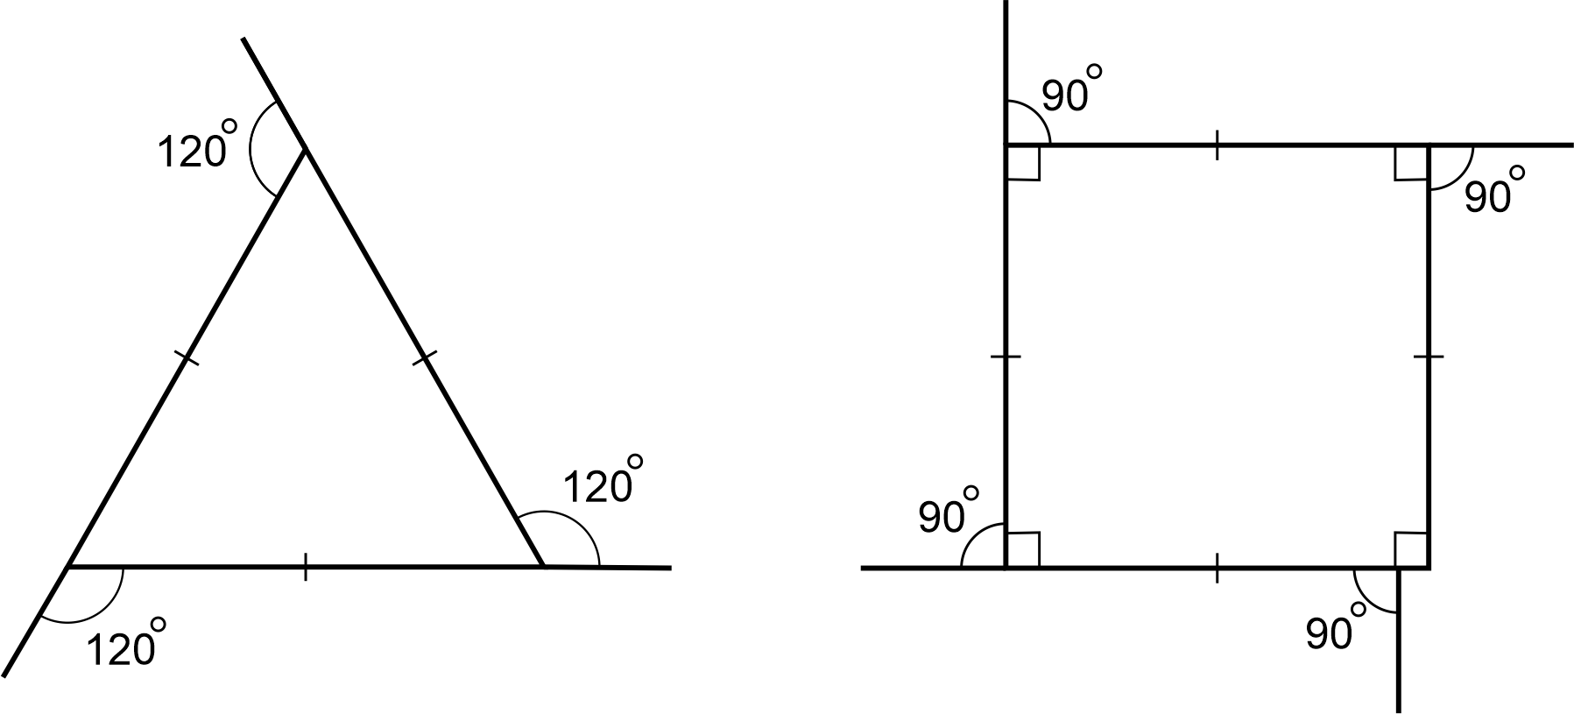
Image long description: A triangle marked up with the symbol for equal lines. Each line extends past the point of the triangle and has an exterior angle of 120 degrees. A square marked up with the symbol for equal lines. Each line extends past the corner of the square. Each interior angle is marked with the symbol for 90 degrees, and the exterior angles are also labelled 90 degrees.

- Apply the result for the sum of the interior angles of a triangle to find, by dissection, the sum of the interior angles of a polygon with more than 3 sides
Example(s):
Deriving the formula for the sum of the interior angles of a polygon $$=\left(n-2\right)×{180}^{°}$$by dissecting different polygons into triangles.
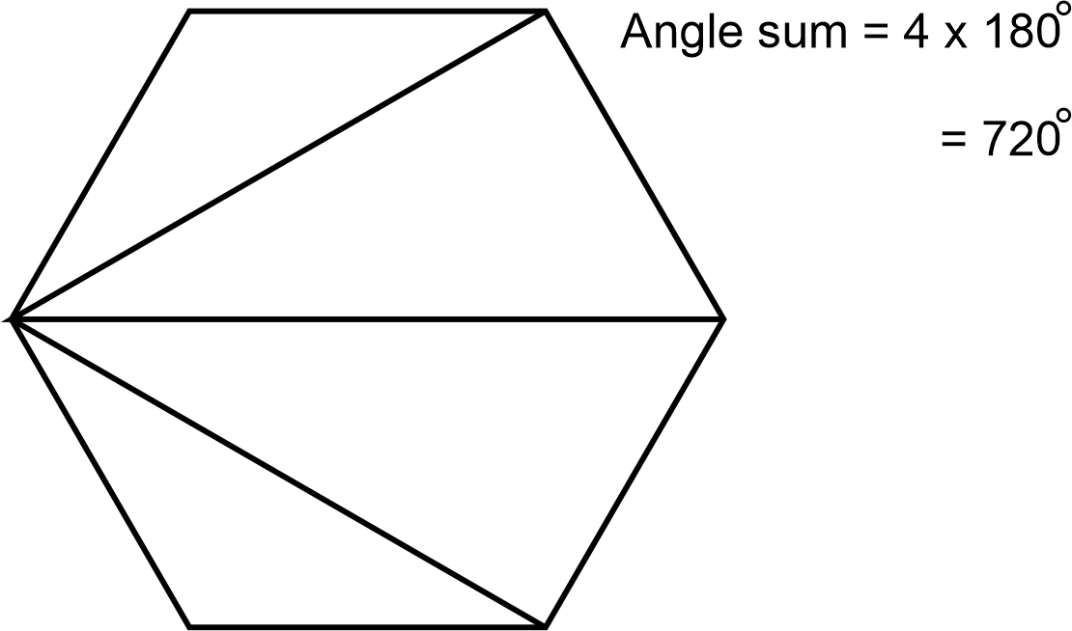
UGP6
- Apply the results for the interior and exterior angles of polygons to solve problems involving polygons

Properties of geometrical figures C (Path)

Outcomes
A student:
- develops understanding and fluency in mathematics through exploring and connecting mathematical concepts, choosing and applying mathematical techniques to solve problems, and communicating their thinking and reasoning coherently and clearly MAO-WM-01
- constructs proofs involving congruent triangles and similar triangles and proves properties of plane shapes (Path: Ext) MA5-GEO-P-02

Content
Stn (Standard), Adv (Advanced) and Ext (Extension) have been used to suggest paths for related Stage 6 courses.

Construct formal proofs involving congruent and similar triangles
- Construct formal proofs of the congruence of triangles, preserving the matching order of vertices and drawing relevant conclusions
Example(s):
Constructing a formal proof for $$∠BAC=∠DAC$$:
In $$∆ABC$$ and $$∆ADC$$,
$$AC$$ is a common side
$$AB=AD$$ (given)
$$∠ACB=∠ACD={90}^{°}$$(given)
$$∴∆ABC≡∆ADC$$ (RHS)
Hence $$∠BAC=∠DAC$$ (corresponding angles in congruent triangles).
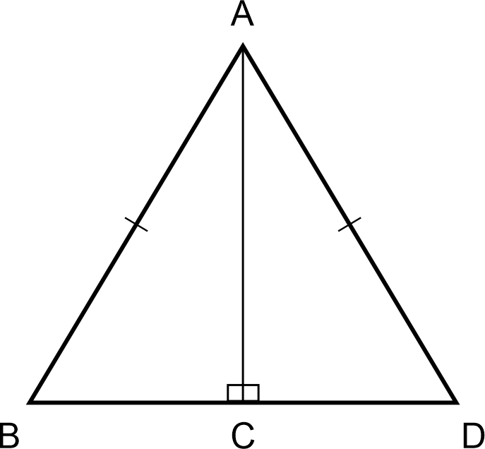

- Construct formal proofs of the similarity of triangles, preserving the matching order of vertices and drawing relevant conclusions

Apply logical reasoning to proofs involving plane shapes
- Recognise that a definition is the minimum amount of information needed to identify a particular figure
- Prove the properties of isosceles and equilateral triangles and special quadrilaterals from the formal definition of the shapes
Example(s):
Formal definitions of some shapes
A scalene triangle is a triangle with no 2 sides equal in length.
An isosceles triangle is a triangle with 2 sides equal in length.
An equilateral triangle is a triangle with all sides equal in length.
A trapezium is a quadrilateral with at least one pair of opposite sides parallel.
A parallelogram is a quadrilateral with both pairs of opposite sides parallel.
A rhombus is a parallelogram with 2 adjacent sides equal in length.
A rectangle is a parallelogram with one angle a right angle.
A square is a rectangle with 2 adjacent sides equal.

- Prove and apply theorems and properties related to triangles and quadrilaterals
Example(s):
Theorems and properties related to triangles and quadrilaterals
The sum of the interior angles of a triangle is 180°.
The exterior angle of a triangle is equal to the sum of the 2 interior opposite angles.
If 2 sides of a triangle are equal, then the angles opposite those sides are equal. Conversely, if 2 angles of a triangle are equal, then the sides opposite those angles are equal.
Each angle of an equilateral triangle is equal to 60°.
The sum of the interior angles of a quadrilateral is 360°.
The opposite angles of a parallelogram are equal.
The opposite sides of a parallelogram are equal.
The diagonals of a parallelogram bisect each other.
The diagonals of a rhombus bisect each other at right angles.
The diagonals of a rhombus bisect the vertex angles through which they pass.
The diagonals of a rectangle are equal.

- Prove and apply tests for quadrilaterals
Example(s):
Tests for quadrilaterals
If both pairs of opposite angles of a quadrilateral are equal, then the quadrilateral is a parallelogram.
If both pairs of opposite sides of a quadrilateral are equal, then the quadrilateral is a parallelogram.
If all sides of a quadrilateral are equal, then the quadrilateral is a rhombus.

- Solve numerical and non-numerical problems in Euclidean geometry based on known assumptions and proven theorems

Circle geometry (Path)

Outcomes
A student:
- develops understanding and fluency in mathematics through exploring and connecting mathematical concepts, choosing and applying mathematical techniques to solve problems, and communicating their thinking and reasoning coherently and clearly MAO-WM-01
- applies deductive reasoning to prove circle theorems and solve related problems (Path: Ext) MA5-CIR-P-01

Content
Stn (Standard), Adv (Advanced) and Ext (Extension) have been used to suggest paths for related Stage 6 courses.

Prove and apply angle and chord properties of circles
- Apply terminology associated with angles in circles
Example(s):
Defining and indicating on a diagram the meanings of the terms subtend, standing on the same arc, angle at the centre, angle at the circumference and angle in a segment.

- Identify the arc on which an angle at the centre or circumference stands
Example(s):
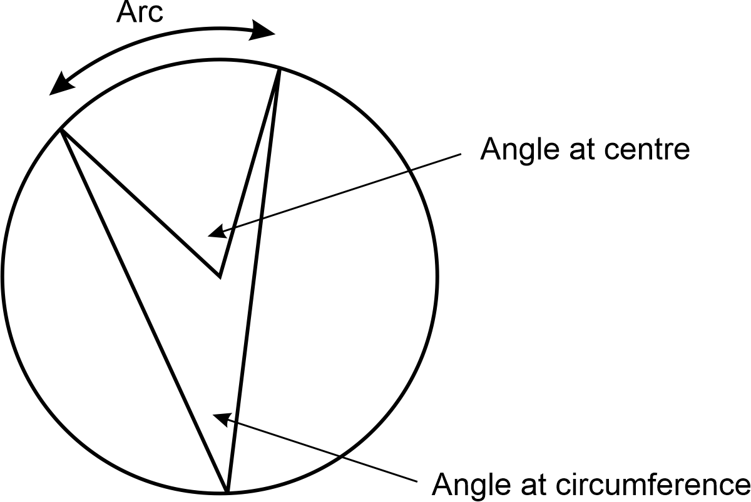
Image long description: A circle with 2 radii touching the circle at 2 points and lines from those 2 points touching the circle at the same point on the opposite side of the shape. The arc is shown between the 2 points the radii touch, the angle at the centre is indicated between the 2 radii and the angle at circumference is indicated between the 2 lines on the opposite side of the circle.

- Demonstrate that at any point on a circle there is a unique tangent to the circle, and that this tangent is perpendicular to the radius at the point of contact
- Prove chord properties of circles
Example(s):
Chord properties of circles
Equal chords of a circle subtend equal angles at the centre.
The perpendicular from the centre of a circle to a chord bisects the chord.
The line from the centre of a circle to the midpoint of a chord is perpendicular to the chord.
The perpendicular bisector of a chord of a circle passes through the centre.
Given any 3 non-collinear points, the point of intersection of the perpendicular bisectors of any 2 sides of the triangle formed by the 3 points is the centre of the circle through all 3 points.
When 2 circles intersect, the line joining their centres bisects their common chord at right angles.

- Prove angle properties of circles
Example(s):
Angle properties of circles
The angle at the centre of a circle is twice the angle at the circumference, standing on the same arc.
The angle in a semicircle is a right angle.
Angles at the circumference, standing on the same arc, are equal.
The opposite angles of cyclic quadrilaterals are supplementary.
An exterior angle at a vertex of a cyclic quadrilateral is equal to the interior opposite angle.

- Apply chord and angle properties of circles to find unknown angles and lengths in diagrams
Example(s):
Finding the length of $$AC$$ if $$AB=14$$cm, giving reasons:
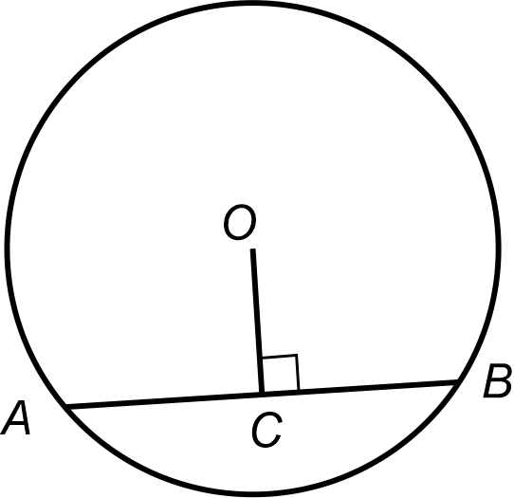
$$AC=\frac{1}{2}AB$$ (line through centre perpendicular to a chord bisects the chord)
$$=\frac{1}{2}×14$$ cm
$$=7$$ cm
Finding the value of $$x$$ giving reasons:
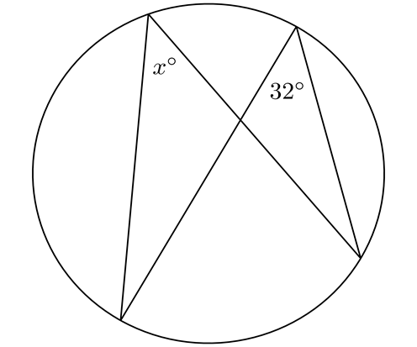
$$x={32}^{°}$$ (angles at the circumference standing on the same arc are equal)

Prove and apply tangent and secant properties of circles
- Prove tangent and secant properties of circles
Example(s):
Tangent and secant properties of circles
The 2 tangents drawn to a circle from an external point are equal in length.
The angle between a tangent and a chord drawn to the point of contact is equal to the angle in the alternate segment.
When 2 circles touch, their centres and the point of contact are collinear.
The products of the intercepts of 2 intersecting chords of a circle are equal.
The products of the intercepts of 2 intersecting secants to a circle from an external point are equal.
The square of a tangent to a circle from an external point equals the product of the intercepts of any secants from the point.

- Apply tangent and secant properties of circles to find unknown angles and lengths in diagrams
Example(s):
Finding the value of $$x$$ if $$PT$$ is a tangent, giving reasons:
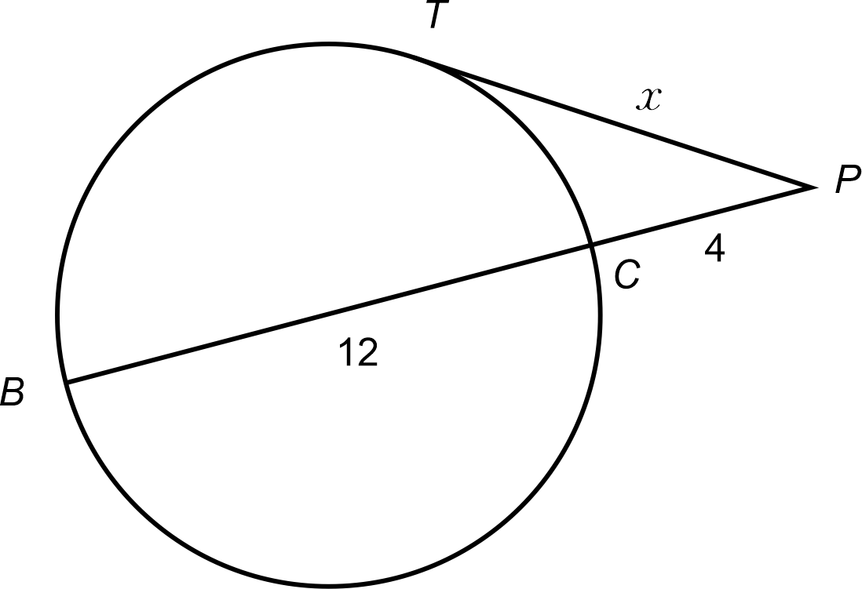
$${PT}^{2}=PC×PB$$ (square of tangent is equal to the product of the intercepts of the secant)
$$x^{2}=4\left(4+12\right)$$
$$x^{2}=64$$
$$∴x=8 \left(x>0\right)$$

Introduction to networks (Path)

Outcomes
A student:
- develops understanding and fluency in mathematics through exploring and connecting mathematical concepts, choosing and applying mathematical techniques to solve problems, and communicating their thinking and reasoning coherently and clearly MAO-WM-01
- solves problems involving the characteristics of graphs/networks, planar graphs and Eulerian trails and circuits (Path: Stn) MA5-NET-P-01

Content
Stn (Standard), Adv (Advanced) and Ext (Extension) have been used to suggest paths for related Stage 6 courses.

Examine and describe a graph/network
- Describe a network as a collection of objects (nodes or vertices) interconnected by lines (edges) that can represent systems in the real world
- Examine real-world applications of networks such as social networks, supply chain networks and communication infrastructure, and explore other applications of networks
- Explain that the terms graph and network are interchangeable
Example(s):
Applying the term graph when referring to abstract entities in mathematical settings and the term network to relate graphs to real-world systems.

- Identify and define elements of a graph including vertex, edge and degree
Example(s):
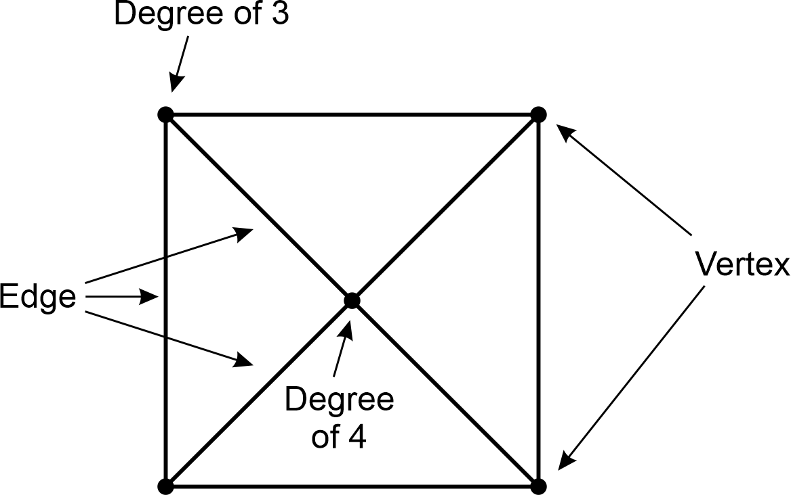
Image long description: A square with 2 diagonals drawn and points on all intersections of lines. A corner of the square has degree of 3, the edges are the diagonals and sides of the square, the vertices are the corners of the square and the point where the diagonals intersect has a degree of 4.

- Explain that a given graph can be drawn in different ways
Example(s):
Explaining that as long as the vertices and their respective connections are the same, graphs can be drawn in different ways.
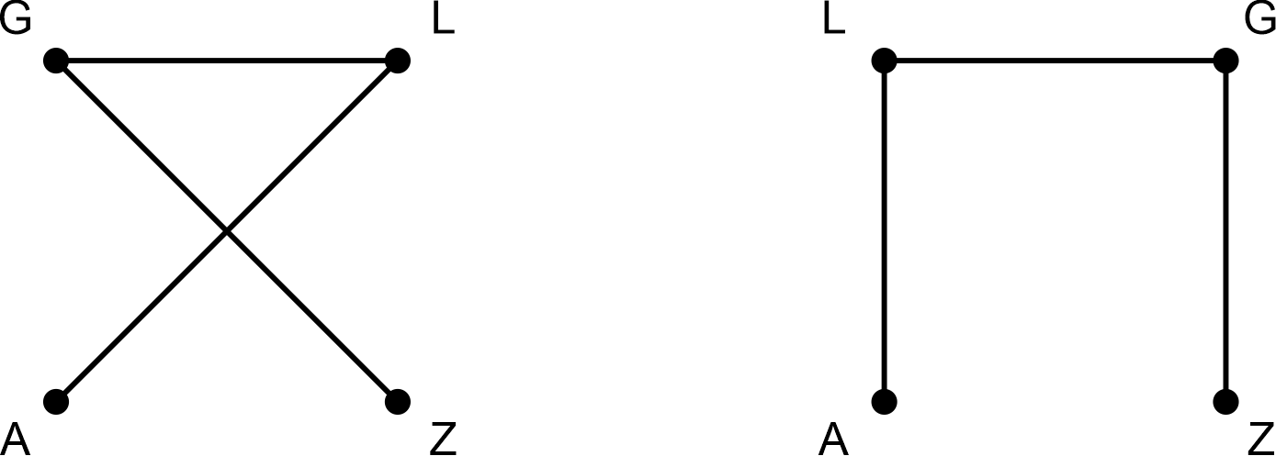

Define a planar graph and apply Euler’s formula for planar graphs
- Define a planar graph as any graph that can be drawn in the plane so that no 2 edges cross
Example(s):
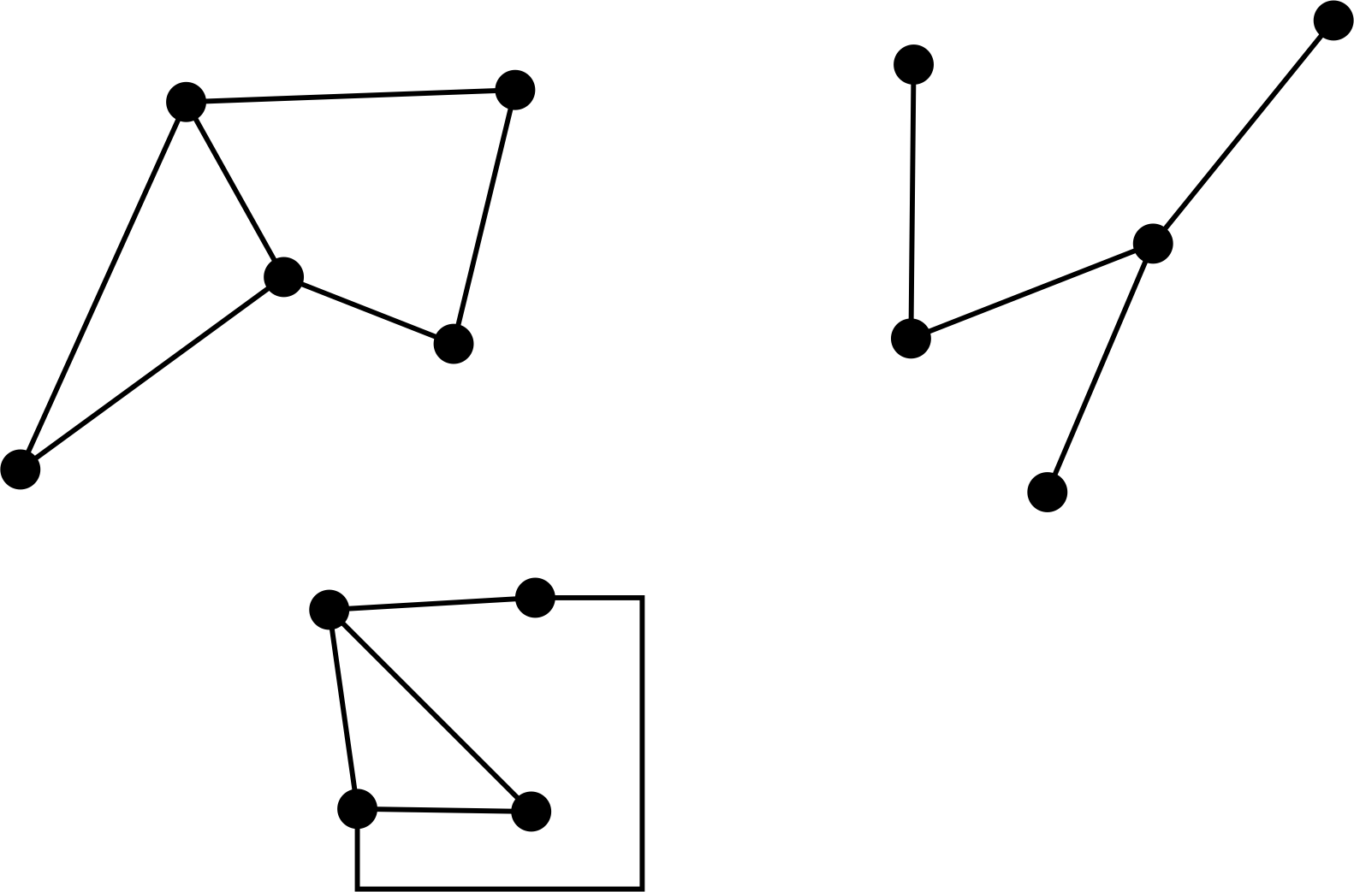

- Define a non-planar graph as a graph that can never be drawn in the plane without some edges crossing
Example(s):
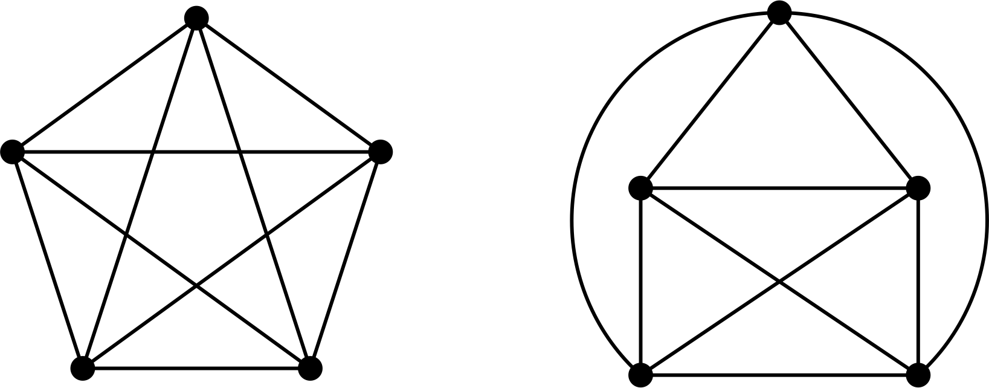

- Demonstrate that some graphs that have crossing edges are still planar if they can be redrawn so that no 2 edges cross
Example(s):
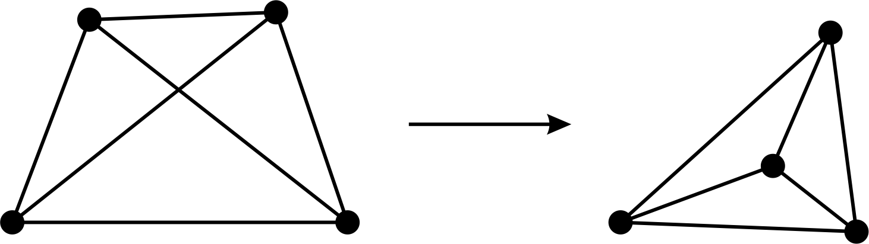

- Identify the number of faces in a planar graph
Example(s):
Finding the number of faces in a planar representation when redrawing a graph and noting that the face external to the graph is known as the infinite face.
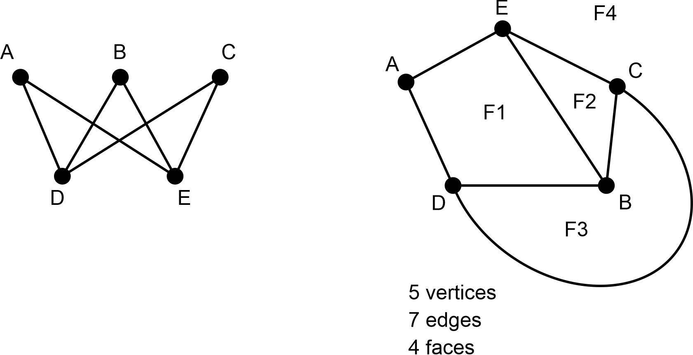
Image long description: Graph A B C D E has 5 vertices and 7 edges and is drawn so that edges cross in multiple places. Graph A B C D E is redrawn so that no edges cross and 4 faces result, including the area outside of the shape.

- Describe and apply Euler’s formula for planar graphs: $$v-e+f=2$$, where $$v$$ = vertices, $$e$$ = edges and $$f$$ = faces
Example(s):
Verifying that Euler’s formula holds for the planar graph below:
$$v-e+f=2$$
$$5-7+4=2$$
$$∴$$ Euler’s formula holds
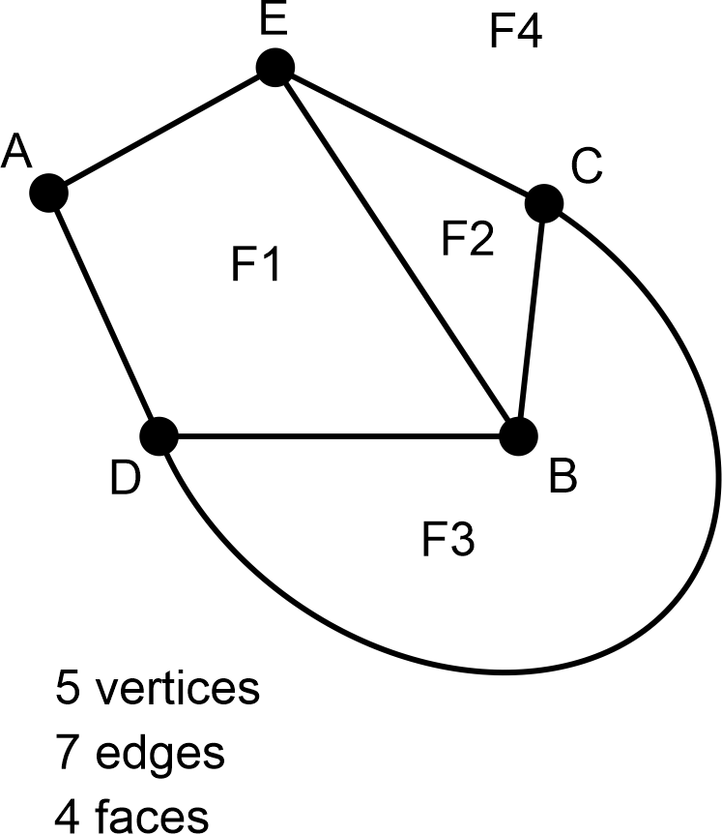
Image long description: Graph A B C D E has 5 vertices and 7 edges and is drawn so that no edges cross and 4 faces result including the area outside of the shape.

Explain the concept of Eulerian trails and circuits in the context of the Königsberg bridges problem
- Explain that a connected graph is a graph that is in one piece, so that any 2 vertices are connected by a path
Example(s):
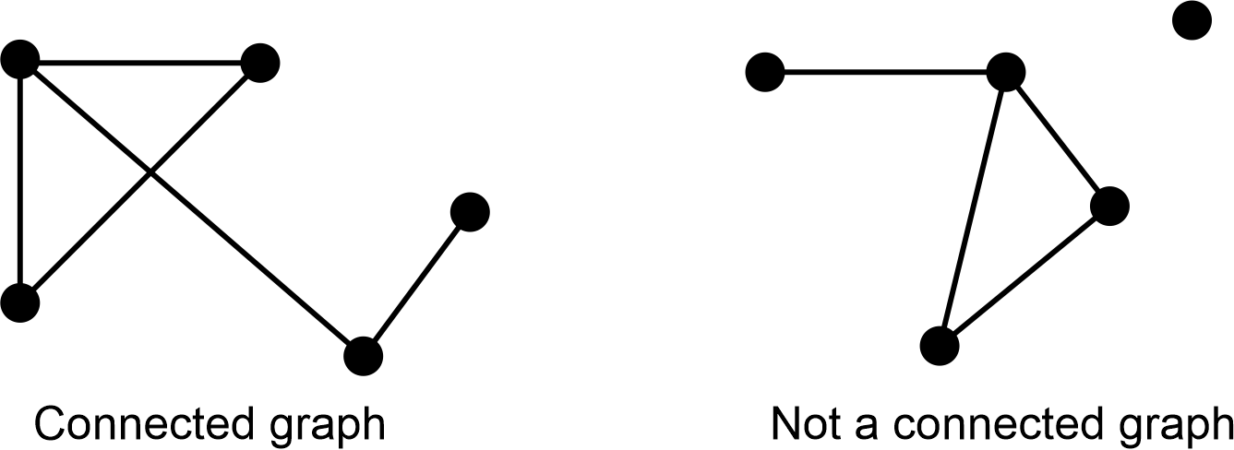
Image long description: The first graph has 5 vertices joined by edges and second graph has 4 vertices joined by edges and one vertex not joined.

- Define a walk on a graph to be a sequence of vertices and edges of a graph
Example(s):
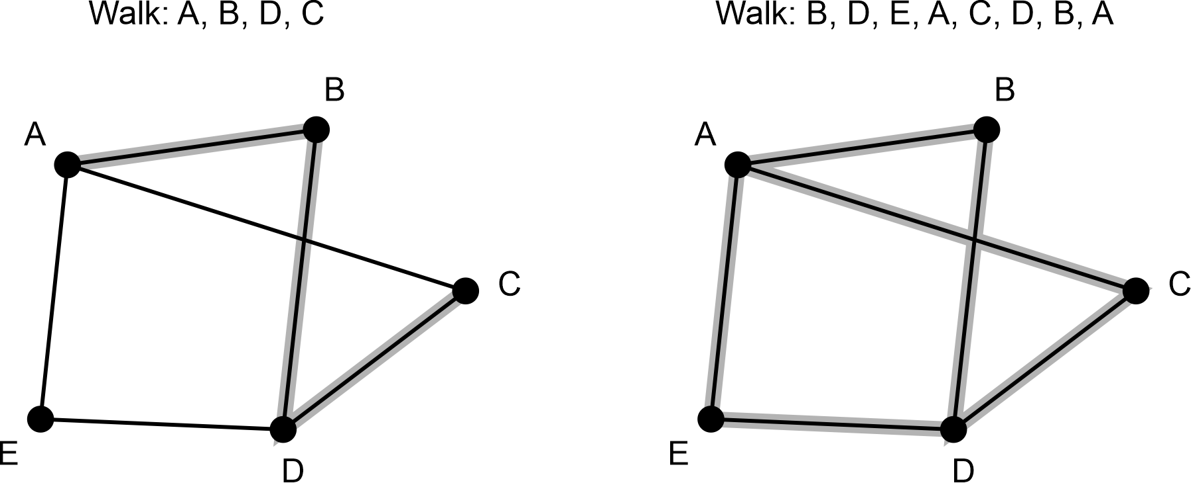
Image long description: 2 graphs with 5 vertices labelled A B C D E demonstrate different walks. Walk A B D C has edges AB, BD and DC highlighted. Walk B D E A C D B A has all edges highlighted.

- Explain the difference between trail, circuit, path and cycle
Example(s):
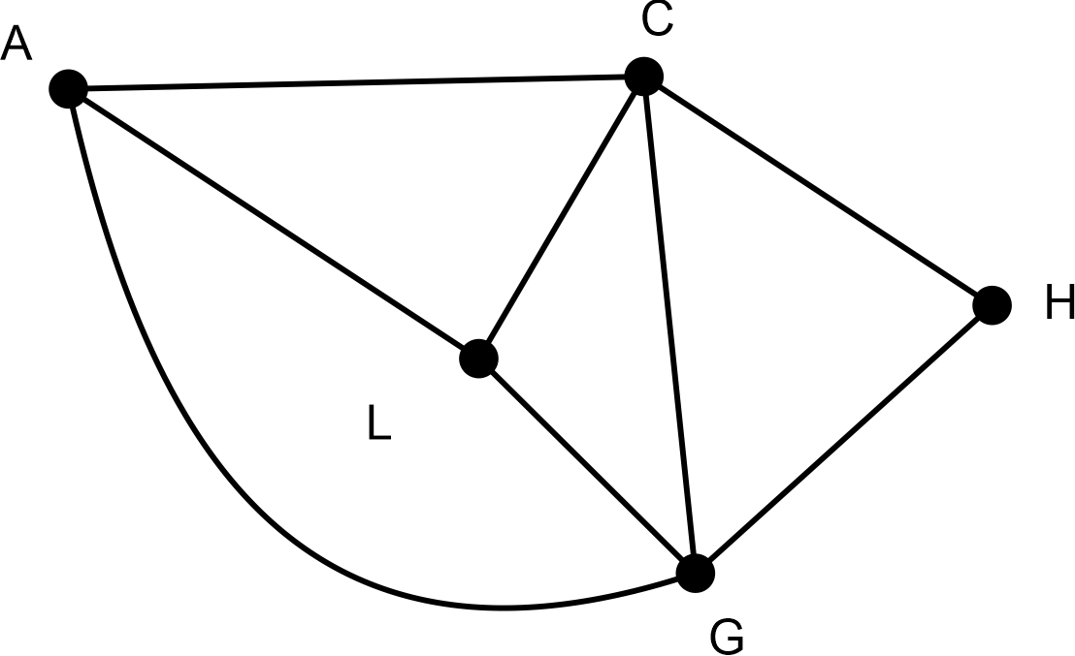
Image long description: Graph A C H G L has 5 vertices and 8 edges that do not cross. A is connected to C and L. L is connected to C, A and G. G is connected to L, C and H. H is connected to C and G. C is connected to A, L, G and H.
A trail is a walk where all edges are distinct or used once; however, vertices may repeat (A – L – C – G – H – C).
A circuit is a trail that begins and ends on the same vertex (A – L – C – G – H – C – A).
A path is a walk where vertices and edges are distinct or used only once (A – L – C – G – H).
A cycle is a closed path that starts and finishes at the same vertex (A – L – C – G – A).

- Relate the definition of a trail to an Eulerian trail as a walk in which every edge in the graph is included exactly once
- Relate the definition of a circuit to an Eulerian circuit that is defined as an Eulerian trail that ends at its starting point
- Relate Euler’s Seven Bridges of Königsberg network problem to the definition of an Eulerian trail or circuit

Data analysis C (Path)

Outcomes
A student:
- develops understanding and fluency in mathematics through exploring and connecting mathematical concepts, choosing and applying mathematical techniques to solve problems, and communicating their thinking and reasoning coherently and clearly MAO-WM-01
- plans, conducts and reviews a statistical inquiry into a question of interest (Path: Stn, Adv) MA5-DAT-P-01

Content
Stn (Standard), Adv (Advanced) and Ext (Extension) have been used to suggest paths for related Stage 6 courses.

Plan and conduct a statistical inquiry into a question of interest
- Design an aim and hypothesis based on a question of interest
- Apply ethical and efficient methods for gathering and organising data
- Produce a report containing multiple data visualisations that provide insights and information

Examine reports of studies in digital media and elsewhere for information on their planning and implementation
- Examine and evaluate the appropriateness of sampling methods and sample size in reports with statements about a population and how they can affect the results of a survey
Example(s):
Comparing different sampling methods, such as random, systematic, stratified and self-selected, and explaining how each of these could affect the results of a particular survey.
Examining sampling methods used to track biodiversity of native species in the local area.

- Critically review surveys, polls and media reports for accuracy and/or bias
IRD8
- Examine the use of statistics and the associated probabilities in shaping decisions made by governments and companies

Probability B (Path)

Outcomes
A student:
- develops understanding and fluency in mathematics through exploring and connecting mathematical concepts, choosing and applying mathematical techniques to solve problems, and communicating their thinking and reasoning coherently and clearly MAO-WM-01
- solves problems involving Venn diagrams, 2-way tables and conditional probability (Path: Adv) MA5-PRO-P-01

Content
Stn (Standard), Adv (Advanced) and Ext (Extension) have been used to suggest paths for related Stage 6 courses.

Solve problems involving Venn diagrams and 2-way tables
- Represent and interpret data in Venn diagrams for mutually exclusive and non-mutually exclusive events
UnC5
- Construct Venn diagrams to represent all possible combinations of 2 attributes from given or collected data
UnC5
- Interpret data in 2-way tables to represent relationships between attributes
Example(s):
Interpreting survey data of 100 people to determine the number of people who play an instrument and play a sport.
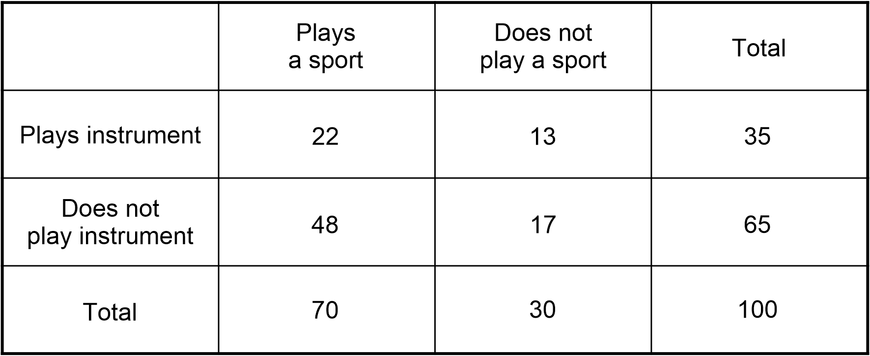
Image long description: 22 people play a sport and play an instrument. 48 people play a sport but do not play an instrument. 13 people do not play sport but play an instrument. 17 people do not play sport and do not play an instrument.
UnC5
- Construct 2-way tables to represent the relationships between attributes
UnC5
- Convert between representations of the relationships between 2 attributes in Venn diagrams and 2-way tables
Example(s):
Transferring information from the Venn diagram below (left) to the 2-way table below (right).
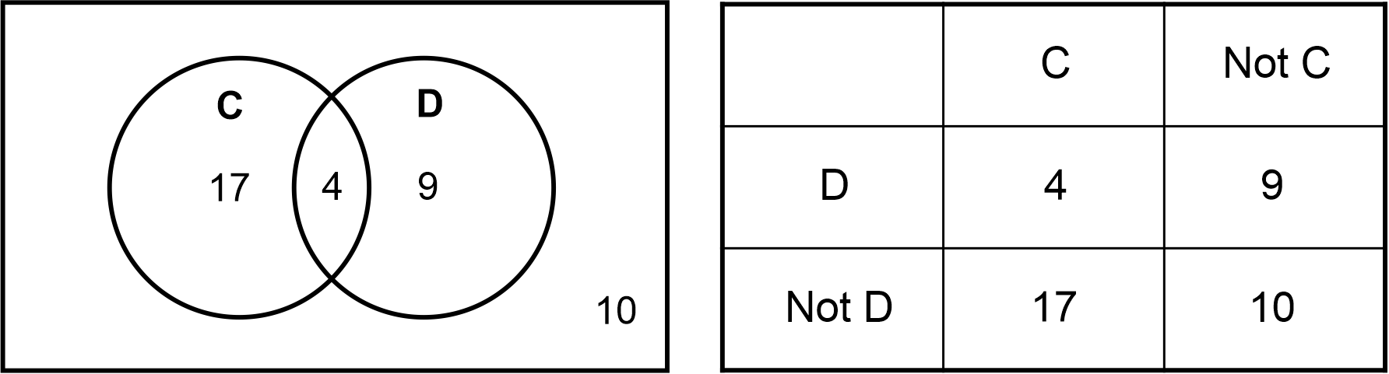
Image long description: First example demonstrates a Venn diagram with intersecting circles C and D. The number inside the intersection is 4, the C circle has 17 and the D circle has 9. The number 10 is outside both circles. Second example demonstrates that 4 elements are for C and D. 17 elements for C and not D. 9 elements for Not C and D and 10 elements for Not C and Not D.
UnC5
- Define a set as a collection of distinct objects
- Use Venn diagrams, set language and notation for events, including $$\overset{‾}{A}$$ (or $$A^{'}$$ or $$A^{c}$$) for the complement of an event $$A$$, $$A∩B$$ for '$$A$$ and $$B$$' (the intersection of events $$A$$ and $$B$$) and $$A∪B$$ for '$$A$$ or $$B$$' (the union of events $$A$$ and $$B$$) and recognise mutually exclusive events
Example(s):
Shading a region on a Venn diagram to represent $$\left(A∩B\right) ∪C$$.
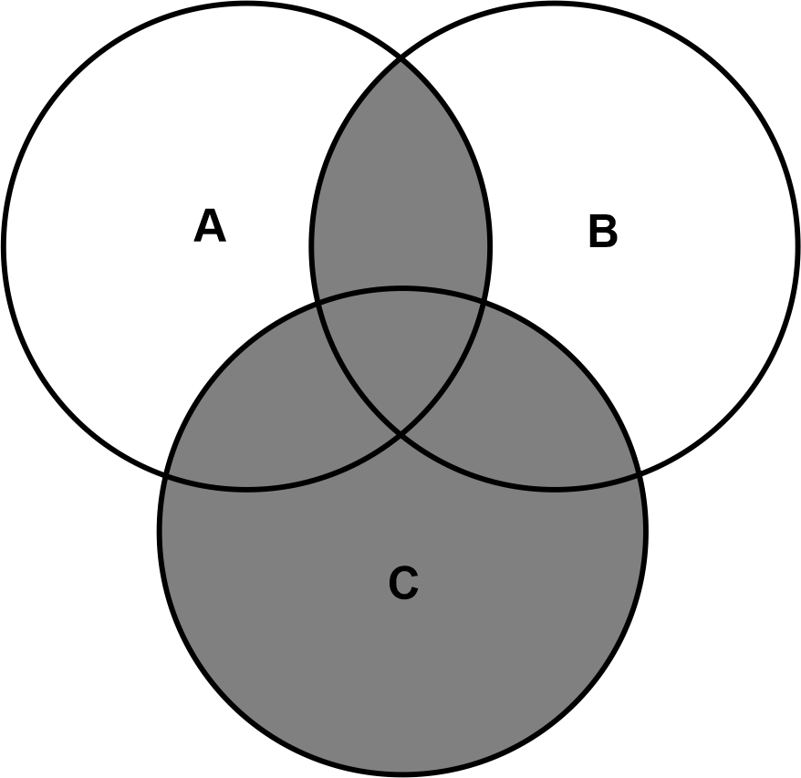

Use the language, 'if … then', 'given', 'of' and 'knowing that', to examine conditional statements and identify common mistakes in interpreting the language
- Calculate the probabilities of events where a condition restricts the sample space
Example(s):
Calculating the probability that a resulting number is 3, given that a number less than 5 has been rolled on an unbiased 6-sided die.

- Describe the effect of a given condition on the sample space
Example(s):
Demonstrating that the sample space is reduced to {1, 2, 3, 4}, given that a number less than 5 has been rolled on an unbiased 6-sided die.

- Identify conditional statements used in descriptions of chance situations
Example(s):
Identifying the term given in the statement ‘Finding the probability that a student chosen at random was born on a Saturday given that they were born on a weekend’ as indicating the condition.

- Explain the validity of conditional statements when describing chance situations, referring to dependent and independent events
Example(s):
Explaining why if you toss a coin and get a tail, then the probability of getting a tail on the next toss is the same.
UnC6
- Identify and explain common misconceptions relating to chance experiments
UnC6

Describe mutually and non-mutually exclusive events using specific language and calculate related probabilities
- Explain the difference between mutually exclusive and non-mutually exclusive events
Example(s):
Using Venn diagrams to represent that when tossing a coin, it is not possible to get heads and tails at the same time. Using Venn diagrams to represent that it is possible to like cats, dogs or both cats and dogs.
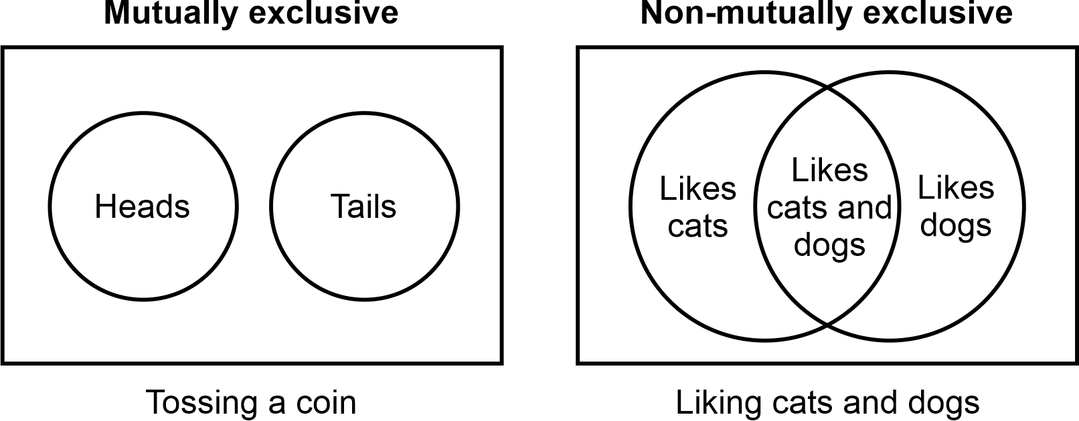
Image long description: Tossing a coin is the mutually exclusive event and is represented by 2 circles that do not overlap. One circle is labelled 'Heads', the other 'Tails'. Liking cats and dogs is the non-mutually exclusive event represented by a Venn diagram with 2 intersecting circles, one labelled 'Likes cats', the other 'Likes dogs'. The overlap is labelled 'Likes cats and dogs'.

- Describe compound events using the terms inclusive or and exclusive or
Example(s):
Recognising that the word or on its own often needs a qualifier, such as both or not both to determine inclusivity or exclusivity. Or without a qualifier usually denotes the inclusive or for non-mutually exclusive events.
UnC5, UnC6
- Describe non-mutually exclusive events using the terminology and, inclusive or and exclusive or
Example(s):
Identifying language that is common to non-mutually exclusive events, such as 25 students play both basketball and football, 46 students play basketball or football, but not both, 19 students play neither sport, and 71 students play basketball or football or both and representing this using a Venn diagram.
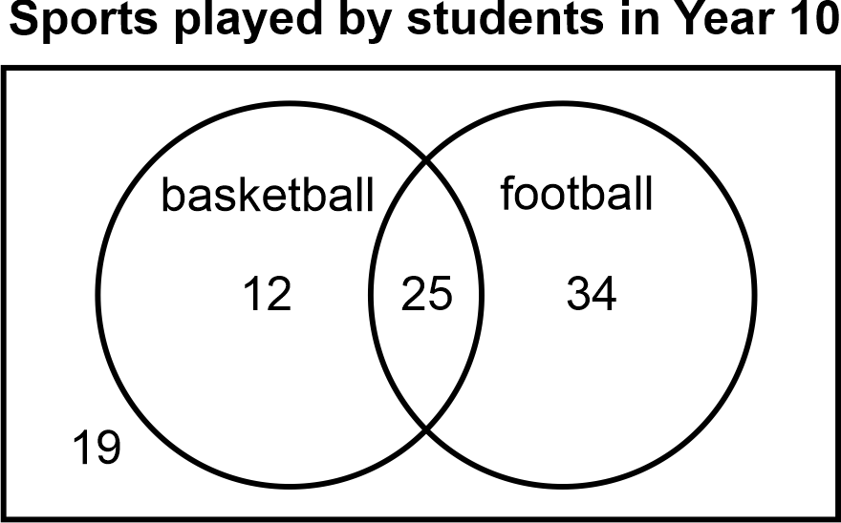
Image long description: Venn diagram shows 2 intersecting circles. One circle represents the number of students who play basketball (12), the second circle represents the number of students who play football (34). The space where the 2 circles overlap represents the number of students who play both sports (25). Outside the Venn diagram, but inside the rectangle represents the number of students who do not play either sport (19).
UnC6
- Describe events using the terms at least, at most, not and and
Example(s):
Identifying the terminology in situations such as rolling a standard 6-sided die and finding the probability of rolling at least a 5, at most a 3, not rolling a 5, and rolling a 4 and a 5.
UnC6
- Calculate the probability of compound events using strategies including Venn diagrams and 2-way tables
UnC5, UnC6

Assessment
The primary role of assessment is to establish where students are in their learning so that teaching can be differentiated and further learning progress can be monitored over time. It provides information that assists teachers to target their teaching at the point of student need. Assessment is most effective when it is an integral part of teaching and learning programs.
Assessment involves:
- establishing where students are in their learning
- ongoing monitoring
- formative and summative tasks
- providing feedback about student progress.

Common Grade Scale
Stage 1, Stage 2, Stage 3, Stage 4, Stage 5
The common grade scale can be used to report student achievement in both primary and junior secondary years in all NSW schools.

Course performance descriptors
Stage 5 – Year 10
Course performance descriptors provide holistic descriptions of typical achievement at different grade levels in a specific course. They are used to identify and report a student’s level of achievement in a Board Developed Course at the end of Stage 5.

Grade A
A student performing at this grade typically:
- demonstrates extensive understanding of the relationships between mathematical concepts
- uses, creates and interchangeably moves between a variety of abstract and concrete representations in familiar and unfamiliar situations
- solves routine problems involving multiple steps consistently in familiar and unfamiliar situations
- uses multiple connections between concepts to solve non-routine problems
- applies deductive reasoning and concise, formal mathematical arguments to prove and justify results in a variety of forms
- uses precise mathematical language consistently and effectively to communicate reasoning, explain solutions and justify results

Grade B
A student performing at this grade typically:
- demonstrates thorough understanding of the relationships between mathematical concepts
- uses, creates and moves between abstract and concrete representations in familiar and unfamiliar situations
- solves routine problems of up to 3 steps in familiar and unfamiliar situations and attempts routine problems of more than 3 steps with some success
- uses some connections between concepts to attempt non-routine problems
- applies formal and informal mathematical reasoning to prove and justify results
- uses appropriate mathematical language effectively to communicate reasoning, explain solutions and justify results

Grade C
A student performing at this grade typically:
- demonstrates sound understanding of the relationships between mathematical concepts
- uses and creates abstract or concrete representations in familiar situations
- solves routine problems of up to 3 steps in familiar situations and attempts routine problems of more than 3 steps
- identifies some connections between concepts when attempting non-routine problems
- uses informal mathematical reasoning to prove or justify results
- uses mathematical language to communicate reasoning and explain solutions

Grade D
A student performing at this grade typically:
- identifies some relationships between mathematical concepts
- uses concrete representations in some familiar situations
- attempts routine problems of up to 3 steps with some success
- uses informal mathematical reasoning
- uses limited mathematical language

Grade E
A student performing at this grade typically:
- recognises some mathematical concepts
- attempts some routine problems with very limited success
- attempts to use informal mathematical reasoning
- uses very limited mathematical language

Assessment of Life Skills outcomes
Stage 4, Stage 5
The syllabus outcomes and content form the basis of learning opportunities for students. Through the collaborative curriculum planning process, teachers select specific Life Skills outcomes which are based on the needs, strengths, goals, interests and prior learning of each student. Students are required to demonstrate achievement of one or more Life Skills outcomes.
Assessment should provide opportunities for students to demonstrate achievement in relation to the selected outcomes. Assessment can occur in a range of situations or environments such as the school and wider community. Evidence of achievement can be based on:
- formative assessment opportunities
- summative assessment opportunities.
There is no requirement for formal assessment of Life Skills outcomes. Stage 6 Life Skills courses do not have external examinations or mandatory projects.

